PDHonline Course E613 (5 PDH)

Electric Utility Distribution Reliability Management

Instructor: Lee Layton, P.E

2019

PDH Online | PDH Center

5272 Meadow Estates Drive
Fairfax, VA 22030-6658
Phone & Fax: 703-988-0088
www.PDHonline.org
www.PDHcenter.com
Electric Utility Distribution Reliability Management
Lee Layton, P.E

Table of Contents

Section Page

Introduction …………………………………………….. 3

Chapter 1, Distribution Reliability ……….……………. 4

Chapter 2, Reliability Indices …………….……………. 9

Chapter 3, Major Events ………………….………...… 19

Chapter 4, Calculating Reliability Indices ………….… 23

Chapter 5, Performance Measurements ……………… 33

Chapter 6, Concepts in Reliability Improvement .......... 43

Chapter 7, Power Quality …………………………….. 57

Summary …………………………………………..…. 62

Introduction

The United States has one of the most robust and reliable electric grids in the world and electric customers in the United States can expect to experience less than two outages per year for a total outage time of slightly less than two hours out of an 8,760 hour year.

The reliability of the electric system is an important factor in maintaining a healthy economy, as well as a high degree of customer satisfaction.

In recent years, many consumer advocates and regulatory bodies have expressed concern that the reliability of the electric delivery system is being compromised due to an increased focus on competition and profitability. Many states have passed, or are in the process of passing legislation and/or approving regulations intended to refocus attention on maintaining and improving reliability. As time goes on, these laws and/or rules are expected to become more structured and pervasive.

The reliability of the electric system is affected by all three components of the electric system—generation, transmission, and distribution. Generation reliability is ensured by, among other things, maintaining adequate planning and operating reserves. With a few notable exceptions, the establishment and enforcement of specific reserve requirements by regional reliability councils and power pools has resulted in fewer service interruptions due to the lack of generation capacity. As a result, most service interruptions experienced by end-use customers are the result of interruptions of transmission and distribution (T&D) facilities, not production facilities. Of these delivery system interruptions, the majority of interruptions are generally the result of interruptions of distribution facilities.

One ingredient in maintaining and improving reliability is the development of a consistent set of reliability indices that may be used to measure, report and compare reliability. To date, most industry effort in this regard has addressed the measuring and indexing of total system reliability. The Institute of Electrical and Electronic Engineers (IEEE), for example, has developed a reliability guideline (IEEE1366) that standardizes the calculation of reliability indices for electric utility systems.

The course explains how electric system reliability is measured at the distribution level and describes ways that utilities may increase system reliability. First we need to define electric system reliability and for that, let’s look at Chapter 1.
Chapter 1
Distribution Reliability

Electric distribution reliability in the United States has remained fairly consistent over the past 10 years in spite of significant programs to improve reliability. Some studies have shown that electric systems are more reliable now however more extreme weather, as well as better reporting, has increased the outage numbers. So while it appears that electric reliability hasn’t changed much, many experts agree that reliability is improving.

Approximately 88% of all customer interruptions occur on the electric distribution network with substations the next largest cause (6%), transmission (4%), and generation at only 2%. See Figure 1 below.

Figure 1

This is a clear indication of the primary importance of distribution system reliability to the reliability of the customers’ electric power service: inability to provide service at individual load points arises mainly from distribution system equipment outages.

This chapter defines some of the key terms used in electric system reliability including a definition of electric system reliability. Of course, reliability depends on your perspective as either the end user or the utility itself.

The appropriate definitions of reliability may vary with respect to the perspective taken of the system. Arguably the most important perspective is how the customer views reliability. The occurrence of an outage indicates to the customer that service reliability is not perfect. That is, service reliability measures the degree to which customers experience service outages. The words "outage" and "interruption" are frequently used interchangeably but often mean separate things. The important distinction is between equipment outages, as observed by operators, and interruptions of service to the customer. Clearly, an equipment outage may not cause a service interruption; planned maintenance is an example of such an equipment outage, and therefore is not considered to be an outage by the customer – unless the customer is indeed without power.

In addition to its obvious consequences to customers, poor service reliability raises public concern with respect to noneconomic attributes such as health where lack of power for oxygen machines, air-conditioning, and heat may create health risks. Reliability concerns of customers depend on their end-use patterns. Research indicates that customers associate service reliability with restoration time and how accessible and responsive the utility is during interruptions.

The utility perspective may differ from the customer perspective. The definition of reliability for the utility should be related to that of the customer (i.e., service reliability.) Indeed, most utilities define reliability as service reliability, which is the reliability on the service side of customer load points, rather than supply reliability. The supply side of customer load points includes not only distribution equipment but also generation and transmission system assets and performance. Reliability on the supply side of customer load points is determined by the availability of utility equipment. Clearly, the availability of equipment in the distribution, transmission, and generation subsystems is related to service reliability, but equipment outages do not correspond directly to loss of continuity of service, since customers can be served by alternate supply assets.

It is also important to note that the maintenance policies adopted by utilities may reflect different perspectives on reliability. A utility that is focused on customer interruptions--service reliability- will adopt such policies as Reliability Centered Maintenance (RCM), which is driven by concerns about the effects of customer interruptions. A utility that is focused on supply reliability, with particular attention to distribution system equipment, will adopt maintenance policies that are driven by equipment availability criteria that may be set without regard to customer values or needs.

Reliability Definition

There are many different definitions of reliability though they all address some common aspects of electric power systems. These include factors such as:

- Continuity of service,
- Meeting customer demands, and
- Vulnerability of the power system.

Reliability concerns are often split into three categories: adequacy, or the capacity and energy to meet demand; security, or the ability to withstand disturbances; and quality, or acceptable frequency, voltage, and harmonic characteristics.

Reliability is commonly defined as:

The degree of performance of the elements of the electric system that results in electricity being delivered to customers within accepted standards and in the amount desired.

Reliability may be measured by the frequency, duration, and magnitude of adverse effects on the electric supply. Electric system reliability can be addressed by considering two basic and functional aspects of the electric system: adequacy and security.

- Adequacy is the ability of the electric system to supply the aggregate electrical demand and energy requirements of the customers at all times, taking into account scheduled and reasonably expected unscheduled outages of system elements.

- Security is the ability of the electric system to withstand sudden disturbances such as electric short circuits or unanticipated loss of system elements.

Similarly, one may define reliability as the system’s ability to provide an acceptable level of continuity and quality, or a reasonable assurance of continuity and quality.

Other Defined Terms
The following terms are used in this course as defined below.

Adequacy: The ability of the electric system to supply the aggregate electrical demand and energy requirements of the customers at all times.

Distribution: All utility equipment of 35 kV and below.

Instantaneous Interruption: An interruption restored immediately by completely automatic equipment, or a transient fault that causes no reaction by protective equipment. Typically less than 15 seconds.

Interruption: Cessation of electric service; lack of availability.

Least-Cost Planning: Attempt to find minimum cost over a wide range of supply options for a given level of service.

Major event day: As defined by IEEE Standard 1366, a day in which the daily SAIDI exceeds a threshold value, T_{MED}. For the purpose of calculating daily system SAIDI, any interruption that spans multiple calendar days is accrued to the day on which the interruption began. Statistically, days having a daily system SAIDI greater than T_{MED} are days when the energy delivery system experiences stresses beyond those normally expected—such as severe weather. Activities that occur on major event days should be analyzed and reported separately.

Momentary Interruption: An interruption restored by automatic, supervisory, or manual switching at a site where an operator is immediately available. Usually less than three minutes.

Outage: Failure of one or more components of the electric system to perform its intended function. Usually this is defined as the time between either the first customer call or the first SCADA indication until circuit is reenergized.

Permanent Outage: 1, 2, 3, 5 minute outages as defined by the utility.

Planned interruption: Any interruption scheduled by the distribution system to safely perform routine maintenance.

Power Factor: Measure of how well voltage and current in an alternating system are in step with one another.

Power quality: attributes of the power when some power is being delivered;

Power supply interruption: – Any interruption originating from the transmission system, sub-transmission system, or the substation, regardless of ownership.

Radial: only one path through system.

Reliability cost: Investment cost of the utility in achieving a defined level of reliability.

Reliability worth: Benefit gained by the utility customer from an increase of reliability.

Sag: Undervoltage condition.

Surge: Overvoltage or transient swing in voltage which doesn’t last over a number of cycles like a swell or sag.

Sustained Interruption: Any interruption that is not instantaneous, momentary, or temporary.

Temporary Interruption: An interruption restored by manual switching by an operator who is not immediately available. Typically, thirty minutes.

Value-Based Distribution Reliability Planning: Maximizing value to customers with a focus on the combination of electricity tariffs and reliability of service.

Value-Based Planning: Incorporation of customer values and costs into overall utility planning.

Chapter 2
Reliability Indices

Not only are there numerous definitions of reliability there are also a variety of ways to measure reliability. A metric for reliability is required for assessment of past performance, consideration of reliability in design, and setting of reliability goals. Many indices have been defined as measures of reliability. They measure different aspects of reliability or combinations of different aspects. Only a small number of these are common across several utilities, and the ones that are commonly used are not always defined in the exact same manner.

Reliability measures dealing with interruptions address three factors: frequency, duration, and extent or severity. The extent is the number of customers or load affected, which is determined by the layout of the distribution system. When assessing reliability, all three factors should be considered. Each reliability index may be important for a different purpose.

To help ameliorate variances in how reliability is measured the Institute of Electrical and Electronic Engineers (IEEE) developed a reliability guideline in 2003. IEEE 1366© is the Standard used for electric utility reliability measurements.

IEEE 1366© states:

“The purpose of this guide is twofold. First, it is to present a set of terms and definitions which can be used to foster uniformity in the development of distribution service reliability indices, to identify factors which affect the indices, and to aid in consistent reporting practices among utilities. Secondly, it is to provide guidance for new personnel in the reliability area and to provide tools for internal as well as external comparisons.

For reliability to be used as a design criterion and to allow the setting of reliability goals there needs to be a measure of it. No one index in IEEE 1366© completely captures the reliability of an electric system so most utilities use more several indices to develop an overall picture of reliability. No one index is really superior as they each can serve different purposes, and maybe no one index individually is useful. It’s important to note that identical indices can vary because of differences in how interruptions are defined and interpreted. For example, many utilities do not include scheduled outages, storms, and other non-failure related interruptions in their reporting, while others don’t include momentary outages.

Many different indices are used to calculate electric system reliability. Some are related only to generation, transmission, or distribution and some can be used all the entire system reliability.
For the purposes of distribution reliability the following four indices are generally considered the most important:

- SAIDI - System Average Interruption Duration Index
- SAIFI - System Average Interruption Frequency Index
- CAIDI - Customer Average Interruption Duration Index
- CAIFI - Customer Average Interruption Frequency Index

Twelve of the most significant interruption-related indices – including the four just mentioned – are defined and described in this Chapter. Indices that begin with an “S” are system oriented and those that begin with a “C” are customer oriented. Table 1 list the major indices used for electric distribution reliability.

Table 1
Major Distribution System Reliability Indices
Index | Description
Sustained Outage Indices
1. SAIDI | System Average Interruption Duration Index
2. CAIDI | Customer Average Interruption Duration Index
3. CTAIDI | Customer Total Average Interruption Duration Index
4. SAIFI | System Average Interruption Frequency Index
5. CAIFI | Customer Average Interruption Frequency Index
6. ASAI | Average Service Availability Index
7. CEMIn | Customers Experiencing Multiple Interruptions
Load Related Indices
8. ASIFI | Average System Interruption Frequency
9.ASIDI | Average System Interruption Duration Index
Momentary Outage Indices
10. MAIFI | Momentary Average Interruption Frequency Index
11. MAIFIe | Momentary Average Interruption Frequency Index – Events
12. CEMSMI_{n} | Customers Experiencing Multiple Sustained and Momentary Interruptions

Sustained Outage Indices

- System Average Interruption Duration Index (SAIDI)

IEEE Standard 1366-2003© defines SAIDI as the total duration of interruption for the average customer during a predefined period of time, usually one calendar year. It is measured in customer minutes. This measurement one of the four most important reliability indices and it measures the average duration of all interruptions per customer. This index is simple to understand and is perhaps the best single indicator of an electric distribution system’s health.

The starting time for calculating duration is determined by when the Utility knows about an interruption, either by automated means or by the first phone call from the affected area. Interruptions where the customer indicates that the repair can be scheduled for a later date still should be counted as an interruption. However, in these cases, the duration should be logged as the estimated amount of time required to repair the problem, including travel time.

The total number of customers served is the average number of customers served over the defined time period.

$$SAIDI= \frac{\sum{Customer Interruption Durations}}{Total Number of Customers Served}$$

$$SAIDI= \frac{\sum{(r_{i}*N_{i})}}{N_{T}}$$

Where,
SAIDI = System Average Interruption Duration Index, minutes.
Σ = Summation function.
Customer Interruption Durations = Σ(r_{i} * N_{i})
r_{i} = Restoration time, minutes.
N_{i} = Total number of customers interrupted.
N_{T} = Total number of customers served.

- Customer Average Interruption Duration Index (CAIDI)

CAIDI is the average amount of time that a customer is without power for a typical interruption. It is primarily determined by response time to a reported interruption. However, the number of customers affected by an interruption can affect CAIDI because the distribution system has limited resources to respond to an interruption that covers an extensive portion of its territory.

CAIDI is one of the four primary distribution indices. CAIDI is another measure of duration and yields the average amount of time an interrupted customer is without power (e.g. “it took 90 minutes to get my power back on”.)

$$CAIDI= \frac{\sum{Customer Interruption Duration}}{Total Number of Customers Interrupted}$$

$$CAIDI= \frac{\sum{(r_{i}*N_{i})}}{\sum{N_{i}}}$$

Where,
Σ = Summation function.
Customer Interruption Duration = Σ(r_{i} * N_{i} )
r_{i} = Restoration time, minutes.
N_{i} = Total number of customers interrupted.

CAIDI shows how types of outages vary and how well the outage restoration process is managed.

A large difference between CAIDI and SAIDI indicates concentration of outages from poor design, poor maintenance, differences in weather, or maybe bad luck.

- Customer Total Average Interruption Duration Index (CTAIDI)

A variation on CAIDI is Customer Total Average Interruption Duration Index (CTAIDI) which is takes into account that some customers may have experienced more than one momentary event and in this index they are only counted once whereas in CAIDI, every momentary is counted.

$$CTAIDI= \frac{\sum{Customer Interruption Duration}}{Total Number of Customers Interrupted}$$

$$CTAIDI= \frac{\sum{(r_{i}*N_{i})}}{CN}$$
Where,
Σ = Summation function.
Customer Interruption Duration = Σ(r_{i} * N_{i} )
r_{i} = Restoration time, minutes.
N_{i} = Total number of customers interrupted.
CN = Total number of unique customers interrupted

- System Average Interruption Frequency Index (SAIFI)

Another one of the “Big Four”, the System Average Interruption Frequency Index (SAIFI) measures the frequency of outages occurring on an electric system.

$$SAIFI= \frac{\sum{Total Number of Customers Interrupted}}{Total Number of Customers Served}$$

$$SAIFI= \frac{\sum{N_{i}}}{N_{T}}$$

Where,
SAIFI = System Average Interruption Frequency Index.
Σ = Summation function.
N_{i} = Total number of customers interrupted.
N_{T} = Total number of customers served.

SAIDI can also be found by dividing SAIDI by CAIDI.

- Customer Average Interruption Frequency Index (CAIFI)

CAIFI is the number of interruptions that the average customer experiences during the year, month, or day. Interruption recovery time has no effect on this index. CAIFI is one of the “big four” and it measures frequency of interruptions and reports the average number of interruptions over customers who had at least one interruption.

$$CAIFI= \frac{\sum{Total Number of Interruptions}}{Total Number of Customers Interrupted}$$

$$CAIFI= \frac{\sum{N_{i}}}{CN}$$

Where,
CAIFI = Customer Average Interruption Frequency Index.
Σ = Summation function.
N_{i} = Number of interruptions.
CN = Total number of unique customers interrupted

CAIFI should be equal to or slightly greater than SAIFI and should be greater than one. Significant variances between CAIFI and SAIFI indicate concentration of outages from poor design, poor maintenance, differences in weather, or just happenstance.

- Average Service Availability Index (ASAI)

The Average Service Availability Index (ASAI) represents the fraction of time - often expressed in percentage - where a customer has power provided during the reporting period. It is sometimes called the Service Reliability Index. ASAI is usually calculated on either a monthly basis (730 hours) or a yearly basis (8,760 hours), but can be calculated for any time period.

$$ASAI=\frac{Customer Hours Service Availability}{Customer Hours of Service Demanded}$$

$$ASAI=1-\frac{\sum{(r_{i}*N_{i})}}{N_{T}*T}*100$$

Where,
ASAI = Average System Availability Index, percent.
Σ = Summation function.
T = Time period under study, hours.
r_{i} = Restoration time, hours.
N_{i} = Total number of customers interrupted.
N_{T} = Total number of customers served.

- Customers Experiencing Multiple Interruptions (CEMI_{n})

The Customers Experiencing Multiple Interruptions (CEMI_{n}) index is the ratio of individual customers experiencing more than “n” sustained interruptions to the total number of customers served. This index is used to evaluate the impact of multiple outages on customers. For instance is “n” is set to three then the CEMI₅ reports how many customers experienced more than five interruptions during the time period.

$${CEMI}_{n}=\frac{Total No. of Customers experiencing more than "n"\text{ sustained interruptions}}{Total Number of Customers Served}$$

$${CEMI}_{n}=\frac{{CN}_{k>n}}{N_{T}}$$
Where,
CEMI_{n} = Customers Experiencing Multiple Interruptions
CN = Total number of unique customers interrupted
k =Number of Interruptions Experienced by an Individual Customer
n = Number of interruptions under study
N_{T} = Total number of customers served.

Load Related Indices

- Average System Interruption Frequency (ASIFI)

The Average System Interruption Frequency Index (ASIFI) measures the frequency of interruptions based on the amount of load (i.e., not customers) interrupted versus the load served. It is the same calculation as SAIFI using load instead of customers. The index is often used to evaluate areas with few customers and predominately large loads such as industrial and commercial areas.

$$ASIFI= \frac{\sum{Total Connected kVA Load interrupted}}{Total Connected kVA Load served}$$

$$ASIFI= \frac{\sum{L_{i}}}{L_{T}}$$

Where,
ASIFI = Average System Interruption Frequency
Σ = Summation function.
L_{i} = Load interrupted
L_{T} = Total amount of load served

- Average System Interruption Duration Index (ASIDI)

The Average System Interruption Duration Index (ASIDI) is similar to SAIDI except it is based on load instead of customer and is also used in areas of few customers and predominately large loads.

$$ASIDI= \frac{\sum{Connected kVA Duration of Load Interrupted}}{Total Connected kVA Load served}$$

$$ASIDI= \frac{\sum{(r_{i}*L_{i})}}{L_{T}}$$

Where,
ASIDI = Average System Interruption Duration Index
Σ = Summation function.
r_{i} = Restoration time, hours.
L_{i} = Load interrupted, kVA
L_{T} = Total amount of load served, kVA

Momentary Outage Indices

10. Momentary Average Interruption Frequency Index (MAIFI)

Momentary Average Interruption Frequency Index (MAIFI). This index is similar to SAIFI but tracks the average frequency of momentary interruptions. Momentary interruptions have a significant impact on a customer’s reliability experience. In fact, many utilities report anecdotally that customers often seem more concerned about momentary interruptions than sustained interruptions. Measuring momentary reliability, however, requires an enhanced focus and more extensive data gathering for the development of meaningful transmission reliability indices. Momentary Indices may either be calculated for each momentary outage, or by Momentary Event. The following momentary indices are recommended for use in benchmarking the performance of the transmission and distribution substation components of the delivery system.

Outage events of less than five minutes are considered momentary outages and are no included in the SAIDI calculation. MAIFI calculated frequency of momentary events and reports the average number of momentary interruptions per customer.

$$MAIFI=\frac{\sum{Total Number of Customer Momentary Interruptions}}{Total Number of Customers Served}$$

$$MAIFI= \frac{\sum{({ID}_{i}*N_{i})}}{N_{T}}$$

Where,
MAIFI = Momentary Average Interruption Frequency Index.
Σ = Summation function.
ID_{i} = Number of interrupting device operations.
N_{i} = Total number of customers interrupted.
N_{T} = Total number of customers served.

11. Momentary Average Interruption Frequency Index – Events (MAIFI_{E})

The Momentary Average Interruption Frequency Index – Events (MAIFI_{E}) measures the average frequency of momentary interruption events.

$${MAIFI}_{E}=\frac{\sum{Total Number of Customer Momentary Interruption Events}}{Total Number of Customers Served}$$

$${MAIFI}_{E}= \frac{\sum{({ID}_{E}*N_{i})}}{N_{T}}$$
Where,
MAIFI_{E} = Momentary Average Interruption Frequency Index Events
Σ = Summation function.
ID_{E} = Number of interrupting device events.
N_{i} = Total number of customers interrupted.
N_{T} = Total number of customers served.

12. Customers Experiencing Multiple Sustained and Momentary Interruptions (CEMSMI_{n})

The Customers Experiencing Multiple Sustained and Momentary Interruptions (CEMSMI_{n}) index is analogous to CEMSIn except it includes both sustained and momentary interruptions. This index is used to identify problems that may be “hidden” in calculations involving averages.

It is the ratio of individual customers experiencing more than “n” sustained interruptions to the total number of customers served. This index is used to evaluate the impact of multiple outages on customers. For instance is “n” is set to three then the CEMI₅ reports how many customers experienced more than five interruptions during the time period.

$${CEMSMI}_{n}=\frac{Total No. of Customers experiencing more than "n"\text{ interruptions}}{Total Number of Customers Served}$$

$${CEMSMI}_{n}=\frac{{CNT}_{k>n}}{N_{T}}$$
Where,
CEMSMI_{n} = Customers Experiencing Multiple Interruptions
CNT = Total Number of Customers who have Experienced more than n Sustained Interruptions and Momentary Interruption Events
k =Number of Interruptions Experienced by an Individual Customer
n = Number of interruptions under study
N_{T} = Total number of customers served.

Chapter 3
Major Events

IEEE 1366© makes an exception for unusual reliability occurrences on an electric system such as major weather events and other non-routine outage events that are beyond the control of the utility - primarily natural disasters.

Previously, there has been no hard and fast rule of what constitutes a major event. It has usually been defined as an event that lasts a specified period of time and causes an interruption for at least a specified number of customers. For example, an ice storm that results in interruptions of up to 10 days and causes an interruption for 80% of customers is clearly a major event. In this case, the interruption records would be kept separately. What about a severe thunderstorm that caused some customers interruptions of up to 25 hours and where 5% of the customers experience some kind of interruption because of it? Is this a major event or not? Some utilities would say yes and others would say no.

It is desirable to be more consistent across the nation and to take into account the fact that utilities with lower SAIDIs should have a lower threshold for what constitutes a “major event.” The IEEE Working Group on System Design within the Distribution Subcommittee developed a statistical approach to determine a threshold daily SAIDI level that determines a “major event day.” The Group defines a “major event” as an interruption or series of interruptions that exceed reasonable design and/or operational limits of the electric power system.

This methodology is fully described in IEEE 1366©, “Guide for Electric Power Distribution Reliability Indices”. The calculation involves taking the daily SAIDI values for the last five years and the natural logarithm of each value in the data set.

Calculation of Major Event Days

The following process (“Beta Method”) is used to identify major event days. This is a methodology developed by IEEE, available in IEEE Standard 1366© -2003, “IEEE Guide for Electric Power Distribution Reliability Indices.” Its purpose is to allow major events to be studied separately from daily operation and, in the process, to better reveal trends in daily operation that would be hidden by the large statistical effect of major events. This approach supersedes previous major event definitions.

A major event day is a day when the daily system SAIDI exceeds a threshold value, T_{MED}. The SAIDI index is used as the basis of this definition, since it leads to consistent results regardless of utility size and because SAIDI is a good indicator of operational and design stress. Even though SAIDI is used to determine major event days, all indices should be calculated based on removal of the “T_{MED} days”.

In calculating daily system SAIDI, any interruption that spans multiple days is accrued to the day on which the interruption begins. The major event day identification threshold value, T_{MED}, is calculated at the end of each reporting period as follows:

- Collect values of daily SAIDI for five sequential years ending on the last day of the last complete reporting period. If fewer than five years of historical date are available, use all available historical data until five years of historical data are available.

- Only those days that have a positive SAIDI/day value will be used to calculate the T_{MED}. Exclude the days that have no interruptions.

- Take the natural logarithm, of each daily SAIDI value in the data set.

- Find α (Alpha), the average of the logarithms - also known as the log-average - of the data set.

- Find β (Beta), the standard deviation of the logarithms - also known as the log-standard deviation - of the data set.

- Compute the major event day threshold, T_{MED}, using this equation:

TMED = e ^{(α+2.5β)}

Any day with daily SAIDI greater than the threshold value T_{MED} that occurs during the subsequent reporting period is classified as a major event day.

T_{MED} Calculation Example

The following example shows how to calculate T_{MED}. In this example only 31 days of data is used to simplify to example. IEEE 1366© recommends that 60 months of data be used to calculate T_{MED} however to simplify this example only one month of data is used.

Table 2
Distribution Outage Summary
May 20XX
Day | Number  Outages | Customer  Minutes | Customers  Affected | SAIDI | Natural Log  (LN) | $${(X-\overline{X})}^{2}$$
1 | 4 | 2,046 | 17 | 0.027 | -3.602 | 1.324
2 | 13 | 10,729 | 246 | 0.143 | -1.945 | 0.256
3 | 8 | 12,517 | 303 | 0.167 | -1.790 | 0.436
4 | 4 | 621 | 6 | 0.008 | -4.794 | 5.490
5 | 17 | 379,178 | 5,449 | 5.056 | 1.621 | 16.576
6 | 24 | 163,378 | 835 | 2.178 | 0.779 | 10.429
7 | 14 | 20,955 | 280 | 0.279 | -1.275 | 1.382
8 | 10 | 2,503 | 41 | 0.033 | -3.400 | 0.901
9 | 8 | 5,991 | 54 | 0.080 | -2.527 | 0.006
10 | 5 | 11,020 | 140 | 0.147 | -1.918 | 0.284
11 | 7 | 5,919 | 125 | 0.079 | -2.539 | 0.008
12 | 2 | 453 | 9 | 0.006 | -5.109 | 7.068
13 | 10 | 4,120 | 74 | 0.055 | -2.902 | 0.203
14 | 3 | 2,589 | 41 | 0.035 | -3.366 | 0.838
15 | 7 | 6,335 | 69 | 0.084 | -2.471 | 0.000
16 | 7 | 3,500 | 66 | 0.047 | -3.065 | 0.377
17 | 9 | 6,828 | 98 | 0.091 | -2.396 | 0.003
18 | 10 | 12,241 | 239 | 0.163 | -1.813 | 0.407
19 | 4 | 4,388 | 30 | 0.059 | -2.839 | 0.150
20 | 9 | 12,998 | 117 | 0.173 | -1.753 | 0.487
21 | 5 | 633 | 11 | 0.008 | -4.775 | 5.401
22 | 25 | 50,595 | 447 | 0.675 | -0.394 | 4.232
23 | 13 | 4,353 | 68 | 0.058 | -2.847 | 0.157
24 | 17 | 23,807 | 189 | 0.317 | -1.148 | 1.699
25 | 2 | 5,791 | 77 | 0.077 | -2.561 | 0.012
26 | 7 | 4,760 | 71 | 0.063 | -2.757 | 0.094
27 | 6 | 1,195 | 21 | 0.016 | -4.139 | 2.851
28 | 8 | 10,814 | 145 | 0.144 | -1.937 | 0.264
29 | 7 | 2,306 | 52 | 0.031 | -3.482 | 1.063
30 | 5 | 4,372 | 56 | 0.058 | -2.842 | 0.153
31 | 7 | 10,262 | 130 | 0.137 | -1.989 | 0.213
 |  |  |  |  | -2.45 | 62.77

Averaging the natural logs in this data set results in a log-average value of -2.45.

The Standard Deviation of the natural logs in the data set can be found from,

$$Standard Deviation= \sqrt{\frac{\sum{{(x-\overline{x})}^{2}}}{n-1}}$$

The equation${(X-\overline{X})}^{2}$ is the natural log of the daily SAIDI minus the average of the sum of the natural logs all squared. Since there are 31 days in May, n-1 is 30, therefore,

$Standard Deviation= \sqrt{\frac{62.77}{30}}$ = 1.44649

With this data we can find the TMED value,

α = - 2.45

β= 1.44649

T_{MED} = e ^{(α+2.5β)}

T_{MED} = e ^{(-245 + 2.5 * 1.44649)}

T_{MED} = 3.21

Therefore any SAIDI value greater than 3.21 should be excluded from the calculation of the indices. Looking at the data set in Table 2 we see that the 5th of May had a SAIDI of 5.056 so that day is excluded from the calculations.
Chapter 4
Calculating Reliability Indices

The time spent collecting the data described above will be wasted unless the data are analyzed and the results are used as a tool to improve the distribution system performance.

The data can be useful in many ways. For example, interruption records, which included data on equipment failures, led a certain utility to discover that two lightning arrester manufacturers had bad batches of arresters, which were failing prematurely. Another utility used information on lightning damage and location to determine lightning prone areas in its territory. The utility then selectively improved the grounding in those areas, resulting in a least-cost reduction in interruptions caused by lightning and a reduction in equipment damage.

The ultimate goal of these efforts is to reduce the number and duration of interruptions, improving reliability. Analysis of interruption trends, derived from consistent data collection over many years, helps ensure that money invested to improve reliability is spent wisely.

We will use the data in Table 2 and the excerpt of this data in Table 3 for the calculation of the reliability indices described in Chapter 2. The data in Table 3 is for the month of May, which has 31 days.

Table 3
Distribution Outage Summary
May 20XX
Day | Number  Outages | Customer  Minutes | Customers  Affected |  | Day | Number  Outages | Customer  Minutes | Customers  Affected
1 | 4 | 2,046 | 17 |  | 16 | 7 | 3,500 | 66
2 | 13 | 10,729 | 246 |  | 17 | 9 | 6,828 | 98
3 | 8 | 12,517 | 303 |  | 18 | 10 | 12,241 | 239
4 | 4 | 621 | 6 |  | 19 | 4 | 4,388 | 30
5 | 17 | 379,178 | 5,449 |  | 20 | 9 | 12,998 | 117
6 | 24 | 163,378 | 835 |  | 21 | 5 | 633 | 11
7 | 14 | 20,955 | 280 |  | 22 | 25 | 50,595 | 447
8 | 10 | 2,503 | 41 |  | 23 | 13 | 4,353 | 68
9 | 8 | 5,991 | 54 |  | 24 | 17 | 23,807 | 189
10 | 5 | 11,020 | 140 |  | 25 | 2 | 5,791 | 77
11 | 7 | 5,919 | 125 |  | 26 | 7 | 4,760 | 71
12 | 2 | 453 | 9 |  | 27 | 6 | 1,195 | 21
13 | 10 | 4,120 | 74 |  | 28 | 8 | 10,814 | 145
14 | 3 | 2,589 | 41 |  | 29 | 7 | 2,306 | 52
15 | 7 | 6,335 | 69 |  | 30 | 5 | 4,372 | 56
 |  |  |  |  | 31 | 7 | 10,262 | 130
Totals |  |  |  |  |  | 277 | 787,197 | 9,506

Table 4 is an excerpt from Table 3 that shows the details the outage information for May 1st of the year under study.
Table 4
Detailed Distribution Outage Report
May 1, 20XX
Outages | Time  Off | Time  On | Duration  (Minutes) | Customers  Affected | Load  Impacted
1 | 9:00:00 AM | 9:50:00 AM | 50 | 6 | 6,000
2 | 10:25 AM | 12:15 PM | 110 | 3 | 4,500
3 | 11:17 AM | 4:00 PM | 283 | 4* | 16
4 | 5:04 PM | 6:15 PM | 71 | 4* | 16
Totals |  |  |  | 17 | 10,532
* Outages # 3 and #4 are repeat outages.

There were four outages on May 1st that impacted 13 customers. Four customers experienced two outages on May 1st.
For all of the following examples the total number of customers is assumed to be 75,000.

Sustain Outage Indices

- System Average Interruption Duration Index (SAIDI)

$$SAIDI= \frac{\sum{(r_{i}*N_{i})}}{N_{T}}$$

Where,
SAIDI = System Average Interruption Duration Index, minutes.
Customer Interruption Durations = Σ(r_{i} * N_{i})
N_{T} = Total number of customers served.

The sum of the outage times for May 1st is,

Outage Duration |  | Customers  affected | Customer - Minutes
50 | x | 6 | 300
110 | x | 3 | 330
283 | x | 4 | 1,132
71 | x | 4 | 284
 |  | 17 | 2,046

So, (r_{i} * N_{i}), 2,046 minutes and with 75,000 customers the SAIDI is,

$$SAIDI= \frac{2,046}{75,000}$$

SAIDI = 0.027 minutes

- Customer Average Interruption Duration Index (CAIDI)

$$CAIDI= \frac{\sum{(r_{i}*N_{i})}}{\sum{N_{i}}}$$

Where,
Customer Interruption Duration = Σ(r_{i} * N_{i} )
N_{i} = Total number of customers interrupted.

For CIADI, we use customer-minutes and the actual number of customers interrupted,
$$CAIDI= \frac{2,046}{17}$$

CAIDI = 120 minutes.

- Customer Total Average Interruption Duration Index (CTAIDI)

$$CTAIDI= \frac{\sum{(r_{i}*N_{i})}}{CN}$$

Where,
Customer Interruption Duration = Σ(r_{i} * N_{i} )
CN = Total number of unique customers interrupted

In this form of CAIDI only the unique customers interrupted are counted. Since outages #3 and #4 affected the same customers so there was only 13 unique customers involved on May 1st.

$$CTAIDI= \frac{2,046}{13}$$

CTAIDI = 157 minutes.

- System Average Interruption Frequency Index (SAIFI)

$$SAIFI= \frac{\sum{N_{i}}}{N_{T}}$$

$$SAIFI= \frac{17}{75,000}$$

SAIFI = 0.00023

- Customer Average Interruption Frequency Index (CAIFI)

$$CAIFI= \frac{\sum{N_{i}}}{CN}$$

$$CAIFI= \frac{17}{13}$$

CAIFI = 1.31

- Average Service Availability Index (ASAI)

$$ASAI=1-\frac{\sum{(r_{i}*N_{i})}}{N_{T}*T}*100$$

Where,
T = Time period under study, hours.
r_{i} = Restoration time, hours.
N_{i} = Total number of customers interrupted.
N_{T} = Total number of customers served.

In this example we will use data for the entire month of May so look at Table 3 for the customer-minutes and the hours for the month. Even though there are 744 hours in the month of May since it is a 31-day month the normal convention is to use 730 hours per month for consistency.

From Table 3, Σ(r_{i} * N_{i}) = 787,197 and the number of customers is 75,000 so ASAI is,

$$ASAI=1-\frac{787,197}{75,000*730}*100$$

ASAI = 98.6%

- Customers Experiencing Multiple Interruptions (CEMI_{n})

$${CEMI}_{n}=\frac{{CN}_{k>n}}{N_{T}}$$

Where,
CN = Total number of unique customers interrupted
k =Number of Interruptions Experienced by an Individual Customer
n = Number of interruptions under study
N_{T} = Total number of customers served.

Tables 2 and 3 don’t have sufficient information for this index so we will just assume data. If we wanted to know how many customers experienced three or more outages we would look through the outage database for each customer and see how many outages were experienced. For this example let’s assume 792 customers experienced three or more sustained outages and 3,500 experienced three or more momentary outages during the month of May. CEMIn only considers sustained outages so,

$${CEMI}_{n}=\frac{792}{75,000}$$

CEMIn = 0.011.

Load Related Indices

- Average System Interruption Frequency (ASIFI)

$$ASIFI= \frac{\sum{L_{i}}}{L_{T}}$$

Where,
L_{i} = Load interrupted
L_{T} = Total amount of load served

This index is simply the amount of load interrupted compared to the amount of load served. According to Table 4 on May 1st 10,532 kW was interrupted. The utility serves a total of 350,000 kW therefore,

$$ASIFI= \frac{10,532}{350,000}$$

ASIFI = 0.03.

- Average System Interruption Duration Index (ASIDI)

$$ASIDI= \frac{\sum{(r_{i}*L_{i})}}{L_{T}}$$

Where,
r_{i} = Restoration time, hours.
L_{i} = Load interrupted, kVA
L_{T} = Total amount of load served, kVA

Continuing with the load indices, now the amount of time the load was interrupted is considered.

The sum of the load times minutes times for May 1st is,

Outage Duration  Minutes |  | Load  affected | Customer - Minutes
50 | x | 6,000 | 300,000
110 | x | 4,500 | 495,000
283 | x | 16 | 4,528
71 | x | 16 | 1,136
 |  | 10,532 | 800,664

The Utility services 350,000 kW therefore,

$$ASIDI= \frac{800,664}{350,000}$$

ASIDI = 2.29.

Momentary Outage Indices

10. Momentary Average Interruption Frequency Index (MAIFI)

$$MAIFI= \frac{\sum{({ID}_{i}*N_{i})}}{N_{T}}$$

Where,
ID_{i} = Number of interrupting device operations.
N_{i} = Total number of customers interrupted.
N_{T} = Total number of customers served.

Again, Tables 2 and 3 don’t show the number of device interruptions. For this example say 32 devices operated in May resulting in 65 total operations (i.e., most devices experienced several operations) which impacted a total of 3,000 members. A device could be a circuit breaker or circuit recloser.

This index is only concerned with the number of operations (65) and we are considering the entire month of May where 3,000 were interrupted. Therefore,

$$MAIFI= \frac{(65*3,000)}{75,000}$$

MAIFI = 2.6.

11. Momentary Average Interruption Frequency Index – Events (MAIFI_{E})

$${MAIFI}_{E}= \frac{\sum{({ID}_{E}*N_{i})}}{N_{T}}$$
Where,
ID_{E} = Number of interrupting device events.
N_{i} = Total number of customers interrupted.
N_{T} = Total number of customers served.

Again, Tables 2 and 3 don’t show the number of device interruptions. For this example say 32 devices operated in May resulting in 65 total operations (i.e., most devices experienced several operations) which impacted a total of 3,000 members. A device could be a circuit breaker or circuit recloser.

This index looks at the number of events which is how many devices had an operation regardless of the number of operations (i.e., whether the device had one momentary operation or three it is only counted as one event.). For this index we are only concerned with the number of events (32) and we are considering the entire month of May where 3,000 were interrupted. Therefore,

$${MAIFI}_{E}= \frac{32*3,000}{75,000}$$

MAIFI_{E} = 1.28

12. Customers Experiencing Multiple Sustained and Momentary Interruptions (CEMSMI_{n})

$${CEMSMI}_{n}=\frac{{CNT}_{k>n}}{N_{T}}$$
Where,
CNT = Total Number of Customers who have Experienced more than n Sustained Interruptions and Momentary Interruption Events
k =Number of Interruptions Experienced by an Individual Customer
n = Number of interruptions under study
N_{T} = Total number of customers served.

Just like for CEMI_{n}, Tables 2 and 3 don’t have sufficient information for this index so we will just assume data. If we wanted to know how many customers experienced three or more outages we would look through the outage database for each customer and see how many outages were experienced. For this example let’s assume 792 customers experienced three or more sustained outages and 3,500 experienced three or more momentary outages during the month of May. CEMSMI_{n} considers both sustained and momentary outages so,

$${CEMSMI}_{n}=\frac{(792+3,500)}{75,000}$$

CEMSMI_{n} = 0.057.

Partial Restorations

The following example explains how to calculate customer-minutes for a multi-step restoration process which is actually a very typical scenario. In this example a feeder serving 1,000 customers experienced a sustained interruption. Multiple restoration steps are required to restore service to all customers.

Table 5 shows the times of each step, associated customer interruptions and minutes the customers were affected

Table 5
Partial Restoration Example
Time | Customers  Out of Service | Customers  Restored | Total Customers  Restored | Duration  Minutes | Customer  Minutes
8:00 AM | 1,000 | - | - |  | -
8:45 AM | 500 | 500 | 500 | 45 | 22,500
9:00 AM | 300 | 300 | 700 | 60 | 18,000
9:30 AM | 200 | 100 | 800 | 90 | 9,000
9:45 AM | 1,000* | 900 | 900 | 15 | 13500
10:00 AM | - | 100 | 1,000 | 120 | 12,000
Totals |  | 1,900 |  |  | 75,000
*At 9:45 AM the entire circuit tripped out leaving all 1,000 customers out of service until 10:00 AM, so 900 customers experienced another 15 minute outage while the remaining 100 customers who were out for the entire time experienced 120 minutes of outage time.

Figure 2 below is a graphical view of the restoration process.

Figure 2

In this example a total of 1,000 customers were affected and 900 of these customers were affected twice during this one outage so the total number of customers affected is 1,900. With 75,000 customer-minutes the indices are:

SAIDI = 75,000 / 1,000 = 75 minutes

CAIDI = 75,000 / 1,900 = 39.47 Minutes

SAIFI = 1,900 / 1,000 = 1.9

Chapter 5
Performance Measurements

There are many issues to consider when wanting to improve electric system reliability.

Electric utilities serve a disparate customer base from rural farms to high tech computer network server farms. Even in the residential class there may be differences in expectations. For instance urban residential customers may expect greater service reliability than rural customers.

Electric utilities must strive to provide the level of service needed by the load, consistent with the cost the customer is willing to bear. Approaching reliability from the customer’s perspective helps the utility to develop appropriate levels of service for the customer’s benefit.

In some instances, extreme levels of reliability may be needed that are beyond the utility’s ability to provide when considering such things as feeder lengths or degree of environmental exposure, frequency of storms, extreme terrain, or cost. To achieve such requirements, a joint approach could be used that involves adding facilities on the customer’s premises that are owned and maintained by the customer.

Data Gathering

All outages should be categorized into “buckets” of similar types of outages (e.g., small animal related outages). The interruption categories should be analyzed to determine if they are acceptable with regard to customer expectations and each should be considered when determining or modifying operating and design practices and criteria.

Goals should be set to either maintain or improve reliability. When an electric utility sets a reliability goal, personnel can take a proactive role in bringing it about through system planning and budgeting. A thorough analysis of interruption causes, number of accounts affected, and durations can tell the utility where to focus its efforts. Table 6 shows several areas to consider for review.

Table 6
Areas To Consider for Review
Right-of-way re-clearing | Sectionalizing scheme
lightning protection | Level of system automation
System grounding | Use of wildlife guards
Pole treatment &maintenance | Response time
Construction practices | Line patrolling activities

Prioritizing the likely contributors of interruptions will enable the utility to better target capital expenditures to improve performance of the system. Continuous improvement in reliability provides several long-term benefits including increased customer satisfaction, lower maintenance expenses, lower demands on operations personnel, better system performance during extreme weather events, and improved safety for line workers and the general public.

Interruption Analysis

The most basic step in analyzing reliability is maintaining detailed records of every outage. Utilities should track detailed information about service interruptions to enable the utility to analyze its’ service reliability. This means each outage should be cataloged as to what caused the outage and what equipment failed during the outage as well as weather conditions, and other pertinent data.

Two codes have traditionally been associated with interruption reporting: cause codes and equipment codes.

- Cause codes indicate the initiating condition which would include decay, animals, lightning, tree limbs, etc.
- Equipment code indicates what equipment was involved, such as a broken insulator.

However, when a protective device such as a fuse operates as designed to disconnect a faulted conductor, no equipment has failed or been damaged. Therefore, a “special” equipment code is also needed to indicate that no failure of equipment or material defect occurred. Every interruption has a cause, but not every interruption results in damaged or failed equipment. Therefore, in the case where no equipment was damaged, the corresponding code in Table 8, “999, No Equipment Failure”, would be used. Including this special code ensures that every interruption will have a cause code and an equipment code associated with it even when no equipment is at fault. Sample cause codes and equipment codes are shown in Tables 7 and 8.

Table 7
Cause Codes
Cause Code | IEEE Code | Description | Cause  Code | IEEE Code | Description
Power Supply¹ |  |  | Animals
000 | 4 | Power supply | 600 | 8 | Small animal/bird
Planned Outage |  |  | 610 | 8 | Large animal
100 | 3 | Construction | 620 | 8 | Animal damage
110 | 3 | Maintenance | 690 | 8 | Animal, other
190 | 3 | Other planned | Public
Equipment or Installation/Design |  |  | 700 | 5 | Customer-caused
300 | 1 | Material or equipment failure | 710 | 5 | Motor vehicle
310 | 10 | Installation fault | 720 | 5 | Aircraft
320 | 10 | Conductor sag or inadequate clearance | 730 | 5 | Fire
340 | 10 | Overload | 740 | 6 | Public cuts tree
350 | 10 | Mis-coordination of protection devices | 750 | 5 | Vandalism
360 | 10 | Other equipment installation/design | 760 | 10 | Construction/maintenance activities
Maintenance |  |  | 790 | 10 | Public, other
400 | 1 | Decay/age of material/equipment | Other
410 | 1 | Corrosion/abrasion of material/equipment | 800 | 10 | Other
420 | 6 | Tree growth | Unknown
430 | 6 | Tree failure from overhang or dead tree no ice/snow | 999 | 9 | Cause unknown
440 | 6 | Trees with ice/snow
450 | 1 | Contamination (leakage/external)
460 | 1 | Moisture
470 | 6 | Utility crew cuts tree
490 | 10 | Maintenance, other
Weather
500 | 2 | Lightning
510 | 7 | Wind, not trees
520 | 7 | Ice, sleet, frost, not trees
530 | 7 | Flood
590 | 10 | Weather, other
Note 1.This cause code is used for outages caused by something on equipment not owned by the utility.

Table 8
Equipment & Material
Failure Codes
Failure  Code | Description | Failure  Code | Description
Generation or Transmission |  | Underground Conductors and Devices
010 | Generation | 400 | Primary cable
020 | Towers, poles, and fixtures | 410 | Splice or fitting
030 | Conductors and devices | 420 | Switch
040 | Transmission substations | 430 | Elbow arrester
090 | Other | 440 | Secondary cable or fittings
Distribution Substation |  | 450 | Elbow
100 | Power transformer | 460 | Pothead or terminator
110 | Voltage regulator | 490 | Underground, other
120 | Lightning arrester | Line Transformer
130 | Source side fuse | 500 | Transformer bad
140 | Circuit breaker | 510 | Transformer fuse or breaker
150 | Switch | 520 | Transformer arrester
160 | Metering equipment | 590 | Line transformer, other
190 | Distribution substation, other | Secondaries and Services
Poles and Fixtures, Distribution |  | 600 | Secondary or service conductor
200 | Pole | 610 | Metering equipment
210 | Crossarm or crossarm brace | 620 | Security or street light
220 | Anchor or guy | 690 | Secondary and service, other
290 | Poles and fixtures, other | No Equipment Damaged
Overhead Conductors & Devices |  | 999 | No Equipment failure
300 | Line conductor
310 | Connector or clamp
320 | Splice or dead end
330 | Jumper
340 | Insulator
350 | Lightning arrester line
360 | Fuse cutout (damaged, malfunction, maintenance)
370 | Recloser or sectionalizer (damaged, malfunction, maintenance)
390 | Overhead line conductors and devices, distribution, other

In addition to cause codes and equipment codes, incorporating weather condition and voltage level codes may be beneficial. Weather condition codes indicate the conditions that existed when the interruption occurred; they are not to be confused with the cause codes, which indicate a weather component that might have initiated an interruption. These are shown in Table 9.

Table 9
Weather Condition Codes
Code | Condition | Code | Condition
010 | Rain | 060 | Sleet
020 | Lightning | 070 | Extreme Cold
030 | Wind | 080 | Extreme Heat
040 | Snow | 090 | Weather Other
050 | Ice | 100 | Clear, calm

Voltage level codes can be used to identify system behavior that is a function of the operating voltage on the damaged components at the time of the interruption. Table 10 indicates the phase-to-phase voltage level, as some systems operate “Wye” configurations and others operate “Delta” configurations. It is generally accepted that higher voltage systems are more susceptible to lightning damage because of different basic insulation levels.

Table 10
Voltage Level Codes
Code | Voltage | Code | Voltage
001 | < 1KV | 005 | 35 KV
002 | 5 KV | 006 | 60 KV
003 | 15 KV | 007 | > 60 KV
004 | 25 KV

All of the codes are formatted so that summary and high level reports are easy to produce based on the data in the interruption report. The cause codes listed in Table 7 represent an important development. Note that the codes recommended in Column 2 of Table 7 are the codes prescribed by IEEE. Utilities are encouraged to use an expanded coding system such as presented in the first column to categorize outages. The numbering system should be flexible so that utilities can incorporate additional codes as needed. Subcategory coding may also be used to isolate problems with specific types or brands of equipment on the system and to monitor their performance.

Data Analysis

Collecting detailed data on outages is meaningless unless the data is collated and analyzed to determine the factors affecting service reliability. A Pareto chart, like the one shown below, is a good example of how the data may be presented.

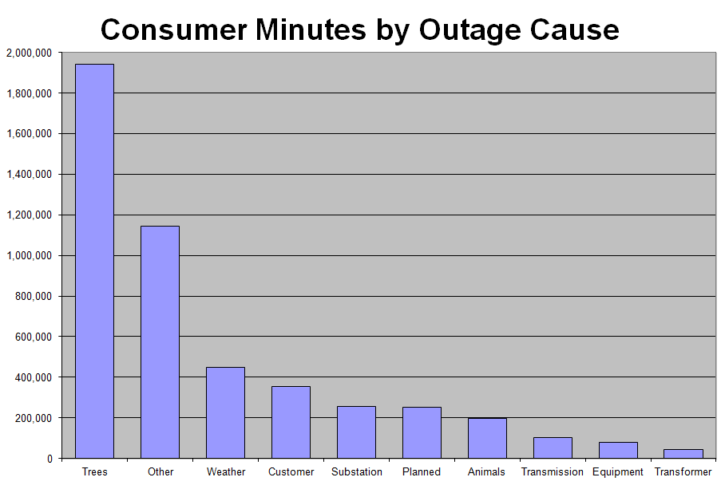
Figure 3
A Pareto chart like the one in Figure 3 allows the utility to focus on the most common causes of outages and perhaps focus their resources on the largest outage categories.
Figure 4 is another example of how to analyze the data using a Pareto chart. In this case, the SAIDI for each circuit on the system is shown from best SAIDI to worst. It’s common to pick a “threshold SAIDI” by looking at the chart and focus attention on the circuits above a certain SAIDI value. In this example, the redline shows a threshold SAIDI of 180 minutes so all circuits with a SAIDI in excess of 180 minutes should receive special attention to understand what is causing the unusually high SAIDI.

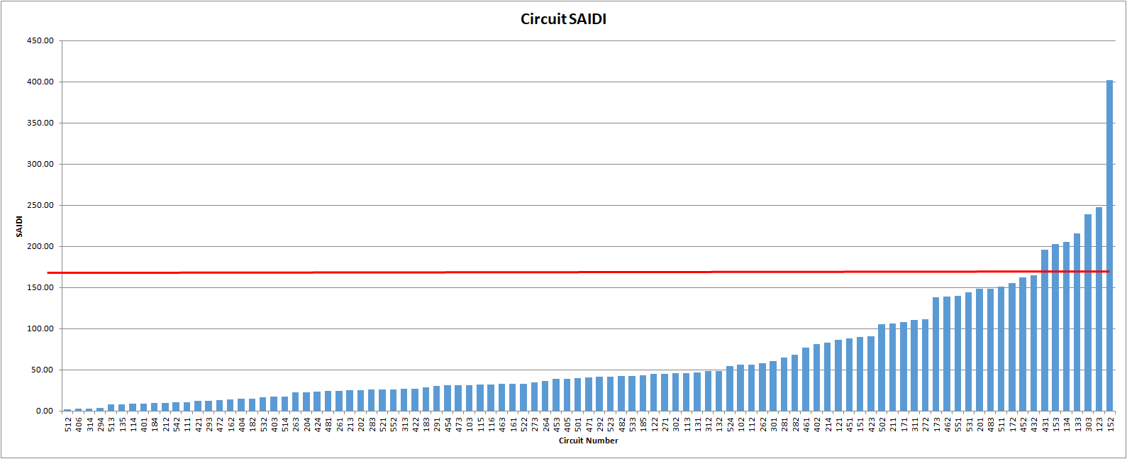
Figure 4
Figure 5 is another Pareto chart that shows the frequency of circuit outages. In this example the utility is looking at any circuit which had more than two sustained outages in one year. This is customer satisfaction issue since multiple outages tend to upset customers.
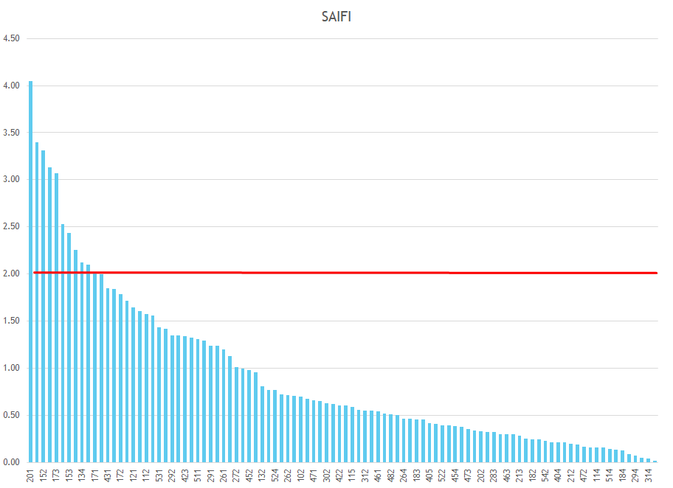
Figure 5
Figure 6 shows the number of outages a utility has experienced over several years. This is good indicator of the trend in general reliability. This is also a good goal oriented measure such as “we will average no more than 200 outages per month” for example.
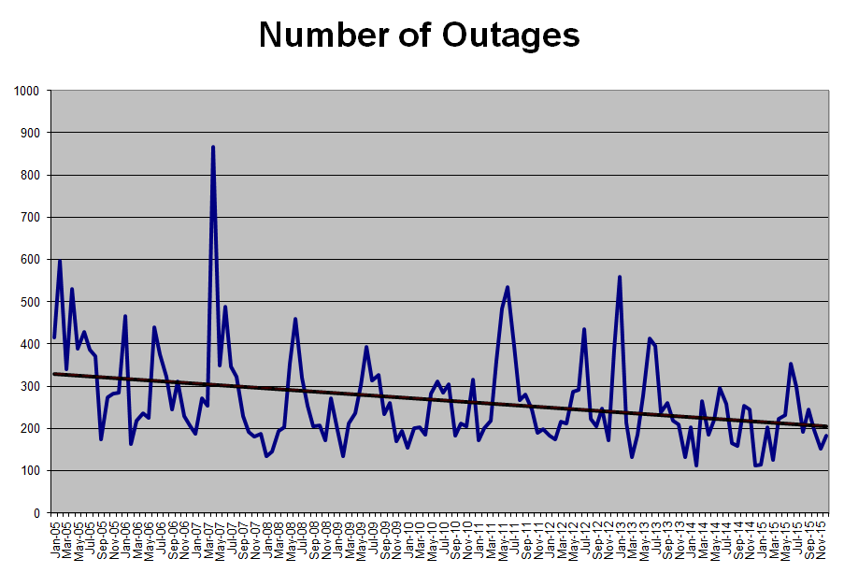
Figure 6
The next chapter will delve into the factors affecting system reliability and efforts and standards a utility may take to improve distribution reliability.
Reliability Improvement Process
Reliability improvement is not a “one and done” event. It is a process of continuous improvement. Many engineers think the flowchart shown below is the solution to all problems!
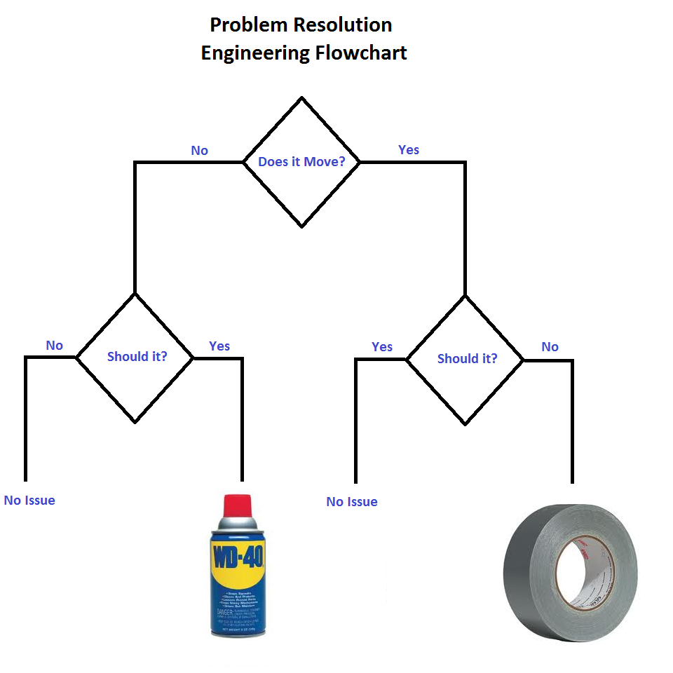
Figure 7
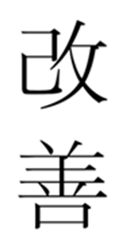
Duct tape and WD-40 are not the solution to every problem! We need to do a little more investigation into the root causes of an outage to determine the best remedy. On widely used approach is the Continuous Process Improvement programs made famous by Dr. Ed Deming in his work in bringing Toyota Manufacturing to be recognized a top quality automotive producer.
The Japanese process of Kiazen or continuous process improvement is applicable to electric system reliability. Five key tenets of Kiazen are;

- Good process yield good results,
- Seek to understand the current situation,
- Speak with data and manage by facts,
- Find the root cause of the problem, and
- Use a Plan, Do, Check, Act, cycle of continuous improvement.

Applying this concept to electric distribution reliability begins with determining what’s important and establishing procedures, guidelines and goals to achieve the desired results.

To understand the current situation the utility must gather and maintain good data on outages. Good data is the key to developing a strong reliability program. With data the utility can work to find the root cause of outages and then work to eliminate or minimize the impacts of the various causes. Finally, this is a never ending process. It is a continuous process of planning, checking on progress, taking action on results, and repeating the process.
Chapter 6
Concepts in Reliability Improvement

Once the data gathering and analysis are completed and potential areas for improvement are identified the utility must now begin to develop a plan to reduce outages and improve service reliability. This chapter describes some of the most common ideas to improve system reliability and only broadly covers the topics mentioned. Volumes of information have been written on each of these topics.

Reliability is expensive and the utility must factor in the cost of improving reliability into their plan. An accepted industry practice is that reliability improvements should cost no more than $2.00 per reduced customer minutes interrupted (2.00 $/CMI, 2016 dollars). You will remember from the SAIDI calculations that SAIDI reduction is proportional to the CMI reduction. A project with an anticipated cost of $400,000 must be able to reduce outages by 200,000 customer minutes per year to be cost effective.

Vegetation Management
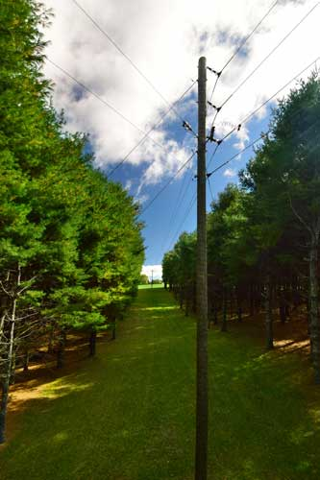
As shown in the data analysis in Chapter 5, vegetation is a leading cause of distribution faults. An extensive vegetation management program is critical to ensuring electric service reliability.

The utility should set goals for vegetation related outages and then develop a plan to meet the goal. Common results oriented goals may look something like this:

Distribution “Grow-ins” Less than 1/year/100 miles
Distribution “Fall-ins” Less than 8/year/100 miles

The term “Grow-ins” is used for vegetation faults resulting from trees growing up into the electric lines from within the right of way. The term “Fall-ins” is used for trees falling into the line from outside of the right of way. The goal is different for these two categories because the utility has more control over vegetation within the right of way versus vegetation outside of the right of way. Fall-ins may include dead trees and “danger trees” which are unusually large trees that may contact the power lines if they fall into the right of way.

Once the utility has established goals for the performance of the vegetation related outages then procedures must be set up to meet the goals. The most basic approach is to set up a right of way re-clearing cycle to trim vegetation to limit faults.

In addition many utilities add a “mid-cycle” clearing program to address “hot-spots” of fast growing vegetation (e.g. bamboo) and in residential areas where vegetation cannot be sufficiently cut-back on the normal right of way cycle without generating excessive customer complaints.

Herbicides are another way to limit vegetation related faults and is often included as part of a right management plan.

Most sophisticated vegetation management programs include a pre-planner who meets with customers before a circuit is trimmed to negotiate removing dead and danger trees outside of the right of way and to assuage any concerns the property owner may have about the re-clearing.

A simple five-year vegetation management plan might look like this:

Figure 8

The actual vegetation re-clearing cycle is depending on climate and species of vegetation in the utility service area. In areas with almost year round growing seasons such as the deep South cycles may need to be every four years and in areas with shorter growing seasons the cycle may six or even eight years.

Pole Treating

Having a wood pole fall over on its own accord due to infestation with wood destroying organisms (WDO) is a major reliability failure and well as a public liability. To address this issue most utilities have a wood pole inspection and treatment program to ensure the integrity of their poles and to extend the life of the pole.

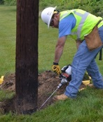
Pole inspections involve a visual inspection of the pole, “sounding” the pole (which means hitting the pole at its base with a hammer and evaluating its condition by the sound of the hammer strike.) If the sounding is suspect then the inspector digs drills into the base of the pole and pulls a core sample out for testing and then the base of the pole is re-treated with a preservative. With the process utilities are seeing wood poles last well over 60 years even in humid, damp environments.

The utility should have a goal for the number of poles that fail the inspection each year and then develop an inspection cycle that will result in the acceptable failure rate. An example may be:
Photo Credit: Osmose

Distribution Wood Pole Reject Rate: <1% per year

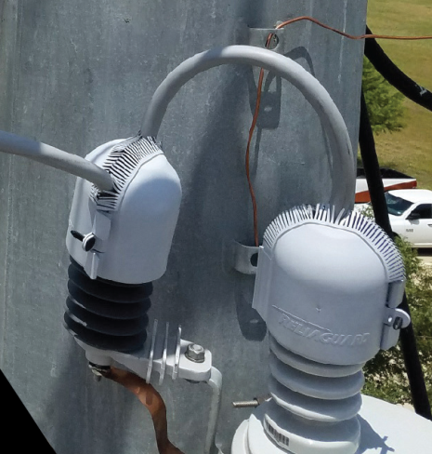
To achieve this reject rate the utilities inspection cycle can be adjusted based on experience. Typical inspection cycles are eight to twelve years and can be adjusted up or down to achieve the desired reject rate.

Animal Outage Prevention

Small animals – especially squirrels – are a major cause of outages for electric utilities. Some utilities state that over half of their annual outages are caused by squirrels and other small animals.

Small animal guards, such as the one shown in the adjacent photo, can help reduce outages and improve SAIDI. While it may not be cost effective to install these devices system-wide, an analysis of outage data by circuit can show which circuits would benefit most from the installation of small animal guards. Thereafter the data can be used to identify smaller areas that can benefit from the installation of guards; these areas may be isolated line sections or residential subdivisions.
Photo Credit: Reliaguard

Figure 9 shows the effects of installing small animal guards of just four of an electric utility’s 100 circuits. The guards were installed over a four year period (2008-2011) and as you can see, the number of outages dropped dramatically with the installation of the guards.

Figure 9

Circuit Outages

While circuits are not the root cause of an outage, focusing on circuit outages is important due to the number of customers affected when a circuit outage occurs.

An industry practice is that a utility should experience no more that 0.3 circuit outages per year. Therefore a utility with 100 total circuits (distribution substation breakers) should have less than 30 sustained circuit outages per year.

Most distribution rights of way are 30 feet wide. On especially critical circuits it may be advantageous to increase the right of way to 40 feet to the first protective device or to the most critical load on the circuit. While a 40-foot right of way may not be economically viable for the entire system or even an entire circuit, it may be a lowest solution in some areas.

There are several sectionalizing type programs that may be used to increase the reliability, or reduce the SAIDI impact, of a circuit outage. Installing fuses (such as shown on the photo on the right) on lateral taps will prevent faults on the lateral from affecting the entire circuit.

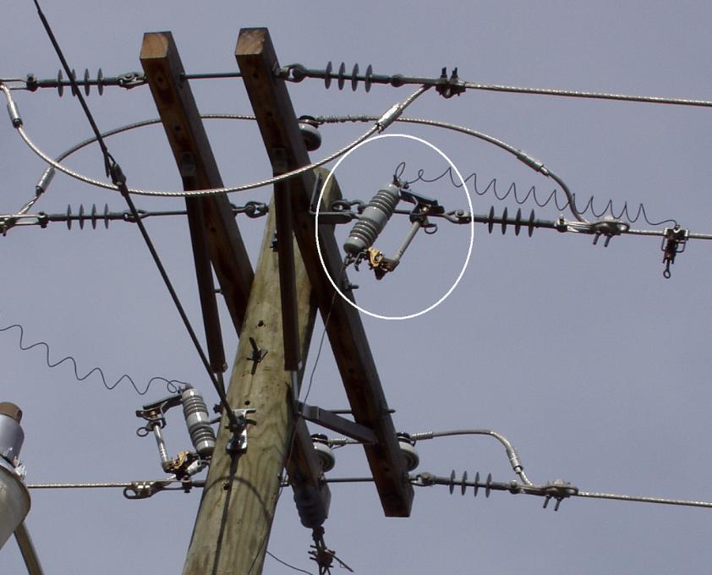
Split circuits into two circuits can reduce the size of each circuit and reduce the number of customers impacted by a circuit fault. Even moving load to an adjacent circuit to balance the size of the circuit can reduce the SAIDI impact on a trouble prone circuit, though this doesn’t get at the root cause of the circuit reliability.

As previously mentioned installing small animal guards on areas where animal outages are prevalent can have a dramatic impact on circuit reliability.

Education also plays a part in circuit reliability. Many outages are caused by other utilities such as cable and fiber contractors installing cables on joint-use poles. Proactively working with the other utilities prior to initiating a cable install can reduce outages. Educating farmers and homeowners on the presence (and danger) of both overhead and underground lines will also help reduce outages. State DOT crews, or contractors, mow their rights of way where electric power lines are also frequently located. A common outage scenario is DOT mowing crews cutting guy wires which then flip up into the energized conductors causing outages. Participating in their safety meetings will also reap reliability rewards.

Operational Practices

While vegetation management, pole maintenance and sophisticated restoration schemes are important perhaps the most important factor affecting reliability are the utilities operational practices. How a utility manages its reliability program while impact the results.

Inspection Program
A good inspection and maintenance plan is the first step. Table 11 shows a typical inspection and maintenance schedule for a distribution system.

Table 11
Inspection and Testing Cycles for Distribution Electric Utility Equipment
Equipment | Cycle
Overheard line inspections (to first protective device) | Annually
All overhead lines | 3 Years
Underground lines | 7 Years
Relay Testing (Electromechanical) | 3 Years
Relay Testing (Digital) | 10 Years
Circuit Breakers | 10 Years
Oil Circuit Reclosers | 5 Years
Regulators | 10 Years
Pole Testing | 12 Years
Vegetation Maintenance | 5 Years

Each utility must develop its own schedule based on operational characteristics of its service territory.

Incident Elevation
With exceptions for items such as underground cable failure, underground transformer failure, and broke poles, another industry practice is to have service restored to any single outage within three hours and all outages (excluding a major event) within eight hours. Anytime a single outage exceeds three hours the outage should be reported up to a crew leader or foreman and escalated from there to their supervisors at specific additional time points (e.g., after 4 hours, etc). The intent of this practice is to ensure that a single outage doesn’t get “lost” in the system. A utility goal may be:

“Annually no more than 3% of single outages should exceed three hours in length.”

Response time / Call out procedures
Every electric utility has line personnel on-call for outages. Since outage minutes begin once the utility is aware of an outage, the speed of response to an outage directly affects customer-minutes. Generally response time should be adequate if the system CAIDI is less than the system SAIDI on an annual basis and the utility is meeting its “3-hour, single outage restoration” time.

Some utilities have a practice of not leaving any outage un-dispatched for more than thirty minutes. So if the on-call crew is already working an outage and a second outage occurs if the on-call crew can’t reach the new outage within 30 minutes a second crew is called in to work the new outage.

Fault Detection, Isolation and Restoration

Another process that only addresses the symptoms of a fault and doesn’t cure or prevent the fault is FDIR. Fault Detection, Isolation, and Restoration (FDIR) is a relatively new term for processes that utilities have been using for a long time to isolate and restore power quickly. Using FDIR can reduce SAIDI and improve reliability when faults occur. The key concepts behind FDIR are:

- It’s a self-healing network
- It can automatically detect faults and restore power
- In can perform complex switching operations
- It minimizes the area impacted by an outage, and
- It reduces outage time.

Consider the following example. Figure 10 shows a substation with two circuits. Circuit 1 has a hospital and a radio station on the feeder. There are numerous automatic switches on the circuit. Circuit 2 has a shopping center on the feeder with one automatic switch at the shopping center. The switches are all closed except for the tie switch between Circuit 1 and Circuit 2 at the shopping center.

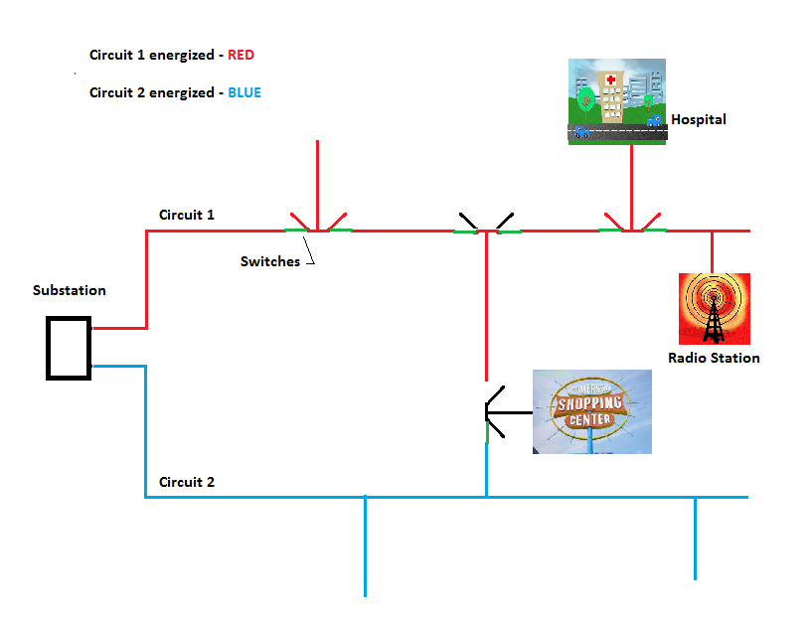
Figure 10

In Figure 11, a vehicle has hit a pole on Circuit 1 causing the substation breaker to open and creating an outage for the hospital and the radio station. The FDIR scheme analyzes the location of the fault and opens Switch #1 allowing power to be restored to the first section of Circuit #1. The FDIR scheme also opens Switch #2 to isolate the fault from the vehicle accident. Now FDIAR automatically closes Switch #4 at the shopping center to supply power to the hospital and radio station from Circuit #2.

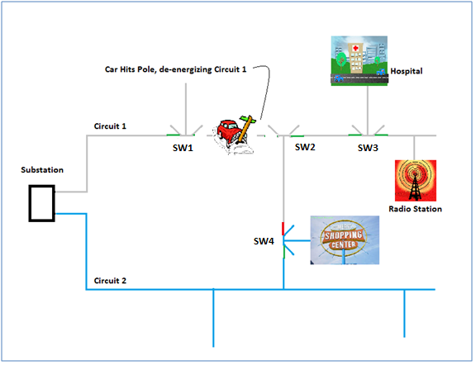
Figure 11

This is only a simple restoration scheme. In practice FDIR systems can perform multiple, complex operations to minimize those affected by an outage.

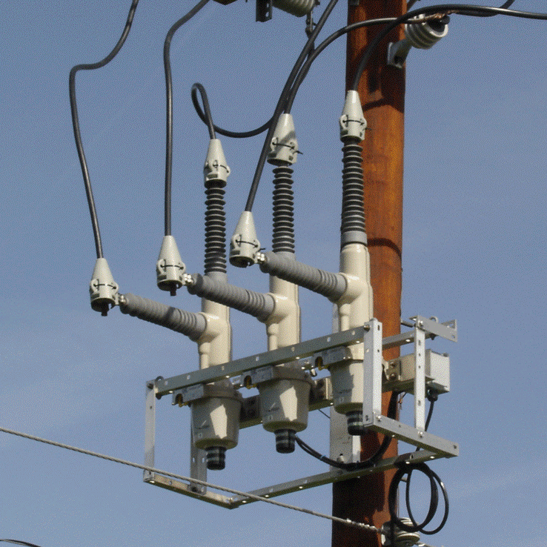
Even when a utility doesn’t want to commit to a full FDIR system, simple remotely operated downline reclosers can have a significant impact on reliability by quickly isolating a fault and allowing remote restoration when the fault clears. An example of a remotely controlled recloser is shown in the photo on the right. These devices are relatively economical to install though remote control may add to the complexity of the installation due to the need for a communications path back to the control center.

Major Weather Events

Major weather events should trigger a Tmed day so it will not be included in the base reliability measurements. It still impacts the end-use customer and must be considered in the concept of customer satisfaction. Customers understand a major weather event is not preventable by the utility. During a major event the customer wants to know “when will my power be turned on?”
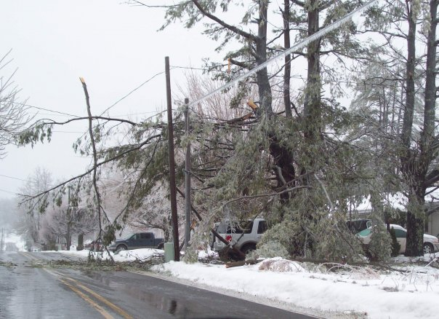
Providing regular – and reasonably accurate – updates yields significant customer satisfaction scores.

Even though major events are not included in the base reliability measurements it is not a “freebie”. Utilities should have a goal for service restoration for major events such as a “Storm CAIDI”. For example,

Goal: Major Storm CAIDI < 300 Minutes per event

Having a CAIDI goal for major events puts the emphasis on getting the most customers back on in the shortest possible time.

Planning

Most distribution system planning centers on ensuring adequate voltage levels are maintained and adequate system capacity is available to meet the load demands. Reliability has traditionally been a tertiary concern. With more emphasis now being given to reliability it should be considered another primary goal, just like voltage and capacity levels. This moves planning from a cost-based selection criteria to a value-based selection which maximizes customer value.

When deciding to include reliability in planning the utility must decide on whether to use a historical basis or a predictive basis in the planning criteria. With an historical basis, the system is designed to assess the past state of the distribution system where as a predictive basis is used to design to assess future performance. The historical approach is generally straightforward as data is available. However the predictive approach has become more widely used in recent years.

One approach to predictive analysis is a reliability-index approach where the system is designed to meet a set of reliability index targets such as a circuit SAIDI of 60 minutes for example.

Software and data for the computation of reliability indices are required. Indices, such as SAIDI and SAIFI, are used as design constraints. The benefits of this approach are:

- Addresses reliability from a customer standpoint,
- Imposes no restrictions on design other than to meet customer expectations; and
- Methods for reliability-based design are becoming widely available.

Clearly, it is not possible to plan to prevent all interruptions, yet planning can decrease the rate of occurrence of service interruptions. There are many causes for equipment outages and service interruptions. Outages can be caused by equipment failure due to weather conditions or other causes, and by equipment being switched off deliberately, by mistake, or by failure of control equipment. Service interruptions can be caused by a downed line, failed cables, a damaged transformer, or failures in customers’ equipment. Momentary interruptions can be caused by natural events such as trees brushing conductors, thus causing a high-impedance fault; small animals contacting conductors or lightning. Some interruption prevention solutions may be routinely included in planning because the cost of implementation is not high; e.g., placing two sub-transmission lines coming into a substation on different structures. The distribution system needs to be planned, designed, and maintained with particular attention to interruption prevention.

Overhead vs. Underground
One often discussed planning criteria is “should all future lines be installed underground versus overhead?” Numerous utilities have studied this dilemma and most all of the studies support the existing sentiment that overhead lines are cheaper to install, maintain, and repair even when considering the reduction in major storm damage and annual right of way re-clearing costs. Overhead design is much less costly but more vulnerable to natural hazards such as wind, ice, and lightning as well as car accidents, customer tree cutting, and other man-made outages. Adverse weather and trees cause most lengthy outages on overhead lines, and trees brushing against conductors in high winds cause most momentary outages. Underground systems suffer from dig-ins, animals gnawing into cables, cable failure due to insulation failure, and lightning. In addition to reliability, the cost and time for routine maintenance and repair are also higher for underground systems and overhead feeders are easier to maintain as faults are easily located and fixed. However, Underground systems improve aesthetics.

Feeder Layout
The feeder system must distribute power while satisfying economic, electrical, and service considerations. The reliability must be very high, and voltage and quality must be satisfactory and options include, radial, looped and network systems.

Worldwide, 80% of distribution systems are radial. For radial systems, on average, the failure of a segment interrupts the service to approximately the customers on the feeder. A loop system can provide very high reliability. On average for a loop system, two simultaneous failures interrupt only one quarter of the customers. Networks are the most reliable. The loss of a segment will not interrupt any customers, and multiple failures can occur with little or no interruption. Network systems are more costly and require more expensive protective devices and coordination schemes. Network system are extremely expensive and generally only viable in high density areas such as major metropolitan areas. Looped systems are also expense but less so than networks and are frequently used for high reliability customers such as hospitals and large industrial customers. As previously mentioned a FDIR system is a hybrid radial/loop system that makes sense in suburban and some rural areas.

Sectionalizing Criteria
The system’s approach to line sectionalizing and protection will impact reliability. Protection criteria, both faults and over-voltages, should be considered as part of reliability planning in the design of the power system.

The planner goes by the general guideline that he must provide a distribution system that can be protected. Equipment, such as circuit breakers, reclosers, sectionalizers, fused disconnects, control relays, and sensing equipment, detects interruption of normal service and isolates the faulted equipment. The decision of breaker tripping schemes such “fuse saving” or minimizing momentary interruptions weigh on reliability.

Component Reliability Analysis
Reliability planning is generally based on either a historical data or predictive analysis.

Reliability in distribution planning has generally been accounted for subjectively in the past by primarily relying on historical data. The historical perspective involves the documentation of past reliability incidents, the aggregation of the data, and use of the data for performance comparison. Historical reliability analysis is much more commonly practiced than predictive reliability analysis. Predictive reliability analysis is an assessment of the current and possible future states of the distribution system.

With predictive planning the designer considers the reliability, or Mean Time Between Failure (MTBF), for each component on the system and develops a perspective feeder reliability based on the sum of the failure data. While this approach is valuable for “what-if” scenarios and baseline reliability it doesn’t tell the entire story because component failure accounts for only 15% of sustained outages on distribution overhead feeders, while 75% are from external factors, such as vehicles, animals, trees, and lightning. The remaining 10% is from supply failures.

To use predictive reliability analysis the planner must have data on the reliability of a multitude of electrical components. Table 12 shows an example of what this might look like.

Table 12
Distribution Equipment
Annual Expected Failure Rates
Component | Failure Rate | Unit
Overhead conductor | 0.22610 | per mile/yr
Underground cable | 0.02537 | per mile/yr
Underground splices | 0.00110 | each/yr
Elbows | 0.00085 | each/yr
Capacitor Banks | 0.09125 | each/yr
Wooden Poles | 0.00003 | each/yr
Switches | 0.08008 | each/yr
Circuit breakers | 0.01810 | each/yr
Recloser | 0.00822 | each/yr
Fuses | 0.00269 | each/yr
OH Transformer | 0.00221 | each/yr
UD Transformer | 0.02350 | each/yr
Lightning Arrester | 0.00076 | each/yr
Voltage Regulator | 0.03255 | each/yr

Using the data in Table 12, a 10 mile overhead feeder should expect to have 1.13 outages related to the conductor (5 * 0.2261). If the feeder is underground then the expected reliability is 0.13 outages per year. Of course, this is just the conductor and doesn’t account for all of the other equipment on the feeder.
Many predictive reliability models include data on how reliability changes over time. While the reliability of conductors doesn’t change dramatically (perhaps 30% increase in failure after 30 years) devices such capacitor banks may have a failure rate 20 times higher than the initial data suggests.
There are several software packages that will do this analysis and it allows the planner to consider different configurations and designs and will provided an estimated SAIDI based on the component reliability.

Chapter 7
Power Quality

Power Quality is a fundamental aspect of reliability and while it is outside the scope of this course, this Chapter reviews some of the basic issues concerning power quality.

Electricity must be delivered in a form that meets the requirements of the consumer. Changes in those requirements and in how electricity is delivered have brought a greater emphasis on power quality. Power quality refers to the attributes of the power delivered to customers, including voltage, wave form, and harmonics. Today, loads are more sensitive, loads are interconnected in extensive networks having automated processes, and there are a growing percentage of loads using power electronics in conversion processes. A power quality problem is a voltage, current, or frequency deviations that result in failure or misoperation of equipment. Both IEEE and ANSI have Standards to address power quality.

In power quality analysis’s a sustained interruption is defined as a loss of voltage of greater than one minute, ninety-five percent of system faults are temporary. These interruptions can appear as voltage variations which, along with capacitor switching, can cause customer equipment failures or restarts. Equipment today requires “cleaner” power than did the electronic equipment of the past. Therefore, common occurrences, including small changes in voltage, are no longer inconsequential.

In addition to the greater service reliability and stricter voltage level requirements, the increased use of robotics and computers for control purposes and of other sensitive electronic loads has placed requirements on the waveform of the electricity supply. Distorted voltage waveforms are caused by customers or by the conditions on the electric system and customer loads are generating more harmonic currents. Also, harmonics may cause interference with communication circuits. Solutions are often hindered by the complicated interaction between the harmonic currents and the electricity supply.

The practices of utilities are changing with the increasing demands for power quality. For example, in the past, most utilities recorded only outages greater than five minutes, because shorter outages were rarely an inconvenience. Issues with which utilities now have to concern themselves are selection and maintenance of proper voltage, and the maintenance of frequency within strict limits. Voltage distortion and current fluctuations can affect the reliability of equipment and thus the reliability of the components of electrical distribution systems. Utilities must decide what level of basic power quality it will provide and above the base level of power quality should be the responsibility of the customer requesting the higher service level.

Power quality problems can be categorized roughly as long duration voltage variations, sustained interruptions, voltage unbalance, impulsive transients, oscillatory transients, voltage sag, voltage swell, momentary interruption, and flicker. Flicker problems, or motor induced sags, are longer in duration than the momentary interruptions, but not as deep in voltage reduction. Voltage sags are the most important power quality problem for many types of industrial customers, in part because they occur more frequently than interruptions. Harmonics, frequencies other than the standard 60 Hertz, can cause problems even if they don’t cause malfunctions. It has been suggested that prolonged exposure to harmonic variations may lead to a 10% reduction in useful life of electrical equipment.

Power quality problems generally fall into one of these eight categories:

- Transients (<30 cycles),
- Longer-duration variations (>30 cycles),
- Interruptions (at least ½ cycle),
- Harmonic distortion,
- Flicker,
- Noise,
- Electromagnetic interference, and
- Radio-frequency interference

The variety of power quality problems arises from both actions on the utility system and activity inside the customer’s premises. Customers, utility-side interruptions are the primary source of problems. Utility-side momentary interruptions, from a few seconds to no more than a minute, are caused by trees brushing conductors causing a usually high-impedance fault, small animals contacting conductors or lightning.
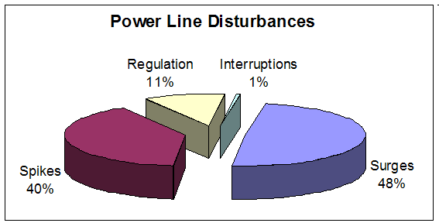
Figure 12
The most common form of secondary voltage condition is a transient surge followed by spikes and over/under voltage conditions. See the adjacent chart for the incident rate of the various types of power line disturbances. It is interesting that the combination of spikes and surges total 88% of the typical power line disturbances.

The majority of customer power quality issues are created by the customers themselves. For example, flicker is usually caused by the starting of large, multi-phase motors. However, flicker can also be caused by other industrial equipment or switched utility equipment such as capacitors. Induction motors, especially small ones for items such as blowers, air conditioning, compressors, and the powering of conveyor belts, can produce a lot of power quality problems as well.

Harmonics are passively generated by electrical equipment with non-linear loads, such as transformers, motors, AC-DC power supplies, clipping devices, diodes and semiconductor devices. The most important index for this problem is THD, total harmonic distortion. THD is the root of squares of the harmonics normalized by standard frequency, and is measured as current or voltage. For the distribution level, it is recommended that there be no more than 5% THD. Other measurements are the telephone influence factor (TIF), which compares harmonic content in relation to the phone system, and the customer-message curve, a weight index of frequencies of human hearing. There is also the K-factor index for estimating the impact of harmonics on losses.

The Information Technology Industry Council (ITIC), www.itic.org, publishes a specification for the acceptable operating voltage ranges for electronic equipment. The specification is commonly referred to as the “CBEMA Curve” because the organization was previously known as the Computer and Business Equipment Manufacturer’s Association (CBEMA). Figure 13, shows the voltage specifications of the CBEMA Curve.

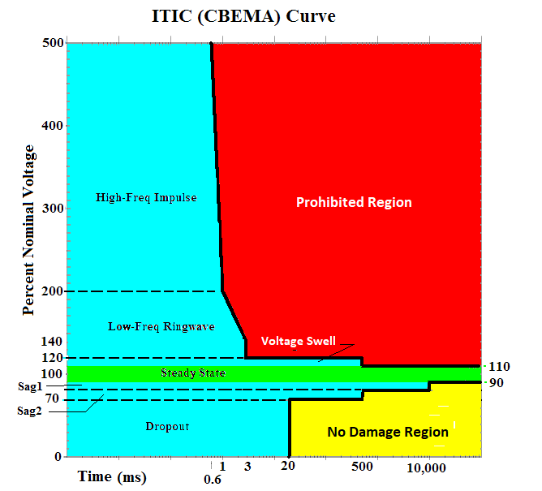
Figure 13

The CBEMA Curve describes both transient and steady-state conditions. The specifications are based on RMS voltage values rather than peak values, which usually describe transient conditions. The curve has time, in milliseconds, along the x-axis and voltage, in percent of nominal RMS, along the y-axis. The CBEMA curve defines seven operating regions for electrical equipment plus two other regions where the equipment may either be damaged or operate incorrectly. The regions are,

- Operating Regions (Blue & Green areas of the chart)
  - Steady-State
  - Voltage swell
  - Low-frequency ringwave
  - High-frequency impulse
  - Voltage sag 1
  - Voltage sag 2
  - Dropout
- No Damage Region (Yellow area of the chart)
- Prohibited Region (Red area of the chart

The normal operating region of the CBEMA Curve is shown in light blue in Figure 15. The steady-state region includes an area between 90 and 110% of the nominal RMS voltage where the voltage can vary between these values for an indefinite time.

The voltage swell region is a transient condition of up to 120% of the nominal RMS voltage for no more than one-half second. The low-frequency ringwave region is includes an area from 200% of nominal peak voltage for up to one millisecond for a 5 kHz ringwave or up to 140% of the nominal peak voltage for up to three milliseconds for a 200 kHz ringwave. The high-frequency impulse region is for a transient of up to one millisecond in duration and is defined by both the amplitude and energy component of the transient.

Voltage sag 1 allows the RMS voltage to drop down to 80% of the nominal RMS voltage for up to 10 seconds (10,000 milliseconds). Voltage sag 2 allows the voltage to drop down to 70% of the nominal RMS voltage for up to one-half second.

The dropout region is any voltage below 70% of the nominal RMS voltage for up to 20 milliseconds. Beyond 20 milliseconds, the curve defines the no damage region where the equipment is not required to operate correctly, but no damage should occur to the equipment for operation in this region.

The final area is the prohibited region where operation is likely to cause damage and mis-operation of the equipment.

It should be noted that 85% of the sags that are outside the CBEMA envelope are from faults. Motor-induced sags (flicker) are longer in duration but not as deep (~10%, not worse than 20 %). The leading cause of sags worldwide is probably lightning, whereas capacitor and other switching are the most common non-weather causes.

Summary

In addition to good customer service and reasonable rates electric service customers expect a high degree of reliability. This course has explained how electric reliability is defined, measured, and attained at the distribution level. The reliability indices discussed in the course are widely used by electric utilities in the United States as a common language of reliability. This course has also provided basic steps that utilities may undertake to improve electric reliability service.

DISCLAIMER: The material contained in this course is not intended as a representation or warranty on the part of the Provider or Author or any other person/organization named herein. The material is for general information only. It is not a substitute for competent professional advice. Application of this information to a specific project should be reviewed by a relevant professional. Anyone making use of the information set forth herein does so at his own risk and assumes any and all resulting liability arising therefrom.

Copyright © 2019 Lee Layton. All Rights Reserved.

Copyright © 2019 Lee Layton. All Rights Reserved.
+++

