PDHonline Course M557 (8 PDH)
_______________________________________________________________________________
Oil & Gas Refining
Production and Processes
Instructor: Jurandir Primo, PE
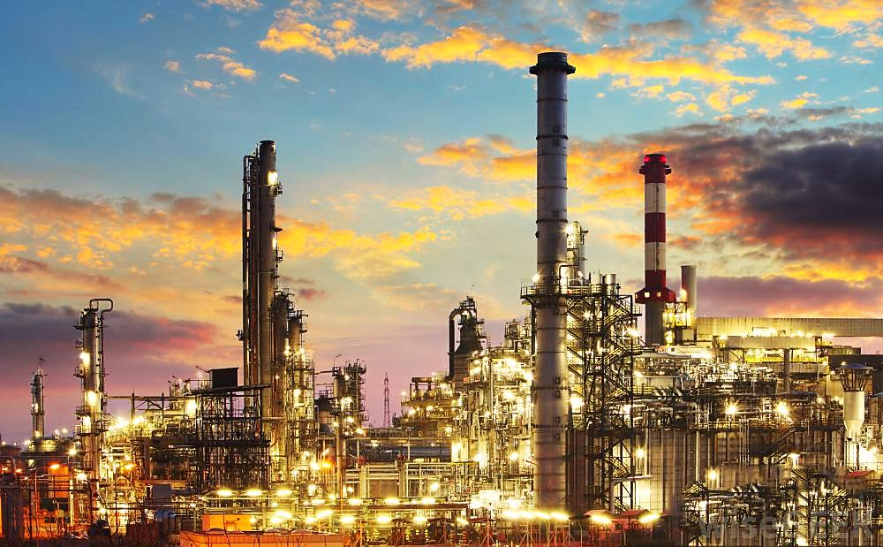

2015
PDH Online | PDH Center

5272 Meadow Estates Drive
Fairfax, VA 22030-6658
Phone & Fax: 703-988-0088

www.PDHonline.org
www.PDHcenter.com
OIL & GAS REFINING
PRODUCTION AND PROCESSES

CONTENTS:

- INTRODUCTION
- REFINERIES HISTORY
- TRANSPORTATION HISTORY
- TRANSPORTATION & STORAGE NOWADAYS
- OIL & GAS REFINING PROCESSES
- GAS REFINERIES

- INTRODUCTION

Refining is a complex series of processes that manufactures finished petroleum products out of cru-de oil. While refining begins as a simple distillation (by heating and separating), refineries use more sophisticated additional processes and equipment in order to produce the mix of products that the market demands. Generally, this latter effort minimizes the production of heavier, lower value pro-ducts (for example, residual fuel oil, used to power large ocean ships) in favor of middle distillates (jet fuel, kerosene, home heating oil and diesel fuel) and lighter, higher value products (liquid petroleum gases (LPG), naphtha, and gasoline).

The main objective of refineries is to convert crude oil into useable petroleum products. Typically, one barrel of crude oil is approximately 19 gallons of gasoline, nine gallons of distillates (home heating fuel, diesel and kerosene), plus lesser amounts of other refined products such as, jet fuel, liquid petroleum gas and residual oil. To a limited extent, refiners can adjust the refining process to alter the resulting mix of refined products, and to fit changing customer needs.

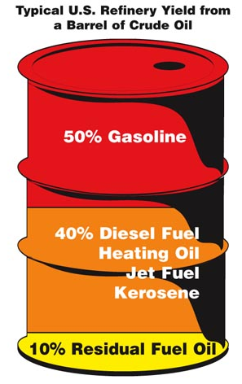 | In the U.S., crude oil is measured on a volumetric basis at a standard temperature of 60ºF, typically in units of barrels (1 bbl = 42 gal), commonly designated as barrel per day (bpd). Outside the U.S., crude oil tends to be measured on a mass basis in units of metric tons per day. In general, a small refinery produces 100,000 bpd or less, a middle-size refinery produces 100,000-250,000 bpd, and large refineries (typically integrated with a petrochemical processing facility) produce more than 250,000 bpd.

Aside from the fuels derived from petroleum, such as gasoline, distillate fuel (including home heating oil and diesel), kerosene-type jet fuel, residual fuel oil used in industry, marine transportation and for electric power generation, there are many other non-fuel uses. These include various specialized products for use in the textile, metallurgical, electrical, and several industries. Someone may be surprised to learn about some everyday products that are derived from crude oil, including:

. Solvents, such as those used in paints, lacquers, and printing inks;
. Lubricating oils and greases are used for automobile engines, and other machinery;
. Petroleum (or paraffin) waxes are commonly used in candy making, packaging, candles, matches, and polishes;
. Petrolatum (petroleum jelly) is blended with paraffin wax in medical products and toiletries;
. Asphalt is used to pave roads and airports, to surface canals and reservoirs, and to make roofing materials and floor coverings;
. Petroleum coke is used as a raw material for many carbon and graphite products, including furnace electrodes and liners, and the anodes used in the production of aluminum;
. Petroleum feedstocks are used for the manufacture of chemicals, synthetic rubber, and a huge variety of plastics.

Nearly every aspect of our modern lifestyle is impacted by oil. Refined oil is used to power our vehicles, to create medicines that keep us healthy, manufacturing plastics, cosmetics, and other personal products that enhance our daily lives. Today, crude oil is refined all over the world. The Jamnagar refinery is the world's largest oil refinery, with an aggregate capacity of 1.24 million barrels per day (bpd). In fact, most of the oil industry’s largest refineries are in Asia and South America. However, the practice of refining oil was created in the United States, where it continues to be an important part of the nation’s economy.

Refineries that process crude oil into raw material for a thousand of other products are overwhelming to the outside observer, with a multitude of tanks, vessels, pipelines of various sizes, fired heaters, pumps, compressors, instrumentation and control systems. The objective of this course is to give an overview of oil & gas refineries, production, processing and transportation, but does not discuss integrated petrochemical complexes. Each refinery can be designed to process gas and oil of a particular composition, as crude petroleum makes a diverse blend to obtain a feedstock that better matches the refinery´s capabilities.

Petroleum may be separated and distributed in downstream processing units, to several other types of components, such as, paraffins, oleofins, naphthenes, and aromatics designated as “PONA”, very important in the catalyst processing, used in terms of functionality and desired reaction conversion. Various fuel components can be blended into final commercial products that meet particular specifications based on the consumer´s location; for example, large urban areas typically have more restrictive pollutant fuel specifications. Intermediate products include alkylate, isomerate, reformate, cat gas, hydrocracker gas, and coker gas. Normal butane is also added as necessary, to meet certain specifications, which may be different in summer and winter.

The oil and gas industry is usually divided into three major sectors: upstream (exploration), midstream, and downstream. The downstream sector commonly refers to the refining of petroleum crude oil and the processing and purifying of raw natural gas, as well as the marketing and distribution. These products are typically transported by pipelines to terminals, such as gasoline, kerosene, jet fuel, diesel oil, heating oil, fuel oils, lubricants, waxes, asphalt, natural gas, and liquefied petroleum gas (LPG), ethanol and other biofuels and hundreds of petrochemicals. At the terminals, crude oil, petrochemical feedstocks, liquefied petroleum gases, and raw materials for various products are stored in tanks, where various additives are added, and trucked to commercial distribution stations.

- REFINERIES HISTORY:

The ninetieth and twentieth centuries have been called the centuries of oil, mainly in the U.S.A. In Southern California, large seeps in Ventura, Santa Barbara, Kern, and Los Angeles counties received the most attention. Interest in oil and gas seeps was stirred in the 1850s and 1860s, in part because one of California’s oldest and most-used roads passed along nearly all the seep areas on the western side of the San Joaquin Valley. Interest in oil seeps became widespread after the 1859 discovery of oil in Pennsylvania, when the value of kerosene as an illuminant became known all over the world. In fact, oil exploration began in Northwestern Pennsylvania, in a remote little place called Titusville to be exact, where oil was first extracted via drilling and considered the first oil well.

However, prior to the Pennsylvania activity, a number of California settlers probably collected oil from seeps and roughly distilled it into lamp oil. By 1867, drilling activity had declined. Many California wells capable of producing oil became idled, because over-production in Pennsylvania brought the oil to San Francisco at a price lower than California operators could meet. In 1876, a wellbore designated as “Pico” 4 was completed, and began producing 30 barrels of oil a day from a depth of 300 feet. This exploration was the first truly commercial oil well in the state, so designated due the placement of a state historical monument. The same year, a first true basic oil refinery in the state was built at Newhall to take care of the new production, with a daily capacity of 20 barrels.

These happenings started the changing of candles to kerosene lamps. In Europe, an early wellbore was hand dug in Poland in 1853, and another in nearby Romania in 1857. At around the same time the world's first, but small oil refineries, were opened at Jasło, in Poland, with a larger one being opened at Ploiești, in Romania, shortly after. Romania is the first country in the world to have a refinery of crude oil output officially recorded in international statistics. By the end of the 19th century, in Russia, the Branobel Company in Azerbaijan took the oil production leadership, in Europe.

Back in U.S., the Standard Oil Trust was formed in 1863 by John D. Rockefeller, suggested by Samuel Andrews, a mechanic, which constructed a small oil distillery in 1862. He considered it advantageous to refine crude oil into kerosene and thereafter, from 1865 to 1870, actions and secret transport deals, helped its kerosene price to drop from 58 to 26 cents, disliking competitors, due the company's business practices. In 1870 became the largest corporation in the USA, controlling 10 percent of U.S. petroleum refining. The company was renamed Standard Oil Company, and Rockefeller decided to buy up all the other competition firms, and form them into one large company. When organized in 1870, the company also owned more 2 refineries in Cleveland, Ohio.

New oil exploration in Pennsylvania and Ontario were quickly outpaced by demand, leading to "oil booms" in Ohio, Texas, Oklahoma and California. In 1889, a representative from Standard Oil, Theodore M. Towle, was sent to Whiting to purchase land for a new refinery, due water transportation, Whiting was an ideal site. The company built a twenty-inch pipeline that connected the waters of Lake Michigan with the refinery and shortly after, the construction of the giant storage tanks began. In 1890, on Thanksgiving Day, the first shipment of 125 tank cars of kerosene started to market. At that time the refinery had a charging capacity of about 10,000 barrels of crude oil per day.

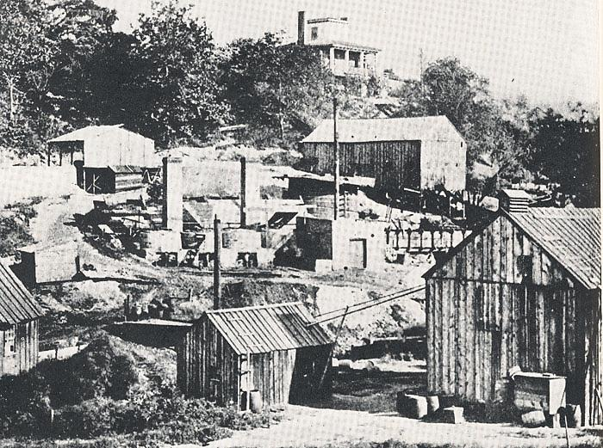
Birthplace of Standard Oil. At Walworth Run, Cleveland, Samuel Andrews, a mechanic, built a small oil distillery. In 1862 he persuaded Rockefeller to invest. This is believed to be the first refinery, as photographed in 1870.

In 1911, following the Supreme Court ruling, the company became known as Standard Oil of Cleve-land, Ohio, or SOHIO. In 1922, the Standard Oil absorbed the American Oil Company, founded in Baltimore in 1910, and began branding products as Amoco, which later would become its company name. By 1952, Amoco was ranked as the largest domestic oil company. Standard Oil of Indiana officially became Amoco Corporation in 1985, and merged with British Petroleum (BP) in 1998. It was the world’s largest industrial merger at the time.

Oil Refinery Development: Samuel Martin Kier (1813 - 1874) was an American businessman, a native of southwestern Pennsylvania, and historically, is considered the first person to refine crude oil, in the mid-1840s. That time, wells were mainly drilled for salt water, and occasionally, produced foul-smelling petroleum alongside the brine. In the salt business, the oil had no commercial application and was a nuisance, and drillers have to burn it or allow it to run off into nearby waterways. However, Kier was an entrepreneur, and he believed that he could turn the oily by-product of his salt wells into something of value.

Kier first used the flammable oil produced by his salt wells, to light his salt works at night, but produced an awful smell and a great deal of smoke. Kier knew crude oil would burn and thought that it could make a good and inexpensive lamp oil. In 1849, Kier took samples of his crude oil to Philadelphia where they were analyzed by Professor James C. Booth, a chemist, which agreed that crude oil could be used for illumination, but needed to be distilled or refined to get the best burning fluid.

Thus, in 1850, Kier started experimenting with distillation and became the first person in the U.S. to attempt to use liquid petroleum as a starting material to produce lamp oil. After further experimenting, he discovered an economical way to produce kerosene. Kerosene had been known for some time but was not widely produced and was considered to have little economic value. But at the time whale oil, the principal fuel for lamps in U.S. was becoming increasingly scarce and expensive. His refining experiments were successful and by 1851, Kier produced a product called Carbon Oil, a fuel oil which burned with little smoke and odor, sold for $1.50 a gallon.

In partnership with John T. Kirkpatrick, Kier created the first U.S. petroleum refinery in Pittsburgh, Pennsylvania. He started with a small one or two-barrel still, but by 1854, he had a larger five-barrel still in operation. When Edwin L. Drake struck oil near Titusville, Pennsylvania in 1859, the market became flooded with oil, and Pittsburgh saw seven new oil refineries come into operation. By the end of the 1860s, there were 58 refineries operating in Pittsburgh alone. Samuel M. Kier spent a great deal of his life trying to make crude oil useful and valuable and along the way he gave birth to the U.S. refining industry.

In 1853, Samuel M. Kier established America's first oil refinery in Pittsburgh, using a five-barrel still, as a marker identifying the "Kier Refinery”, and about 1854, was the first oil industry to produce illuminating oil from petroleum. In the early days, Samuel Kier used horizontal cylindrical distilleries that only held 5 to 6 barrels of oil at a time, able to raise the temperature of the oil very slowly. As the temperature rose, they removed the distillates like gasoline for which they had no use, procuring only the lamp oil or kerosene. Over time, other distillates from crude oil became useful, and the refining process evolved.

Associated Oil Company: In 1900, W.S. Porter, a pipeline salesman, convinced the presidents of the five largest companies in the Kern River Oil Field and McKittrick oil fields of California, to enter into an agreement, to turn over their oil interests to form a new company in exchange for stocks and bonds for the appraised value of their properties. Securing agreements from 34 other oil companies in the area, the Associated Oil Company was incorporated on October, 1901 and on January, 1902 began actively producing and marketing crude oil.

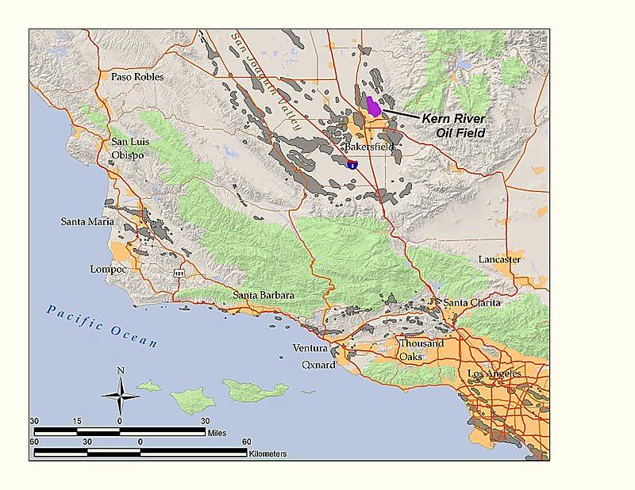

The Standard Oil Company and the Southern Pacific Railroad acquired an interest with the Associa-ted Oil Company, for the purposes of transporting their own oil to the San Francisco Bay area, where the petroleum could be refined and marketed. In 1905, the Matson's Pacific Oil and Transpor-tation Company was acquired. In 1906 the company completed its first eight inch pipe line from the San Joaquin field to Port Costa, and shortly thereafter, this line being inadequate, constructed an eight inch pipe line from the Santa Maria field to its refinery at Gaviota, a distance of about thirty five miles, including the Coalinga-Monterey pipeline and other marine facilities.

In 1907, the Associated Pipe Line Company was formed as a subsidiary of the Associated Oil Company with the Southern Pacific Company providing property along its railroad tracks which ran from the Bakersfield Kern River oil fields to Port Costa, California, later being shipped to China and other parts of the world. In 1913, the Associated Oil Company decided to construct a topping plant called the Avon Refinery (now the Golden Eagle Refinery), on San Francisco Bay on a twenty acre site at Avon, Contra Costa County. It was completed and put in operation in August, 1913, at that time having a capacity of about ten thousand barrels of crude oil a day. On the completion, the refinery launched the production of gasoline and kerosene.

The refinery was named Avon Refinery because it was located within the Avon section of the Southern Pacific Railroad track system, to process heavy crude oil from the southern San Joaquin Valley, to which it was connected by a pipeline. Later, the refinery was acquired in 1920 by the Pacific Oil Company to expand operations in 1923 and 1924, and to include the manufacture of gasoline. By 1925 the Avon Refinery became the first West Coast refinery to produce gasoline with tetra-ethyl lead additive. The location of Avon refinery was ideal, having deep water shipping facilities and being traversed by both the Southern Pacific and Santa Fe railroads.

In 1926, the Associated Oil Company was sold to a new holding company, the Tide Water Associa-ted Oil Company. Tide Water was founded in New York City in 1887, and by 1920 was selling gasoline, oil and other products on the East Coast under its Tydol brand. In 1926, control of Tide Water Oil passed to a new holding company, the Tide Water Associated Oil Company, which acquired the control of the Associated Oil Company. In 1936, the separate companies, Associated Oil Company and Tide Water, were dissolved into a new holding company, now renamed Tidewater Associa-ted Oil Company. Associated J. Paul Getty's purchase of Mission in 1937 set the stage for the birth of Tidewater as a major national player in the oil industry.

The company, currently known as Aloha Petroleum, Ltd. (Aloha), also began its history in Hawaii back in the early 1920s controlled by Associated Oil, as a division of Tidewater Oil then, owned by J. Paul Getty. The petroleum products for its Associated Oil stations were brought from the mainland aboard the famous ship Falls of Clyde, which is now permanently docked and displayed at the Hawaii Maritime Museum in Honolulu.

In the mid 1950's, Tidewater Oil needed a plan to deal with the advent of supertankers and hyper-tankers to transport oil and gasoline in and out of the Avon refinery. These much larger draft vessels could enter San Francisco Bay, but not the shallower waters beyond the Carquinez straits. The plan involved a system of "lightering" the ships by offloading a portion of their cargo into smaller tankers thereby raising the draft of the super-tankers sufficiently to allow them to continue to the wharf. This system, developed in 1957 is still in effect, and supertankers that have too deep a draft are still "lightered" to this day.

The Avon Refinery development study, was created when the Tidewater Oil Company was considering expansion options at the plant, containing maps, charts, tables, drawings, foldouts, economic data and recommendations for the problems of lightering ships in the channel prior to their transit up to the existing wharf facilities. Later, Avon Refinery became the Golden Eagle Refinery, with a processing capacity of 166,000 barrels of crude per day, making mostly automotive fuels, including the lesser polluting California Air Resources Board gasoline and diesel fuels. It is now owned by Tesoro, of San Antonio, TX, and had previously been owned by Tosco and Ultramar Diamond Shamrock.

Wyoming Oil Industry: In 1866, John C. Fiere, an employee of Fort Bridger Sutler, reported to his boss that he had found oil nearby. He had experience in the Pennsylvania oil fields and offered to develop the oil spring commercially. Therefore, in the 1890s, significant oil strikes were made in northern Natrona County. Investors that would like to have nearby supplies of crude oil underwrote a
construction of the Wyoming’s first refinery, in 1895. Pennsylvania investors formed an oil industry in Casper, Wyoming, and named it the Pennsylvania Refinery. They also struck oil at what became known as the Shannon Field north of Casper.

In 1917, five refineries were operating in the state, including small operations at Greybull and Cowley. By 1923, Casper alone boasted five refineries; the tiny Pennsylvania Oil and Gas Company facility on South Center Street built in 1895; the Belgo-American refinery later known as the Midwest Refinery built east of Highland Cemetery in 1903; the giant Standard Oil refinery in southwest Casper, opened in March 1914 and expanded in 1922 into the largest gasoline-producing refinery in the world; the Texaco refinery, three miles east of Casper that opened in 1923; and the small White Eagle refinery opened the same year.

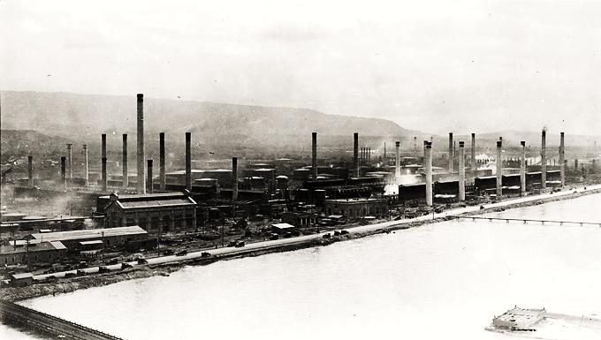
Standard Oil refinery on the North Platte River, Casper, Wyoming, 1920s.
Tulsa “Oil Capital of the World”: In 1905, two years before Oklahoma becomes a state, oil is discovered in south of Tulsa. The Glenn Pool discovery became the greatest oilfield in America at the time, and lead Tulsa to become the “Oil Capital of the World.” Daily production soon exceeded 120,000 barrels, exceeding the Tulsa County’s earlier “Red Fork Gusher”, and the giant Spindletop Hill discovery near Beaumont, Texas, four years earlier. The Ida Glenn No. 1 well is named for the Creek Indian woman, from whom oilmen had leased 160 acres. By the time, in 1907, Glenn Pool made Oklahoma the America’s biggest oil producing state.

Harry Ford Sinclair (1876-1956), later the founder of the Sinclair Oil and Refining Company, and J. Paul Getty, receive their initial start during the Glenn Pool boom, as noted by the Oklahoma Historical Society. The Oklahoma Natural Gas Company is founded, and in 1907 builds a pipeline from the Glenn Pool to provide gas to Oklahoma City. “It was Oklahoma’s first major oilfield, and the richest field the world had yet seen,” explains Norman Hyne, professor of petroleum geology at the University of Tulsa. “Unlike the thick, sour oil from Spindletop, the famous 1901 Texas discovery that had already played out, this oil was light and sweet, just right to refine into gasoline and kerosene”.

The reservoir was shallow, less than 1,500 feet deep, and the well within the range of the cable tool drilling rigs of that time. The giant field produced 325.5 million barrels of oil by 1986, with annual royalties of almost one million dollars paid to Creek Indians who held 160-acre allotments in the field. It is said that more money was made on the Glenn Pool oil field, than the California gold rush and Colorado silver rush combined. The field today uses enhanced recovery technologies to continue to produce oil. In April 2008, a monument was unveiled in Glenpool’s Black Gold Park by the Glenn Pool Oil Field Commission.

Texas Oil Industry: In 1901, the world famous Lucas gusher shot a stream of black crude oil high above the derrick, under the hill on Spindle Top Heights, later known simply as Spindletop. The geyser of oil flowed out of the 6-inch casing pipe for ten days at a rate of 70,000 to 100,000 barrels per day. The Hamill brothers successfully capped the gusher, and therefore, an oil boom like no other witnessed swelled the size of Beaumont from 8,000 residents to more than 50,000 in a few months. Investors and men of vision rushed to Beaumont to see if they could take advantage of the new oil discovery. By the end of 1901, there were over 100 wells at Spindletop many of them loca-ted on small "doormat" pieces of land, barely large enough for the derrick and drilling equipment.

The most significant company that started during the Spindletop oil boom was The Texas Company. This new company was formed primarily by the efforts of two industrialists, J. S. Cullinan and Arnold Schlaet. Other two enterprising Texans, former Texas Governor J. S. Hogg and J. W. Swayne, were
very active in the Spindletop development under the business name of Hogg-Swayne Syndicate, however, did not have a market for their oil or a method of getting it to a point of shipment. Then, they acquired lands for a pumping station near Spindletop, and for a refinery at Port Arthur.

Next, they also constructed storage tanks and started to lay a pipeline to Port Arthur, where Spindle-top crude oil could be loaded in barges or ships. Early in 1902, the company entered into negotiations for erection of a loading dock at Port Arthur Terminal. The Texas Company’s first pipeline from Spindletop was completed to reach the railway loading stations of Garrison and Nederland on May, and to Port Arthur in August, 1902. In September, 1902, The Texas Company's supply of crude oil was cut off, when the Spindletop wells suddenly stopped flowing, after the field caught fire. The Texas Company had an option to purchase the 865-acre about 20 miles northwest of Spindletop for $1,000,000. The option was about to expire when the third and last test well blew in a gusher on January, 1903. The company paid, getting money from partners, and this new, abundant supply of crude oil saved the company from bankruptcy.

From 1935 to 1940, there was a rapid increase in the quality, as well as the quantity, of lubricating oils manufactured at Port Arthur Works, when numerous technical changes were made to overcome capacity limitations and to increase the capacity of all of equipment. The gas produced in the cracking operation contained large quantities of propylene and butylene. A Polymerization Unit was built in 1936 to convert (polymerize) these gases into motor gasoline. This unit was converted to computer control in the late 1950's, and was the first unit in the world to use computer control.

In 1944, The Texas Company and American Cyanamid Co. organized a new company, the Jefferson Chemical Co., Inc., constructed in Groves. The Jefferson Chemical plant was completed in late 1947, to convert refinery gases into basic chemicals for the plastics industries. The Texaco ethylene glycol for automotive antifreeze was introduced in 1948. In 1952, Port Arthur Works installed underground storage for butanes at Sour Lake, Texas. The underground storage consisted of a cavity washed out of a salt dome (a type of structural dome formed when a thick bed of evaporite minerals, such as salt, or halite, intrudes vertically into surrounding rock strata).

Due to the increased octane level of gasoline motors, a Catalytic Reforming Unit was constructed and started up in July, 1954. Many changes have taken place at the Port Arthur Refinery in the last years through efforts to streamline operations, shift product distribution, and improve the efficiency of the refinery. The Texas Company was renamed Texaco, Inc., in 1959. In 2001, Chevron acquired the assets of Texaco to form a new company, Chevron-Texaco. In 1989, Saudi Refining, Inc. purchased 50% of Texaco’s Port Arthur refinery as part of a joint venture with Texaco.

Later, a new alliance between Texaco, Shell Oil Co., and Saudi Aramco were formed. This new alliance was called Motiva Enterprises LLC. From a dream of a few men, the Port Arthur Works company was instrumental in establishing a major international oil company, Texaco, the last company to survive the great Spindletop oil boom.

Texas City, is a city in Galveston County in the state of Texas acquired its first major industry when the Texas City Refining Company purchased in July, 1908, the site on which was constructed what was then considered a large and complete oil refinery, one of the earliest in Texas. For several years it was the only Texas refinery capable of producing the byproducts wax and lubricating oil. Some of the original buildings are still in use on the several times enlarged site, later occupied by the Sid Richardson Refining Co.

First Oil and Kerosene Pipelines: In U.S., about 1860, the village of Titusville, Pennsylvania was the only town along the Oil Creek Valley (see “Colonel” Edwin Drake history). The railroad had not yet reached Titusville; the town’s only connection to the outside world was the stagecoach that visited from Erie, Pennsylvania twice a week. Farmland and dense woods with few proper roads dominated the rest of the rural valley. Thus, in 1862, the first oil discoveries were transported to rail stations by teamsters using converted whiskey barrels with wagon and horses, which was the first method that early oil producers used to transport their oil.

Teamsters were hired by drillers to haul oil from the drilling sites to rivers, railroads, or refineries. Teamsters dictated the price to haul wooden barrels of oil around the region, depending on road and weather conditions. From the very beginning, transportation was essential with the Teamsters holding the first regional monopoly position. They charged more to move a barrel of oil 5 miles by horse than the entire rail freight charge from Pennsylvania to New York City.

Like previous pipeliners, Samuel Van Syckel (1842- ) was motivated by the often ruinously high pri-ces charged by the teamsters to haul a wagon loaded with oil barrels to a distant, or even nearby a place, which could be a small refinery, a storage tank, a railroad yard, canal, a river bank (deep water), a city or to some other intermediate sales point. Pre-pipeline price was always swinging in the first five years of the oil industry, and saw the price of crude oil fall to less than 10 cents a barrel while an empty new barrel could cost as much as $3.25.

The Pithole (a place in the foothills of the Appalachian Mountains) field was discovered in 1865, lying some five miles southeast of Miller Farm station, in wilderness, with no roads and difficult terrain. The teamsters soon priced themselves out of the picture for Pithole haulage, and Van Syckel was eager to get that oil moving. A pipeline was the answer and Van Syckel, became very determined to lay a pipeline, however, his idea was subject of much ridicule by his fellow oilmen, and attacked by teamsters, as they were threatened by this new transportation system.

In 1865, Van Syckel with a credit from the First National Bank of Titusville, went on with his idea and laid about 5 miles of two-inch wrought iron pipe in 15 foot joints from Miller Farm RR Station on the west side of Oil Creek in a southeast direction to Pithole. This was in hilly terrain of about 400 feet relief, but over half of that was in the descent from the flanking ridge to Oil Creek. The pipeline was wrought iron, 2 inches in diameter and lap-welded by William Snow, a Van Syckel's engineer who determined the specifications of the pipe, and the manner of laying it. Van Syckel installed three Reed and Cogswell steam pumps, two of these in the Pithole field and the other nearby.

These steam pumps pushed the oil at a rate of 81 barrels per hour to Miller Farm beginning October 10, 1865. A fourth pump was installed at a later date at the Cherry Run crossing increasing the delivery of crude oil by 25 percent bringing the line's 24 hour delivery to 2500 barrels. Mechanical problems were minor and could be easily fixed. Many teamsters were suddenly out of work, and the skeptical oilmen turned sheepish, but most of them took up the pipeline business.

In late 1871 by Tom Scott, the president of the powerful Pennsylvania Railroad, the South Improvement Company (S.I.C.) made a secret alliance between the railroads and a select group of large refiners, including the Standard Oil founded by John D. Rockefeller, which aimed a trust by "destructive" price-cutting. According to the pact, the railroads would raise their rates, but would agree to pay rebates to Rockefeller and other large refiners, thus securing their steady business.
In addition, the latter were to receive the proceeds of the "drawbacks" levied on nonmembers, who as a result, would end up paying much higher prices for their shipments of oil. This became known as the so-called Cleveland Massacre, and was the beginning of John D. Rockefeller's drive toward the oil monopoly, considered one of his shrewdest operations. The oil industry’s pipeline ventures continued to cover relatively short distances until the mid-1870s, when Byron D. Benson, a prominent Titusville, PA oil producer, turned his attention from oil production to oil transportation.

In late 1878, Byron D. Benson (1832-1888) and 9 others oil men met in Titusville, PA and organized the Tidewater Pipe Company, Ltd., to construct an oil pipeline. As a producer, Benson saw at first-hand, how the Standard Oil Company, its partners, and the railroads price settings, were profiting through their combined control of the transport of crude oil, from any oil field to their refineries. The company’s mission was to build a pipeline from Corysville, PA oil fields to Williamsport, PA, where the oil would be loaded onto tank cars of the Philadelphia and Reading Railroad, for final transport to the refineries in Philadelphia and New York. The name "Tidewater" was used, designing a pipeline that would terminate at or near the eastern tidewater coastline.

Benson proposed to use six-inch pipes to build a 109-mile pipeline over mountains nearly 2,600 feet high in the middle of winter. Furthermore, he planned to pump oil 109 miles and over high elevations using only two pump stations. With determination and ingenuity, Benson and his employees overcame many obstacles, including extreme winter weather, lands dense with timber and lacking proper roadways, and the need to create new tools and technologies to make the endeavor successful.

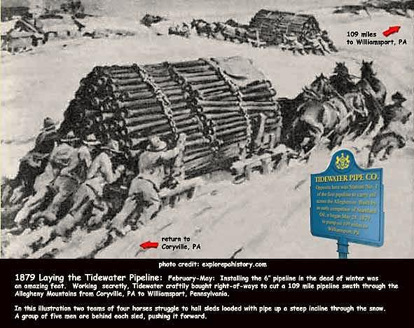
In 1879, the Tidewater Pipeline: In this illustration two teams of horses struggle to push sleds through the snow through the Allegheny Mountains to install the 6” pipeline, from Coryville, PA to Williamsport, PA.

The pipeline was completed on May 22, 1879, a mere 89 days after the first section of pipe was laid. On May 28, the oil pump at Coryville started, and the first barrels of oil reached at Williamsport on June 4, 1879. The success of Benson’s Tidewater pipeline revolutionized the transport of crude oil using a pipeline. However, by 1880, due to over production, the oil industry began seeing crude prices drop. This created a shortage of barrels, making the wooden barrel actually worth twice as much as the oil inside it, forcing Tidewater to extend its pipeline to Bayonne, N.J, and Standard Oil to construct its own pipelines with the terminus at the refineries in New Jersey and Philadelphia.

Rockefeller, by 1880, also made numerous attempts to stop Tidewater from buying out one of the partners that purchased the pipeline oil and also tried to destroy Tidewater's credit and finally attempted to destroy the independent refineries that Tidewater served. In the meanwhile his men were buying the Tidewater's stock in secret. In June 1882, Tidewater agreed to sell a third of its stock to Standard Oil. Tidewater and Standard Oil were prohibited by law to merge, but they came to a market-sharing agreement in October 1883, giving Tidewater 11.5 percent of the oil business.

By 1885, the Rockefeller´s Standard Oil controlled some 90% of America's refineries and pipelines. Today, the majority of crude oil in the U.S. and around the world moves via pipelines spanning thousands of miles. In 1888, the Tidewater Pipe Line Co. became known as the Tidewater Oil Co. The Tidewater Oil Co. marketed products under the name of Tydol and Veedol. Tydol was the name of the service station that sold Veedol products in the U.S., Europe and South America. Tidewater eventually branched to the U.S. western and southern.

In Europe, about the 1880s, Dmitri Mendeleev, a Russian chemist and inventor, who formulated the Periodic Law, and created his own version of the periodic table of chemical elements, proposed the construction of Baku–Batum pipeline to ensure the transportation of Baku oil to the world market. The pipeline technical project was later designed by Vladimir Shukhov, in 1884. In 1885, a mining engineer I. Ilimov established the Caspian and Black Sea Oil Pipeline company. In December 1887, the Government of Russia granted to Ilimov the concession to establish the Society of the Caspian-Black Sea Oil Pipeline, a joint stock company.

However, in 1891, the pipeline construction was postponed as premature, and the construction started only in 1896. At this first stage, the Batum-Mikhailovo (Khashuri) section was constructed, while the construction of Baku-Mikhailovo (Khashuri) section was finished only in 1906. The first pipeline was kerosene pipeline with total length of 835 kilometers (519 mi) and 16 pumping stations. The diameter of the pipeline was mainly 8 inches (200 mm), but some parts had diameter of 10 inches (250 mm) and 12 inches (300 mm).

The pipeline was built along the railroad line and the telephone communication was arranged along the route. Pumping stations were equipped with plunger pumps, driven by steam and diesel engines. The pipeline for its time was the longest pipeline in the world. After the Bolshevik Revolution, kerosene deliveries through the pipeline were re-launched in March 1921 and on 20 May 1921, the first delivery of kerosene arrived at Batum. After 1936 Batum was renamed to Batumi.

Gas Production: The first commercialized natural gas occurred in Britain, around 1785, when the British used natural gas produced from coal to light houses and streets. In 1816, in Baltimore, its main city Maryland, used manufactured coal gas, and became the first city in the United States to light the streets with gas. Naturally occurring natural gas was discovered and identified in America as early as 1626, when French explorers discovered natives igniting gases that were seeping into and around Lake Erie.

Natural gas is contained in the pores and fractures of sedimentary rock deep beneath the surface of the earth and ocean floors, and can be found throughout the world either by itself or in association with crude oil. Raw natural gas (before processing) is composed primarily of methane, and may also contain varying amounts of ethane, propane, butane, and pentane (commonly referred to as natural gas liquids [NGLs]). Raw natural gas may also contain non-energy components such as nitrogen, carbon dioxide, hydrogen sulphide and water. Most NGLs, and all the non-energy components, are removed in processing plants before the natural gas is marketable and placed into pipelines.

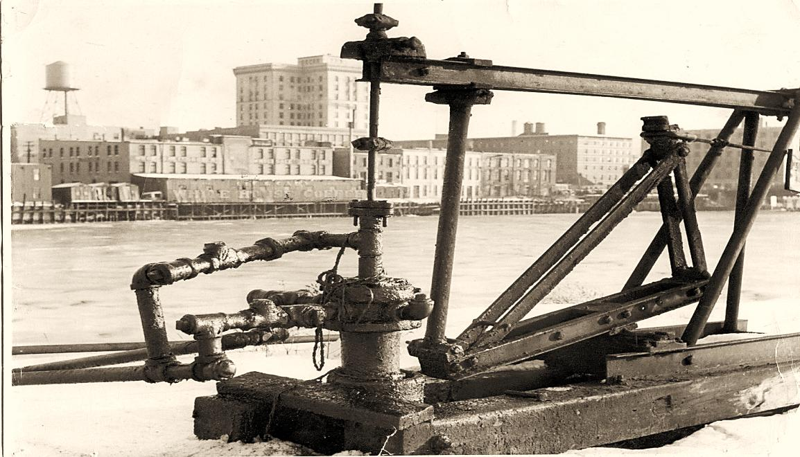

In 1821, the first well specifically intended to obtain natural gas, was dug in Fredonia, New York by William Hart. After noticing gas bubbles rising to the surface of a creek, Hart dug a 27-foot well to try and obtain a larger flow of gas to the surface. The Fredonia Gas Light Company, founded in 1858, was the first natural gas company in the United States, founded by a group of entrepreneurs, after William Hart, considered the "father of natural gas" in the U.S. The pipeline to transport the gas was made from hollowed out logs, connected together with tar and rags.

At that time, natural gas was used almost exclusively as a fuel for lamps, because there were no pipelines to bring gas into individual homes, most of the gas went to light city streets. One of the first major pipelines was constructed in 1891, with 120 miles long, and carried natural gas from wells in central Indiana to the city of Chicago. However, this early pipeline was not very efficient at transporting natural gas, relying completely on the natural underground pressure.

A water well, drilled in the City of Stockton (San Joaquin County) between 1854 and 1858, reached a depth of 1,002 feet and produced natural gas with the water. The gas was burned at the Stockton courthouse for many years, even before Drake drilled his Pennsylvania oil well. Many other water wells drilled in San Joaquin County also produced gas; however, little use was made of the natural gas until 1885 when Standard Gaslight and Fuel Company was incorporated to develop natural gas in the San Joaquin Valley. In 1886, the California Well Company was organized in Stockton for the same purpose.

Canada has a proud history of pipeline constructions and operation, dating back to 1853, when a 25 kilometer cast-iron pipe from the Maurice River area, moving natural gas to Trois Rivières, Quebec, was completed, where it was used to provide street lighting. It was probably the longest pipeline in the world at the time. In 1862, Canada would complete one of the world’s first oil pipelines, from the Petrolia oilfield in Petrolia, Ontario to Sarnia, Ontario, and in 1895 another natural gas pipeline, 0.75 inch in diameter, linked wells in Essex County, Ontario to Windsor and passed under the Detroit River to Detroit. In 1912, Canadian Western Natural Gas builds a natural gas pipeline from Bow Island, AB to Calgary, AB (275 km.).

After 1870, there was a fierce competition for oil drilling, refining and distribution in southern Ontario until 1880, when 16 oil refineries merged to form Imperial Oil. This company was acquired in 1898 by John D. Rockefeller's Standard Oil Trust. Oil discovery and development in the west dates from the early 20th century, and Imperial Oil became a major player. British based corporations, such as Royal Dutch Shell and Anglo-Persian Oil (British Petroleum, BP), also became involved in oil exploration in the west at this time.

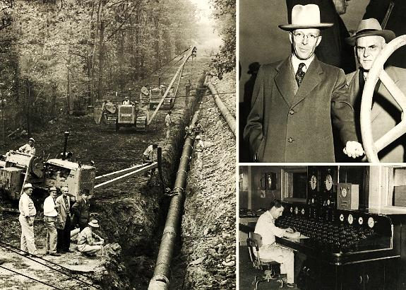

In 1910, the City of Bakersfield in Kern County was supplied with natural gas, delivered through a pipeline laid from the Midway-Sunset oil field, 40 miles away. In 1913, another pipeline from the same source was laid to supply the Los Angeles area. By 1915, gas from local fields was available in the Los Angeles area, and by 1927 most of the communities in Southern California had gas servi-ces. In 1929, the San Francisco Bay region was supplied with gas, through a pipeline laid from Kettleman Hills oil field.

In 1920s, significant effort was put into building a pipeline infrastructure. Gas exploration increased appreciably during the 1940s and even more in the 1950s. In the 1950s, more than 30 gas fields were found, most in the Sacramento Valley. Also, Gaviota Offshore, the first gas field discovered in offshore waters, was found in Santa Barbara County. The search for gas continued throughout the 1970s, and 44 gas fields were found from 1970 to 1980. As in the 1950s, most of the new fields were in the Sacramento Valley. Since late 1961, large quantities of gas have been transported through pipelines from fields in Canada. In 1999, California imported 86 percent of the natural gas it used from other states and Canada.

In 1938, however, with the growing importance of natural gas, concern over the heavy concentration
of the natural gas industry, and the monopolistic tendencies of interstate pipelines to charge higher than competitive prices due to their market power, the U.S. government began regulating the interstate natural gas industry with passage of the Natural Gas Act. The Act was intended to protect con-sumers from possible abuses such as unreasonably high prices. Today, liquefied petroleum gas or liquid petroleum gas (LPG or LP gas), also referred to as simply propane or butane are flammable mixtures of hydrocarbon gases, used as fuel in heating appliances, cooking equipment, and vehicles. After World War II, new welding techniques, along with advances in pipe rolling and metallurgy, further improved pipeline reliability.

In November, 1953, the world’s first LPG ship, the first seagoing Liquefied Petroleum Gas (LPG) ship goes into service. Warren Petroleum Corporation of Tulsa, Oklahoma, sends the Natalie O. Warren from the Houston Ship Channel terminal at Norsworthy, Texas, to Newark, New Jersey. The vessel had an LPG capacity of 38,053 barrels in 68 vertical pressure tanks, equivalent of about 339,000 standard gas grill LP tanks. The ship, the former Cape Diamond dry-cargo freighter, was converted and refitted at Bethlehem Steelyard in Beaumont, Texas. After 14 years of successful service, the Natalie O. Warren was scrapped in Santander, Spain. Today, LPG tankers may carry more than 18 times the capacity of the Natalie O. Warren.

Gas exploration increased appreciably during the 1940s and even more in the 1950s. In the 1950s, more than 30 gas fields were found, most in the Sacramento Valley. The Gaviota Offshore was the first gas field discovered in offshore waters, in Santa Barbara County. The search for gas continued throughout the 1970s, and from 1970 to 1980, 44 gas fields were found. In 1999, California imported 86 percent of the natural gas from other states and Canada.

Coal Refining: According to researches, the first commercially successful carbonization process was developed by Darby, in 1709. In 1791, William Murdoch patented a process for distilling coal for production of illuminating gas, which he used to light his office and the cottages of coal miners. In 1807, the Westminster Bridge and Pall Mall, in England, became the first public places to be lighted by coal gas, and in 1816, Maryland, Baltimore, became the first American city to use coal gas for lighting the streets. The first use of coal gas for heating purposes was in 1855, when the Bunsen burner was developed.

During the early Industrial Revolution coal fuel dominated the energy mix, replacing wood or dung as the fuel of choice. Oil was used, but it was whale oil rather than rock-oil. Whale oil was important for a host of uses, including heating, lubrication, soap, the processing of textiles & rope, and, crucially, candle wax & lamp oil. There are also some reports of a possible oil-distilling factory at the Absheron Peninsular, Azerbaijan, as early as 1837, but these may have used non-industrial methods. The first key technology was devised in 1846 by Abraham Gessner, a Canadian. Gessner developed a process to refine liquid fuel from coal, bitumen, and oil shale.

The resulting fuel, kerosene, burned more cleanly and was less expensive than whale oil. Gesner coined the name kerosene in 1853. He patented his “Improvement in Kerosene Burning-Fluids”, realizing the usefulness of kerosene as a cleaner-burning fuel in lamps to replace whale oil. Because his new lighting fluid was extracted from coal, consumers called it “coal oil” as often as they called it kerosene. In 1850 Gessner created the Kerosene Gaslight Company & installed lighting in the streets of Halifax.

Coal is a mineral deposit that is rich in carbon content. This carbon is important, as it is what gives the coal the greater majority of its energy content. When coal is burned in the presence of air or oxygen, heat energy is released and can be converted to other forms of useful energy. For coal deposits that are relatively close to the surface, open pit or strip mining techniques are used. Coal is used in industrial processes, such as cement manufacturing, steel production and heat and power applications, such as electricity generation.

Coal has been mined in Canada since 1639, when a small mine was opened at Grand Lake, New Brunswick. In 1720 French soldiers opened a mine in Cape Breton, Nova Scotia, to supply the fortress of Louisbourg. In the 1880s, the building of the Transcontinental Railways through Alberta and British Columbia developed several coal mines in various locations, mainly near railway lines in the prairies and mountains. By 1911 western mines produced most of the coal in Canada and, despite downturns, gradually expanded to produce over 95% of Canadian coal.

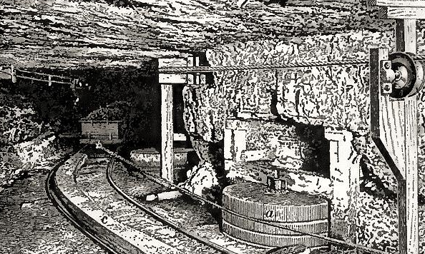

Two years before the beginning of American Civil War in 1861, more than thirty companies used Gesner’s process to produce coal oil. It was cheap, easy to produce and could be burned in existing lamps. The new oils were successful, but the supply of oil from the coal mine soon began to fail, and eventually being exhausted in 1851. This same year, James Young a Scottish chemist also set up a commercial plant, to produce paraffin by the distillation of coal and oil shale. The company grew and expanded its operations, selling paraffin oil all over the world with the nickname of “Paraffin Young”.

In 1853, Ignacy Lukasiewicz, a polish pharmacist interested in the potential of refining seeping rock-oil as a cheap alternative to whale oil, improved Abraham Gesner’s earlier refining method to produce clear kerosene from seep petroleum. Two years later he opened the first industrial refinery in the world, at Ulaszowice near Jaslo. By 1860 Gessner & his competitors had built 40 kerosene plants across the United States. Among Gessner’s competitors were John D Rockefeller & Samuel Andrews, who would go on to set up a network of distilleries called Standard Oil, in U.S.

In 1913, Friedrich Bergius discovered that when coal is treated with hydrogen at high temperature and pressure, in presence of a catalyst process, oil similar to crude oil, can be produced. During 1930 and 1940, these development activities have been done using the well-known Fischer-Tropsch process, for indirect liquefaction of coal. In 1970, Ralph M. Parsons Company (founded in 1944, today Worley-Parsons), combined hydro-liquefaction, pyrolysis, and gasification conversion proces-ses with combustion turbines, heat-recovery steam generators, and steam turbines to yield a broad range of synfuels plus electricity, as part of the project, “POGO” (Power-Oil-Gas-Other).

Today, coal refining technology is also a process that alters the coal characteristics, taken through various processes to get its purity. Coal is washed with water or chemical bath to remove some impurities, as at least, 30% of the sulfur can be removed by washing. At the power plant, coal is pulverized to a hea-vy powder just before being burned. Burning coal emanates sulphur dioxide, carbon dioxide, and nitrogen oxide, to mention a few gases. Using filters or scrubbers, some sulphur particles are partially removed. Some coal refining plants use “fluidized bed combustion” instead of a normal furnace, made up of little particles of limestone, ash, and other non-flammable materials. This bed combustion has low sulphur emissions hence will give out a more pure form of coal.

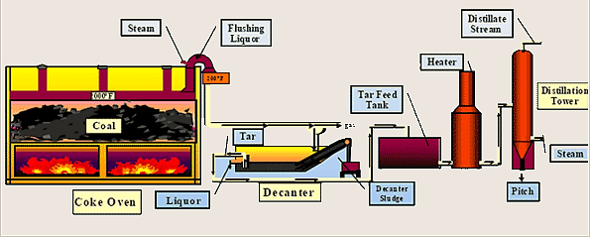

Natural Gas from Coal (NGC), also known as Coalbed Methane (CBM), is an almost pure form of natural gas (methane) found within underground coal deposits, contained within, and produced from, coal seams. This contrasts with conventional natural gas, which is produced from sandstones and carbonates. Unlike raw natural gas in conventional underground reservoirs, CBM is generally “lean, sweet natural gas,” meaning it contains very little NGLs or non-energy components.

Fossil fuels, such as coal, are recognized as an important strategic resource for Canada, and there is a growing need to improve their environmental performance. Scientists at Natural Resources Ca-nada (NRCan) are leading these researches from a diverse set of innovative technologies, to make fossil fuels combustion cleaner, through CO2 capture processes more environmentally sustainable, and increasing its efficiency, mainly by reducing associated harmful emissions.

James Young (1811–1883): Was a Scottish chemist, best known for his method of distilling paraffin from coal and oil shales. In 1847, Young paid attention to natural petroleum seepage in the Riddings coal mine at Alfreton, Derbyshire, from which he distilled a light thin oil, suitable for use as lamp oil, at the same time obtaining a thicker oil, suitable for lubricating machinery. In 1848, in partnership with his assistant Edward Meldrum, set up a small firm refining the crude oil. Young, noticing that the oil was dripping from the sandstone roof of the coal mine, concluded that it somehow originated from the action of heat on the coal seam and from this thought that it might be produced artificially.

Following up this idea, he tried many experiments and eventually succeeded in producing, by distilling a cannel coal (a fluid resembling petroleum) at low heat, which when treated in the same way as the seep oil, gave similar products. Young found that by slow distillation, he could obtain a number of useful liquids, one of which he named "paraffin oil", because at low temperatures it congealed into a substance resembling paraffin wax. In 1852 James Young left Manchester to live in Scotland, and that same year took out a US patent for the production of paraffin oil by distillation of coal.

Both U.S. and U.K. patents were subsequently upheld in both countries, in a series of lawsuits, and other producers were obliged to pay him royalties. In 1865, Young built a second and larger works at Addiewell, near West Calder. In 1866, he sold the firm to Young's Paraffin Light and Mineral Oil Company and remained in the company, taking no active part in it, to occupy with scientific pursuits. The company continued to grow and expanded its operations, selling paraffin oil and paraffin lamps all over the world, acquiring for its founder the affectionate nickname of “Paraffin Young”. Other companies worked under license from Young's firm, also spread over the south of Scotland.

Jean Paul Getty (1892–1976): Was son of George Getty, who was in the petroleum business, in Minneapolis, Minnesota. In 1913, he obtained a diploma in Economics and Political Science from the University of Oxford. Running his own oil company in Tulsa, he made his first million by 1916, with an oil well near Haskell, Oklahoma, which was the first to be drilled by J.P. Getty. Later, Jean Paul Getty became impressed by Tidewater's operation in Oklahoma, mainly because the company was making so much money, while being managed so poorly.

During the early 1930s, Getty began acquiring stock and by 1951, he took control of Tidewater Oil Co., and founded the Getty Oil Company in 1964. After 1970, the Getty Oil Company sold its European activities to Burmah Oil. The sale consisted of rights to the Veedol name and a refinery in Gae-ta, Italy (which had an associated Getty branded service station). Burmah oil (also Burmah-Castrol) kept Veedol separate from its main Castrol (British global brand of industrial and automotive lubricants), however, the Veedol name still stayed in use in several countries, even after BP bought Burmah in 2000. In 1984, Texaco bought the Getty Oil of Los Angeles, California.

Burmah oil was founded with the name of Rangoon Oil Company, in Glasgow in 1886, by David Sime Cargill (1826–1904) a Scottish businessman, to develop oil fields in the Indian subcontinent. In 1890, the company passed into the ownership of Sir Campbell Kirkman Finlay, whose family already possessed vast colonial interests through their trading vehicles, James Finlay and Co. In 1966, the brand name Castrol was acquired by Burmah, then renamed Burmah-Castrol. In 2000, Burmah-Castrol was acquired by the BP Amoco (now renamed BP).

In the end, only some of the refineries changed hands, but Getty continued to exist as a downstream entity, and his company became known as Getty Marketing. In November 2000, the Russian oil company Lukoil, purchased the Getty Marketing, the Getty trademark, and in 2003 converted a small number of Getty stations to Lukoil. ExxonMobil merged with Mobil but, in 2004, Lukoil also bought the ExxonMobil stations from ConocoPhillips, due to an anti-trust settlement. These stations were quickly converted to Lukoil Company for legal reasons.

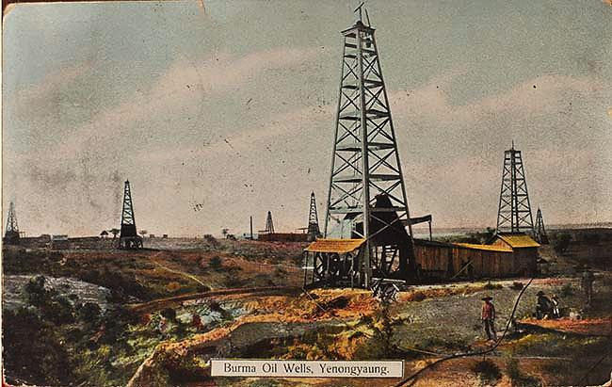

Ludvig Immanuel Nobel (Stockholm, 1831 - St. Petersburg, 1888): Was a Swedish-Russian engineer, a noted businessman and a humanitarian. One of the most prominent members of the Nobel family, he was the son of Immanuel Nobel (also an engineering pioneer) and the older brother of Alfred Nobel (founder of the Nobel Prize). With his brother Robert, he operated Branobel, an oil company in Baku, Azerbaijan which at one point produced 50% of the world's oil. He is credited with creating the Russian oil industry. Ludvig Nobel built the largest fortune of any of the Nobel brothers and was one of the world's richest men.

When Ludvig Nobel was 28 years old, he was given by his father's creditors the technical management of the family business, Fonderies et Ateliers Mécaniques Nobel Fils, a factory making war supplies such as mines and steam engines. While running the factory in St. Petersburg, Ludwig obtained a large contract to manufacture rifles for the Russian government and he needed wood for the rifle stocks. He sent his oldest brother, Robert Nobel in 1873 to procure Russian walnut wood in the Caucasus region of southern Russia.

Without consulting his brother, Robert spent the 25,000 rubbles that Ludwig entrusted to him, and instead, bought a small refinery in Baku. Ludvig entered into an agreement with his brother and sent additional funds to Robert to invest in modernization and refinery efficiency. By 1876, the Nobel brothers established themselves as the most competent refiners in Baku and sent the first shipment of illuminating oil (kerosene) to St. Petersburg. By 1879, Ludvig turned the initial business into a shareholding company, Branobel, of which he was the major shareholder and had as partners his brothers Robert and his, today, famous brother Alfred Nobel.

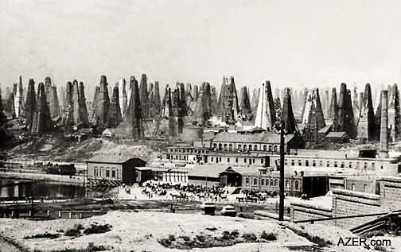
Oil derricks sprouted up in Baku, Azerbaijan. The fields were the largest in the world at the time.

Ludvig Nobel invented oil tankers, and better refineries, pipelines. Nobel established technical che-mical research labs in Baku, trying the new products out on a large scale. Dozens of scientists were employed, finding ways to treat oil, developing new uses for oil, and developing products derived from oil. Nobel also experimented carrying oil in bulk on single-hulled barges and self-propelled tankships, and his primary concern was avoid fires, including the cargo to expand and contract due to temperature changes, and providing a method to ventilate the tanks.

In 1902, the company signed a contract for the purchase of oil fields in Romany, and in 1905, in accordance with the Committee of Ministers, the company purchased the oil fields owned by oil producer A. Adamov. The company's fixed capital in 1914 and by 1916, it was the largest oil company in Russia, producing 76 million poods of oil (approximately 16.38 kilograms, or 36.11 pounds, this measure was abolished in 1924, but remained until the 1940s).

In 1920, the Bolsheviks seized the refinery in Baku and the Branobel's oil business in Azerbaijan was nationalized. In 1920, the Nobel family sold almost half of its possession to Standard Oil of New Jersey (USA), the negotiation led by Gustav Nobel, on one side, and Walter C. Teagle, on the other, proved to be a profitable masterstroke for the Nobel family. Branobel was totally dissolved in 1959 and its last President was Nils Nobel-Oleinikoff, grandson of Ludvig Nobel.

Note: Alfred Bernhard Nobel (1833 – 1896) was born in Stockholm (Sweden), chemist, engineer, innovator, inventor and armaments manufacturer, inventor of the dynamite. Nobel combined nitroglycerin with various nitrocellulose compounds, and obtained a transparent, jelly-like substance, which was a more powerful explosive than dynamite designed as “Gelignite”, or blasting gelatin, patented in 1876. Gelignite was more stable, transportable and conveniently formed to fit into bored holes, like those used in oil and gas drilling and mining. His fortune was used posthumously to institute the Nobel Prizes.

The Rothschilds Family: Were jew bankers in the city of Frankfurt, who established their banking family business in the 1760s, through his five sons. During the 19th century, the Rothschild family is believed to have possessed the largest private fortune in modern world history. Through collaborative efforts, the Rothschilds rose to prominence in a variety of banking endeavors including loans, government bonds, and became major stakeholders in large-scale mining and rail transport ventures, fundamental to the rapidly expanding industrial economies of Europe.

In the 1880's, the French branch of the Rothschild family acquired commercial interests in Russia's Baku oil fields, as an effort to supply their refinery on the Adriatic with cheap Russian oil. In exchange for these interests they built a railroad linking Baku to the newly acquired Black Sea port of Batum. This opened up the Baku oil, a major world supply, to the world. With the success of a new railroad, the Rothschilds had more oil than they could actually sell. At that time, began a heated competition between oil companies owned by the Rothschild family and the by Rockefeller’s gigantic Standard Oil Company.

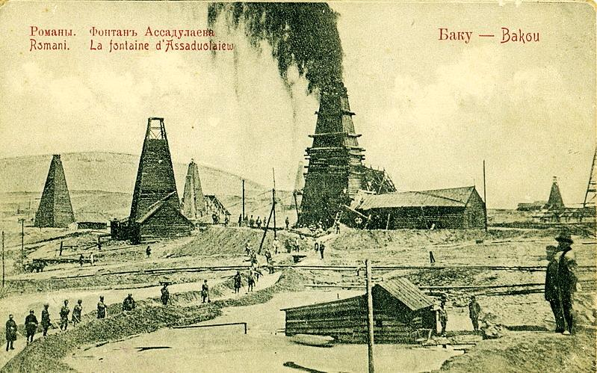

But the two competitors each finally realized that competition was not a good thing. The more oil wells were drilled, the more oil was produced, the more the price of oil per barrel fell. Then, it was decided that the world’s markets would geographically be carved up, with the two barons, Rockefeller and Rothschild, each having their separate, well-defined shares. Moreover, limits would be put on oil produced globally so as to keep the market price as high as possible. Under this arrangement, both Rothschild and Rockefeller could benefit each other.

By the later part of the 19th century, oil was fast becoming an important commodity and the Roths-childs French bank was heavily involved in oil exploration in the Baku area of present-day Azerbaijan through their company, the Caspian and Black Sea Oil Industry and Trade Society established in 1883. Their investment proved to be a lucrative one and by the turn of the century, the various oil companies in Azerbaijan were producing more oil than any other country in the world. In 1898, the Rothschilds established the Mazut Transportation Society that developed a fleet of oil tankers operating in the Caspian Sea.

John Davison Rockefeller (1839-1937): Was an American industrialist and philanthropist, which founded the Standard Oil Company, the University of Chicago and the Rockefeller Foundation. John D. Rockefeller was born on July 8, 1839, in Richford, N.Y. His father owned a farm property and traded in many goods, including lumber and patent medicines. The family moved west, reaching Cleveland, Ohio, in 1853, when it was beginning to grow into a city. He enters a professional school, where he studies double-entry bookkeeping, penmanship, banking, and commercial law.

At 16, in 1855, Rockefeller gets his first job, working for Hewitt & Tuttle, commission merchants and shippers. In 1859, “Colonel” Edwin Drake strikes oil in Titusville, Pennsylvania, instigating an "Oil Rush" to the region. When he was 19, in 1858, he started his first company with a young Englishman; Clark and Rockefeller, and from the start, he revealed a genius for organization and method. In 1861, American Civil War begins, and Rockefeller, like some other northern businessmen, hires substitutes to avoid fighting. The war at first disrupts the industry, but later it accelerated economic development in the North, contributing to Rockefeller's meteoric ascent.

In the 1860s, with the Pennsylvania oil development and the building of a railroad to Cleveland, they branched out into oil refining with Samuel Andrews, a mechanic that had technical knowledge of the field. In 1863, at 24, Rockefeller gets involved in the oil business, along with partners Maurice Clark and Samuel Andrews. In 1865, at the end of American civil war, at 26, Rockefeller and his partner founds The Standard Works, established by his brother William's name; and in 1866, a sales office was opened in New York City.

Within two years Rockefeller became senior partner. Later, in 1870, the Standard Oil Company was built in Cleveland, Ohio, by John Rockefeller, his brother, Flagler, Harkness, and Andrews, burgeoning industrial area, which will soon be linked to the East Coast hubs by the Atlantic and Great Western Railroad. Maurice Clark was bought out, and the firm Rockefeller & Andrews became Cleveland's largest refinery, and soon became the largest oil corporation in the USA. The new company starts a transportation trust to control the U.S. petroleum refining.

The Standard Oil after 1872, controlled one-tenth of American refining, but competitive chaos remained. The chief bottleneck was the transporting of the oil. Out of this situation came the controversial South Improvement Company scheme of 1872, a defensive alliance of Cleveland refiners to meet the bitter opposition of the oil producers of Pennsylvania. The sweeping freight rebate agreements in this scheme brought public opposition, and the plan was outlawed by the Pennsylvania Legislature. However, a looser organization, a refiners' pool, also failed in 1872.

In 1889, the Standard Oil established an Indiana-based subsidiary. The next year, the company began to process oil at an enormous new refinery at Whiting, Indiana, southeast of Chicago. By the mid-1890s, the Whiting plant had become the largest refinery the United States, handling 36,000 barrels of oil per day and accounting for nearly 20 percent of the total U.S. refining capacity. During these years, the company's main product was kerosene, mainly used for lighting. By 1910, Standard Oil was connected by pipeline to oil fields in Kansas and Oklahoma, as well as Ohio and Indiana.

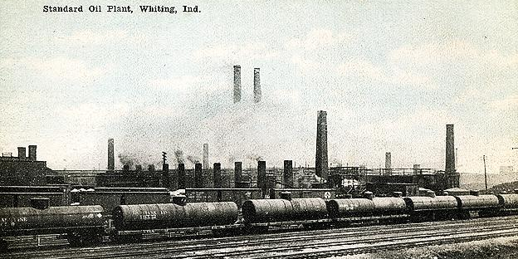

During the 1910s, the company pioneered a new thermal “cracking” process, in which crude oil was processed under pressure in order to produce higher yields of gasoline. By this time, the beginning of the automobile age, gasoline had become the leading product of oil refineries. In 1906, President Roosevelt's attacks on Rockefeller and Standard Oil escalate. Rockefeller is singled out as one of the "malefactors of great wealth." Anti-Rockefeller sentiment is at an all-time high. The U.S. government has seven different suits pending against Standard Oil.

The lawsuits argue that Standard Oil is more than 20 times the size of its closest competitor. In 1911, the U.S. Supreme Court announces its decision to dismantle Standard Oil, and the company is ordered to divest itself of its subsidiaries within six months. In this year, the Royal Dutch Shell Co. also purchased the Azerbaijan oil fields from the Rothschild family. In 1917, John D. Rockefeller, Sr., begins to transfer his wealth for his son John D. Rockefeller Jr., who was the main beneficiary.

In 1920, the Standard Oil Indiana was ranked as the third-largest oil refiner in the United States, behind Standard Oil New Jersey and Standard Oil California. In 1925, with more than 25,000 employees around the country, Standard Indiana merged with the American Oil Co. (Amoco). During the mid-1930s, the company employed about 7,000 people only at its Whiting plant and Chicago offices. In 1937, John D. Rockefeller dies with 97, three years before his goal of 100 years. A simple funeral is held at Riverside Church. At offices, refineries and companies work, stops for five minutes.

By 1970, Amoco and other leading oil companies were huge global corporations that not only refined oil, but also in exploration and drilling, and had large chemicals divisions. At the end of the 1990s Amoco merged with British Petroleum (BP). While most of the company's offices still remained in Chicago by the early 2000s, Amoco's old operations had become known by the BP name, and management of the company was directed from London.

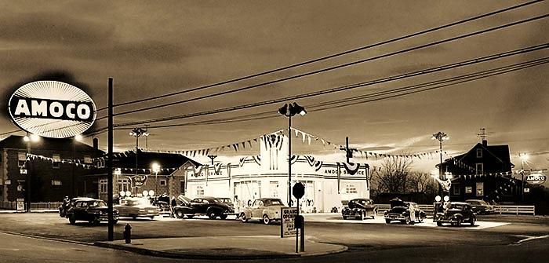

- TRANSPORTATION HISTORY:

As the industry’s pioneers, Pennsylvania’s early oil producers developed the first methods of transporting crude oil from the well site to refineries; many of their transportation methods have become obsolete over the last 150 years. Other transportation methods have evolved into the quick and efficient ways that we transport massive quantities of oil today. Thus, the job of transporting crude oil and refined products could be done by the producer, refiner, pipeline trader or one of several downstream distributors, such as a terminal operator or independent marketer. In other instances, the product can be transported from one storage facility to another by a "common carrier" whose only role in the distribution chain is providing the means of transportation.

The technology of oil transportation has evolved alongside the oil industry. Although anthropogenic use of oil reaches to prehistory, the first modern commercial exploitation dates back to manufacture of paraffin in 1850, through James Young. In the early 1850s, oil began to be exported from Upper Burma, then a British colony. The oil was moved in earthenware vessels to the river bank where it was then poured into boat holds for transportation to Britain.

In U.S., about the 1860s, the Pennsylvania oil fields became a major supplier of oil, and a center of innovation after Edwin Drake struck oil near Titusville, Pennsylvania. Break-bulk boats and barges
ere originally used to transport Pennsylvania oil in 40-US-gallon (150 l) wooden barrels. But transportation with barrels had several problems. The first problem was weight; the standard empty barrel weighed 64 pounds (29 kg), representing 20% of the total weight of a full barrel.

Water Ways: Prior to 1862, the railroad did not service Pennsylvania’s Oil Region. As a result, the region’s waterways became the primary mode of transporting oil to market. Teamsters hauled oil from the well site to flatboats on Oil Creek. The flatboats were loaded with oil barrels and then floated down the very shallow creek to the Allegheny River via a pond freshet or artificial flood. A pond freshet was created by damming water on the principal branches of Oil Creek, some of which were as much as ten miles above Titusville, Pennsylvania. Once at the Allegheny River, the oil was loaded onto barges to refineries in Pittsburgh, Pennsylvania.

In 1861, with the outbreak of the U.S. Civil War, boat captains who had freely hauled cargo along waterways from north to south found themselves in need of safer passages on which they could ply their trade. Jacob J. Vandergrift (1827 – 1899) was a boat captain who came to Pennsylvania's oil region looking to help meet the demands of the growing industry. With a great experience in moving cargo, Vandergrift saw a natural fit for himself in helping to transport oil. Originally he sought to make a profit by bringing into the region over 4,000 barrels that could be loaded with oil and shipped down the Allegheny River to the refineries in Pittsburgh.

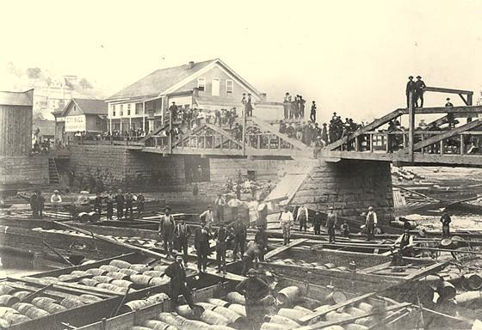

Vandergrift brought his steamboat up the Allegheny River with a tow of two barges filled with 5,000 empty barrels. Upon arriving at the mouth of Oil Creek, he established what would become a very lucrative bulk shipping firm. Vandergrift would buy oil when the price was low, store it, and then sell it during the late fall refining season in Pittsburgh and Philadelphia for a much higher price. Other rivermen joined Vandergrift in this profitable, but risky business, building boat landings and warehouses on the banks of the Allegheny River near the mouth of Oil Creek. During the early years of the petroleum industry, these oil shippers were the principal market makers, bankers, and commodity traders for oil produced in the region.

Railroad: The first railroad to reach the Pennsylvania’s Oil Region arrived in November, 1862. The Oil Creek Railroad stretched approximately 27 miles from Corry, PA to Titusville, PA. It was a single track line, and the first years, the railroad was limited to transporting approximately 30,000 barrels, and monthly 200,000 barrel of oil production. Between 1862 to 1865 teamsters hauled barrels of oil from the well site to the railroad yards, where barrels were stacked on flat-cars for transport. Unfortunately, the traditional wooden barrels were unreliable and leaky, and railway transportation only exacerbated the problem.

Observing these facts, James and Amos Densmore of Meadville, Pennsylvania, designed their first twin tanked railroad cars in 1865, which became the latest of a growing number of oilfield innovations. The two brothers received a U.S. patent on April 10, 1866, for their “Improved Car for Transporting Petroleum”, booming the oil region of Northwestern Pennsylvania. The “Amos & Densmore Tank Car” was a specialty railroad car that could haul 80-90 barrels (nearly 3,400 gallons) of oil. They used a flat train car and affixed two vertical 40-45 barrel tanks made of pine planks banded with iron. The car ran successfully on a line from Miller Farm (south of Titusville, Pennsylvania) to New York, with no leaks and oil loss.

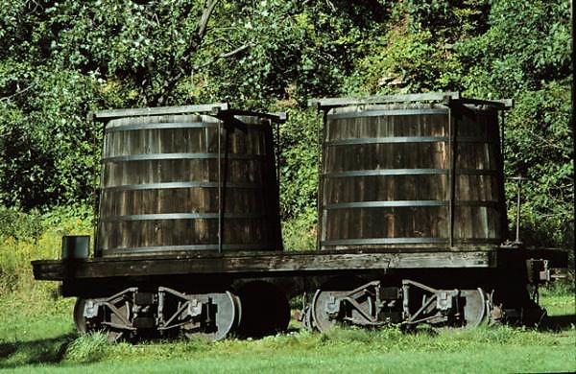
Amos and James Densmore designed their first twin tanked railroad cars in 1865.

The success of the Densmore Tank Car revolutionized the transportation of oil by railway, leading competitors to copy the car’s simple design and to improve upon it. Over the next several decades, many improvements were made, including metal construction, a single-tank design, and expansion domes that prevented leakage. By 1868, a boiler-type tank car was in use. These cylindrical horizontal tanks could carry 80 to 100 barrels of oil each. The new tank cars were not top-heavy and were made of metal, so they did not leak oil.

In 1867, a railroad loop comprised of rails laid by the Atlantic & Great Western Railroad, the Farmer’s Railroad, and the Oil Creek Railroad was completed, encompassing the Oil Creek Valley. This improvement to the valley’s railroad infrastructure in conjunction with the advent of the oil tank car allowed crude oil to be easily shipped by rail from the region to points east and west and elsewhere via connections, marking a significant shift in oil transportation from water to rail. Today, these tank cars are still used to ship corn syrup and refined fuels.

Oil Tankers: In 1863, two sail-driven tankers were built on England's River Tyne. These were followed in 1873 by the first oil-tank steamer, the Vaderland, built by Palmers Shipbuilding and Iron Company of the United Kingdom for the American-Belgian Red Star Line. The modern oil tanker was developed in the period from 1877 to 1885. In 1876, Ludvig and Robert Nobel, brothers of Alfred Nobel, founded Branobel (short for Brothers Nobel) in Baku, Azerbaijan, which was, during the late 19th century, one of the largest oil companies in the world.

In 1877, W.A. Riedmann from Geestemünde (Bremen, Germany) entered the petroleum trade. He noted the difficulties of using barrels, and began to experiment filling large iron drinking water tanks with oil. In 1879, he purchased the Andromeda at Liverpool, brought it to Germany and added seventy iron tanks, connecting the tanks by piping, so that all could be filled from a single tank. The composite hull, with structural members of iron covered with wooden planking, was especially suitable for the addition of tanks, because they could be firmly fastened to the iron beams. Andromeda made seven trips from Germany to North America, as a sailing oil tanker.

The most modern oil tankers were developed in the period from 1877 to 1885. Ludvig and Robert Nobel, in 1876, brothers of Alfred Nobel, founded the Branobel (short for Brothers Nobel) Company in Baku, Azerbaijan, which was, during the late 19th century, one of the largest oil companies in the world. Ludvig Nobel was one of the first pioneers in the development of early modern oil tankers. He first experimented with carrying oil in bulk on single-hulled barges. Turning his attention to self-propelled tankships, he faced a number of challenges, such as transportation safety.

A primary concern was to keep the ship cargo and fumes well away from the engine room to avoid fires. Other challenges included allowing the cargo to expand and contract due to temperature changes, providing a method to ventilate the tanks. The first successful oil tanker was the Zoraster, which carried 242 long tons of kerosene cargo, in two iron tanks, joined by pipes to facilitate loading. Other difference was that, one tank was forward of the ship engine room, and the other was aft. The ship also featured a set of 21 vertical watertight compartments for extra buoyancy.

In 1883, several oil tanker designs took a large step forward. Working for the Nobel Company, the British engineer Colonel Henry F. Swan designed a set of three tankers. Instead of one or two large holds, Swan's design used several holds which spanned the width, or beam, of the ship. These holds were further subdivided into port and starboard sections by a longitudinal bulkhead. Earlier designs suffered from stability problems caused by the free surface effect, where oil sloshing from side to side could cause a ship to capsize. But this approach of dividing the ship's storage space into smaller tanks virtually eliminated free-surface problems.

In 1833, a shopkeeper Marcus Samuel Sr., from a Jewish family in the East-End of London, used to sell antiques. He decided to expand his business in interior design and began importing painted seashells from the Far East (Japan), and founded a company to transport goods, M. Samuel & Co., which was very successful in the business import, laying the foundations for his import/export business. When Marcus Sr. died in 1870, his son Marcus Samuel Jr. (1853 – 1927), and his younger brother Sam Samuel began their partnership in 1878, adding a new Japanese-based company, Sa-muel Samuel & Co., with the London-based M. Samuel & Co.

In the 1880s, the Rothschilds had invested heavily in rail and tunnels to overcome the transport difficulties of getting oil from this landlocked base to the Black Sea and from there to overseas markets, and recognizing the opportunities offered by the emerging rise of the oil industry, and during a trip to Japan, Marcus became interested in the oil exporting business based in Baku, Azerbaijan, which was part of Russia at that time. Thus, Marcus started shipping oil from the Russian oil fields to Japan, and in 1888, he was able to commission his own ships for bulk oil transportation.

The Suez Canal: The 1880s also saw the beginnings of the Asian oil trade. That time, the idea that led the moving Russian oil to the Far East, via the Suez Canal was a big challenge, as prior bids to move the ships loaded with oil through the canal had been rejected by the Suez Canal Company, as being too risky. Samuel Company approached the problem in a different way; asking the Suez Canal for the specifications of a tanker that could be allowed through this strait. In 1890, armed with the canal company's specifications, Samuel ordered three tankers from William Gray & Company in northern England.

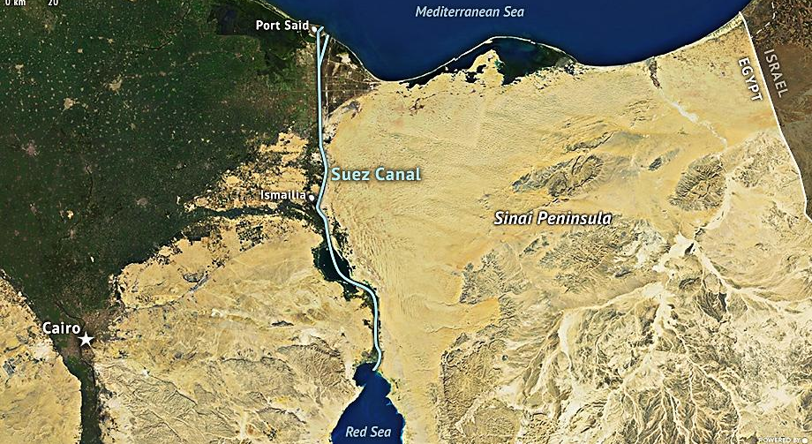

These oil tankers were named Murex, Conch and Clam, and each one had a capacity of 5,010 long tons of deadweight. Thereafter, the Murex was the first bulk-oil tanker to pass through the Suez Canal in route to Thailand in on August 24, 1892, for Marcus Samuel & Company, which allowed ship-ping products to Bangkok and Singapore. What began as a sideline business soon became so profitable that, on October 1897, they created a new company, named after their father's best trade: The "Shell" Transport and Trading Company, shipping oil and goods worldwide, exporting to Europe and North America.

In 1886, the Glückauf was a German ship that represented a major step forward in oil tanker design. The ship was built in Britain and purchased by Wilhelm Anton Riedemann, a shipping firm in Gees-temünde, and an agent for the Standard Oil Company, along with several other sister ships. The oil tanker was on a charter voyage for the Standard Oil Company when it wrecked in Sayville, New York along Long Island. Differing sources give the date of the wreck as March 23, 24, or 25, in 1892 or 1893. On April, it was briefly dislodged and was being pulled out to sea, where the ship ran permanently aground, and became a tourist attraction.

In 1907, the Marcus Samuel & Company merged with the Royal Dutch company of the Netherlands to create the company today known as, Royal Dutch Shell, as the company had 34 steam-driven oil tankers, compared to Standard Oil's four case-oil steamers and 16 sailing tankers. In 1916, the famous oil tanker Murex was torpedoed, by the German submarine U-73, and was sunk with the loss of one man. After the World War I, the French Commissioner General for Petroleum, Henri Bérenger, said that without Shell, “the war could not possibly have been won by the Allies”.

In 1921, Marcus retired and became Baron Bearsted, taking his name from the village near his mansion in Kent, as his most important Royal Dutch partner Henri W. A. Deterding was knighted. From 1921 the second in Shell Transport was Marcus's elder son, Walter Samuel. In 1925 Marcus was advanced another rank in the British peerage, becoming Viscount Bearsted. Naturally he was also very proud of the business he had created, and by the time of his death, The "Shell" Transport and Trading Company had become, in its alliance with Royal Dutch, the biggest oil enterprise in the world. He died on 17 January 1927, at the age of 73, less than 24 hours after his wife.

An FPSO (Floating Production, Storage and Offloading) vessel is mainly designed to receive hydrocarbons from nearby platforms or subsea templates, process them, and store oil until it can be offloaded onto a tanker or, less frequently, transported through a pipeline. FPSOs are preferred in frontier offshore regions as they are easy to install, and do not require a local pipeline infrastructure to export oil. FPSOs can be a conversion of an oil tanker or can be a vessel built specially for the application. A vessel used only to store oil (without processing it) is referred to as an FSO (Floating Storage and Offloading) vessel.

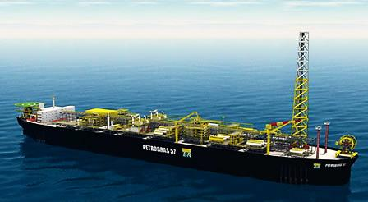

The first constructed oil FPSO was the “Shell Castellon”, built in Spain in 1977. Floating production, storage and offloading vessels are particularly effective in remote or deepwater locations where seabed pipelines are not cost effective. FPSOs eliminate the need to lay expensive long-distance pipelines from the processing facility to an onshore terminal. This can provide an economically attractive solution for smaller oil fields which can be exhausted in a few years and do not justify the expense of installing a pipeline. Furthermore, once the field is depleted, the FPSO can be moved to a new location.

- TRANSPORTATION & STORAGE NOWADAYS:

One of the advantages of oil and gas as energy sources is the variety of ways that can be transported, from the wells to refineries, from refineries to terminals or bulk plants and eventually to end users. At the same time, a highest demand for petroleum-based products has grown in every corner of the world, and transportation therefore became vital to ensuring the reliable and affordable flow of petroleum and gas. Then, depending on the distances involved, the location of the facilities and the amount of oil to be transported, crude oil and refined products can be transported by tanker, barge, pipeline, and tank truck or railroad tank cars.

Transportation infrastructure also refers to the physical assets starting at the production wellhead necessary to transport and convert produced hydrocarbons into both semi-finished and finished products and deliver those products to market. In conventional oil and gas vernacular these assets are typically classified as “Midstream” and “Downstream” that cover the following three distinct hydrocarbon value segments; natural gas, natural gas liquids (NGL), and crude oil. The common asset sectors across these three hydrocarbon segments, includes the following:

Oil Tankers: The classes of marine vessels covered include tankers, oceangoing barges, and inland transport barges, and includes direct capital investment in both new build vessels required to transport incremental production and specially designed marine loading and unloading facilities. Today's cutting-edge tankers are the product of a commitment to safety combined with the power of computer-assisted design. The growth in capital investment is particularly strong for dedicated NGL export facilities and liquefied natural gas (LNG) bunkering facilities mainly to support marine vessels re-fuelling. As a result, the new ships traveling the seas are stronger, more maneuverable, and more durable than their predecessors.

Pipelines: Oil and natural gas pipelines, are the primary means of moving petroleum products to consumer markets. Pipelines are safe, efficient and, because most are buried, largely unseen. The Pipeline Performance Tracking System, PPTS, is a key component of the oil pipeline industry's Environmental and Safety Initiative, a multi-discipline approach to understanding and improving industry performance. This process includes the pipelines systems, associated pumping and compression facilities, and also the supporting assets necessary to stabilize, monitor, and perform the bulk separation from produced hydrocarbons.

Rail Transportation: Railroad infrastructure supports the transportation needs of industries, such as oil and gas, manufacturing products and agriculture. Thus, railroads are safe and efficient means of transporting crude oil and other petroleum products, including direct capital investment in loading and unloading facilities, additional railroad tank cars used in the transportation of increased liquids production, and direct investment in railroad tracks to establish new routes or enhance existing lines associated with delivering increased volumes of hydrocarbon liquids.

Terminals: Water-and land-based terminals generally receive refined petroleum products by pipeline, railroads, tanker or barge. In more remote areas of the state, terminals may be served by railroad tank cars or truck transports directly from refineries. The main function of terminals in the distribution chain is to provide temporary storage for refined products for eventual redistribution to smaller bulk plants closer to end users and to directly supply large commercial accounts.

A terminal facility will usually store a variety of refined products; gasoline, heating oil, kerosene, diesel, etc. Terminals are vital parts of the petroleum distribution network, as these facilities constitute the chief secondary storage for refined products in a given market area. The storage capacities of terminals vary considerably depending on the market and the terminal's distance from a long chain refinery. Terminals may be operated by integrated oil companies, refiners, independent terminal operators, and local distributors.

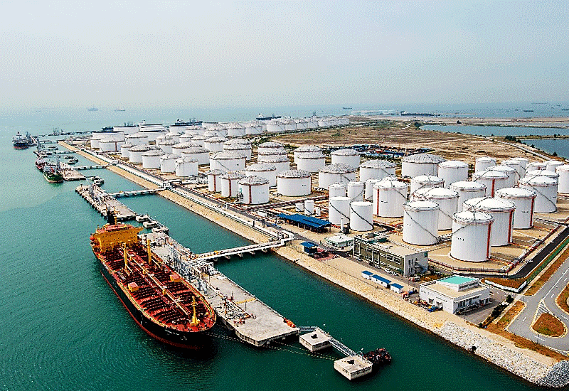

Bulk Plants: Terminal bulk plants are designed for shipment of products between vehicles or types of vehicles (from oceangoing tankers and barges to river vessels or from railroad routes to individual tanks. Smaller than marine or land terminals, bulk plants receive their shipments of refined products by truck transport or rail, either directly from refineries or from terminals. Refinery bulk plants may be of the raw-material type (receipt, storage, and preparation for refining). Distribution bulk plants supply petroleum products directly to enterprises and also ship them in small containers.

Oil bulk plant facilities generally consist of multiple large oil storage tanks. A variety of oil blends are stored at these facilities for the purpose of resale and delivery to retail gas stations, fleet fueling faci-lities or commercial and residential sites that use heating oil. Frequently referred to as distributors or wholesalers, can be independent marketers who own and operate bulk plants and may also conduct service stations and/or home heating oil businesses, redistribute the products in smaller tank trucks to commercial accounts, homeowners, farms and gasoline service stations.

Processing & Storage: Is typically referred to as the “downstream” sector of the petroleum industry, and includes those facilities involved in the physical storage of hydrocarbons, which refers to refineries groups whose function is to process, separate, or liquefy raw hydrocarbons into higher value intermediates and finished products. These facilities include raw or rich natural gas processing plants, natural gas liquefaction facilities (or LNG export facilities), NGL fractionators, and crude oil refinery investments. Not included in this processing and storage sector are the secondary proces-sing facilities, such as petrochemical, fertilizer plants, and gas-to-liquids (GTL) investments.

Offshore Oil & Gas Processes: An FPSO (Floating Production, Storage and Offloading) unit is a floating vessel used by the offshore oil and gas industry for the production and processing of hydrocarbons, and for the storage of oil. An FPSO vessel is generally designed to produce by itself or receive hydrocarbons produced from nearby platforms or subsea templates, process them, and store oil until it can be offloaded onto a tanker or, less frequently, transported through a pipeline. The FSO (Floating Storage and Offloading Unit) is essentially a simplified FPSO without the capability for oil or gas processing. The first FSO in the Gulf of Mexico, the Ta'Kuntah, has been in operation since August 1998, and most FSOs are converted single hull supertankers.

FSRUs (Floating Storage and Regasification Units) are special types of ships generally used for LNG transfer, capable of transporting, storing and regasifying LNG onboard. The floating regasification also requires an offshore terminal, which typically includes a buoy and connecting undersea pipelines to transport the regasified LNG to shore, or an onshore dockside receiving terminal. An FSRU can be purpose-built or be converted from a conventional LNG vessel, and an FSRU can be deployed elsewhere once construction is completed. The global market for floating liquefied natural gas (FLNG) can be divided into two distinct areas: the LNG FPSOs (Liquefied Natural Gas Floating Production Storage and Offloading Vessel) and FSRUs (Floating Storage and Regasification Units).

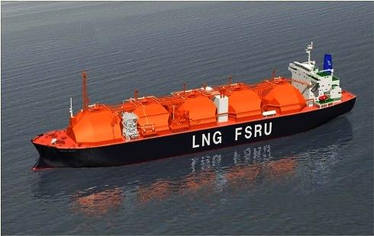

The Supertankers: Until 1956, tankers were designed to be able to navigate the Suez Canal. This same year, the ship size restriction became much less of a priority after the closing of the canal during the Suez Crisis. Forced to contour the African continent around the Cape of Good Hope, ship-owners realized that bigger oil tankers were the key to more efficient transport. Hostilities in the Mid-dle East interrupted the traffic through the Suez Canal, then, there was a fierce competition among the ship-owners, and apart from these considerations, the competition was a simple economic advantage, that is; the larger an oil tanker is, the more cheaply becomes the transportation, and better it helped to meet the growing demands for oil.

Before the World War II, a typical T2 tanker had 532 feet (162 m) long, with a capacity of 16,500 DWT, the ULCCs (Ultra-Large Crude Carriers) built in the 1970s were over 1,300 feet (400 m) long and had a capacity of 500,000 DWT. DWT (deadweight tonnage) is a measure of how much weight a ship is carrying or can safely carry, but does not include the weight of the ship. In 1958 the U.S. shipping magnate Daniel K. Ludwig broke the record of 100,000 long tons of heavy displacement with his Universe Apollo a 23% increase from the previous record-holder, Universe Leader which also belonged to Ludwig.

Supertankers (VLCC and ULCC): The "Supertankers" are the largest tankers today, including the VLCCs (Very Large Crude Carriers) and ULCCs (Ultra Large Crude Carriers), with capacities over 250,000 DWT. These ships can transport 2,000,000 barrels (320,000 m³) of oil. There are various different tanker sizes used for the international transportation of oil, since a modest coastal tanker to a VLCC or ULCC Supertanker. The common rule is the volume that can be carried in a tanker increases as a function of the cube of its length. For instance, a ULCC is about twice the length of a coastal tanker (415 meters versus 205 meters), but can carry about 8 times the volume, or 50,000 DWT (deadweight tons) versus 400,000 DWT. The main tanker classes are:

Class | Length | Beam | Draft | Overview
Coastal Tanker | 205 m  (672 ft) | 29 m  (95 ft) | 16 m  (52 ft) | Less than 50,000 DWT, mainly used for transportation of refined products (gasoline, gasoil).
Aframax | 245 m  (803 ft) | 34 m  (111 ft) | 20 m  (65 ft) | Approximately 80,000 DWT, which is the AFRA (A-verage Freight Rate Assessment) standard. This standard was established to standardize contract terms with well-defined ship capacity.
Suezmax | 285 m  (934 ft) | 45 m  (147 ft) | 23 m  (75 ft) | Between 125,000 and 180,000 DWT, originally the maximum capacity of the Suez Canal.
VLCC | 330 m  (1081 ft) | 55 m  (180 ft) | 28 m  (92 ft) | Very Large Crude Carrier. Up to around 320,000 DWT. Some can be accommodated by the expanded dimensions of the Suez Canal. The most common length is in the range of 300 to 330 meters.
ULCC | 415 m  (1360 ft) | 63 m  (206 ft) | 35 m  (114 ft) | Ultra Large Crude Carrier. Capacity exceeding 320,000 DWT. The largest tankers ever built have a deadweight of over 550,000 DWT.

The world's largest supertanker was built in 1979, by Sumitomo Heavy Industries, Ltd., at their Oppama shipyard in Yokosuka, Kanagawa, Japan as a 418,000 ton ULCC, as the Seawise Giant. This ship was built with a capacity of 564,763 DWT, a length overall of 458.45 meters (1,504.1 ft) and a draft of 24.611 m (80.74 ft) and had 46 tanks, 31,541 square meters (339,500 sq. ft) of deck, then, could not navigate the English Channel. It was last used as an FSO (Floating Storage and Offloading unit, moored off the coast of Qatar in the Persian Gulf at the Al-Shaheen Oil Field. Recently, the world's two largest working supertankers are the TI class supertankers TI Europe and TI Oceania, built in 2002 and 2003 for the Greek Hellespont Steamship Corporation. Hellespont sold these ships to Overseas Shipholding Group and Euronav, in 2004.

Chartering: Is the act of hiring a ship to carry a cargo. Tankers are hired by four types of charter a-greements; the voyage charter, the time charter, the bareboat charter, and a contract of affreightment. In a voyage charter the charterer rents the vessel from the loading port to the discharge port. In a time charter the vessel is hired for a set period of time, to perform voyages as the charterer directs. In a bareboat charter the charterer acts as the ship's operator and manager, taking on respon-sibilities such as providing the crew and maintaining the vessel. Finally, in a contract of affreightment or COA, the charterer specifies a total volume of cargo to be carried in a specific time period and in specific sizes, for example a COA could be specified as 1 million barrels (160,000 m3) of JP-5 in a year's time in 25,000-barrel (4,000 m3) shipments.

Load and Unload Operations: Cargo flows between a tanker and a shore station by way of marine loading arms attached at the tanker's cargo manifold. Oil is pumped on and off the ship by way of connections made at the cargo manifold. Operations aboard oil tankers are governed by an established body of best practices and a large body of international law. Cargo can be moved on or off of an oil tanker in several ways. One method is for the ship to moor alongside a pier, connect with cargo hoses or marine loading arms. Another method involves mooring to offshore buoys, such as a single point mooring, and making a cargo connection via underwater cargo hoses. A third method is by ship-to-ship transfer, also known as lightering. In this method, two ships come alongside in open sea and oil is transferred manifold to manifold via flexible hoses.

Lightering is sometimes used where a loaded tanker is too large to enter a specific port. Prior to any transfer of cargo, the chief officer must develop a transfer plan detailing specifics of the operation such as how much cargo will be moved, which tanks will be cleaned, and how the ship's ballasting will change. The next step before a transfer is the pretransfer conference. After the conference is complete, the person in charge on the ship and the person in charge of the shore installation go over a final inspection checklist. In the United States, the checklist is called a Declaration of Inspection or DOI. Outside the U.S., the document is called the "Ship/Shore Safety Checklist.

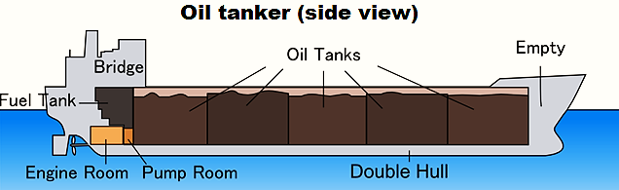

Loading an oil tanker consists primarily of pumping cargo into the ship's tanks. As oil enters the tank, the vapors inside the tank must be somehow expelled. Depending on local regulations, the vapors can be expelled into the atmosphere or discharged back to the pumping station by way of a vapor recovery line. It is also common for the ship to move water ballast during the loading of cargo to maintain proper trim. Loading starts slowly at a low pressure to ensure that equipment is working correctly and that connections are secure. Then a steady pressure is achieved and held until the "topping-off" phase when the tanks are nearly full.

Topping off is a very dangerous time in handling oil, and the procedure is handled particularly carefully. Tank-gauging equipment is used to tell the person in charge how much space is left in the tank, and all tankers have at least two independent methods for tank-gauging. As the tanker becomes full, crew members open and close valves to direct the flow of product and maintain close communication with the pumping facility to decrease and finally stop the flow of liquid. In loading, the transfer starts at low pressure to ensure that equipment is working correctly and that connections are secure. Then a steady pressure is achieved and held during the operation.

While pumping, tank levels are carefully watched and key locations, such as the connection at the cargo manifold and the ship's pump room are constantly monitored. The process of moving oil off of a tanker is similar to loading, but has some key differences. The first step in the operation is following the same pretransfer procedures as used in loading. When the transfer begins, it is the ship's cargo pumps that are used to move the product ashore. Under the direction of the person in charge, crew members open and close valves to direct the flow of product and maintain close communication with the receiving facility to decrease and finally stop the flow of liquid.

Inert Gas System: An oil tanker's inert gas system is one of the most important parts of its design. Fuel oil itself is very difficult to ignite, but its hydrocarbon vapors are explosive when mixed with air in certain concentrations. The purpose of the system is to create an atmosphere inside tanks in which the hydrocarbon oil vapors cannot burn. As inert gas is introduced into a mixture of hydrocarbon vapors and air, it increases the lower flammable limit or lowest concentration at which the vapors can be ignited. At the same time it decreases the upper flammable limit or highest concentration at which the vapors can be ignited.

When the total concentration of oxygen in the tank reaches about 11%, the upper and lower flammable limits converge and the flammable range disappears. Inert gas systems deliver air with an oxygen concentration of less than 5% by volume. As a tank is pumped out, it is filled with inert gas and kept in this safe state until the next cargo is loaded. The exception is in cases when the tank must be entered. Safely gas-freeing a tank is accomplished by purging hydrocarbon vapors with inert gas until the hydrocarbon concentration inside the tank is under about 1%. Thus, as air replaces the inert gas, the concentration cannot rise to the lower flammable limit and is safe.

Oil Pipelines: http://www.petrostrategies.org/images/pipes.JPGPipelines are the most efficient method to transport crude oil and refined products. Pipelines are used to move crude oil from the wellhead to gathering and processing facilities and from there to refineries and tanker loading facilities. Product pipelines ship gasoline, jet fuel, and diesel fuel from the refinery to local distribution facilities. Crude oil is collected from field gathering systems consisting of pipelines that move oil from the wellhead to storage tanks and treatment facilities where the oil is measured and tested. From the gathering system the crude oil is sent to a pump station where the oil delivered to the pipeline.

The pipeline may have many collection and delivery points along route. Booster pumps are located along the pipeline to maintain the pressure and keep the oil flowing. The delivery points may be refineries, where the oil is processed into products, or shipping terminals, where the oil is loaded onto tankers. A pipeline may handle several types of crude oil, and may schedule its operation to ensure that the right crude oil is sent to the correct destination. The pipeline operator sets the date and place when and where the oil is received and the when the oil will arrive at its destination. Crude oil may also move over more than one pipeline system as it journeys from the oil field to the refinery or shipping port. Storage is located along the pipeline to ensure smooth continuous pipeline operation. After crude oil is converted into refined products such as gasoline, pipelines are used to transport the products to terminals for movement to gasoline stations.

Pipelines are also used to transport diesel fuel, home heating fuel, kerosene, and jet fuel, and different types of products can be shipped in batches. Batching is used to move two or more different liquids through the same pipeline, mixed when different liquid products come into contact. This mixed stream may be sent to a refinery for re-refining, and sold as a lower valued product, such as a mixture of premium unleaded gasoline with regular unleaded gasoline, or sold as a mixture. Many fuels have standard product specifications that allow the company to ship gasoline over the line, and not be concerned whether receives gasoline from that same batch, when it has the same quality. Individual additive packages are added at the distribution terminals.

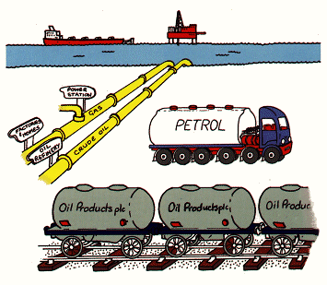

The first U.S. oil pipeline was constructed in 1865, when barrels were proved to be too leaky and expensive, then; producers began looking for other shipping methods and with pipelines revolutioni-zed the transportation of petroleum. The first project of a European pipeline was proposed in 1924, and in 1925, the Soviet Union held negotiations with French companies to set up a joint venture to construct and operate the Baku-Batum crude oil pipeline. The intention was to use the pipeline for oil export to Europe, mainly to France. The construction started in May 1928 and the pipeline was opened on 30 April 1930. It supplied mainly Batum's refinery.

The piping diameter must be large enough to allow the maximum volume to pass with the minimal resistance for optimal efficiency. The velocity must also be kept high enough to keep the pipe free of corrosion or debris that can plug the pipe. The pipes are usually made of high-quality carbon steel that is produced to specific standards, tested and quality checked from its raw steel state to the finished product. Generally, the pipes or joints are manufactured in approximately 40-foot lengths. Pipes transporting certain types of fluids must contain special corrosion resistant alloys. Heavier (thicker) oil may need to be heated to keep it flowing easily. Depending on the distance the fluid needs to travel, the pipeline may need to be insulated or equipped with additional pumps or heating stations to keep the product flowing.

Technical surveys are conducted to gather data on the seafloor terrain, soil properties and environmental events such as currents and ice movements. In most environments, offshore pipelines can lie on the seafloor, protected by the water covering them. Even during hurricanes, pipelines see limited effects from the massive waves on the surface, though they must still be designed to withstand strong subsurface currents and tidal surges. In some areas, pipelines must be buried to protect them from near-shore wave forces, ship anchors and commercial fishing activities. In the Arctic, burial may be required in some areas because of ice and environmental conditions and surveys of the ocean bottom are conducted to identify those areas.

Pipeline Installation: Once manufactured, the pipe is coated to protect it from corrosion and may have special insulation applied before it is shipped to the installation site. Pipelines can be installed by a number of methods depending on the site conditions. Barges and other types of vessels are often used to construct and lay the pipelines. “Lay barges” are equipped like small factories to weld the pipes together and then lower them to the seabed one pipe or joint at a time as the vessel slowly moves ahead. It is critical that each weld be inspected using X-ray and/or ultrasonic techniques to ensure a proper weld and the integrity of the pipeline system.

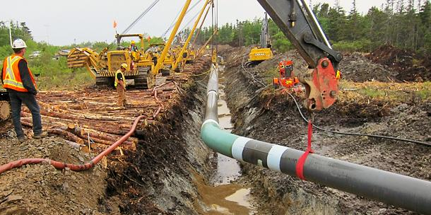

For burying pipelines, tractors and some specialized equipment are used to dig a trench, and then cover the pipeline. The trenches may be dug before the line is laid down or can be dug around a pipeline sitting on the seabed. The final phase of the pipeline installation is to conduct a hydrostatic test, and a check on its material integrity, while under pressure. For a hydro test, water is pumped into the pipeline and then pressurized to a minimum 1.25 times its design pressure for an extended period of time. Once the final testing is finished and has determined that the material used is sound, the water is removed and the pipeline is set for operation.

Pipeline systems are sometimes operated remotely from distant control centers. These centers use state-of-the-art control and communications systems to monitor and control every aspect of the pi-ping system, including starting and stopping pumps, opening and closing valves and monitoring flow rates, pressures and temperatures. Computers are also used to help monitor the systems and detect any early signs of abnormal conditions or events. If an irregularity is detected, support personnel are alerted to take appropriate action. The U.S. is the most fully developed petroleum transport nation, crude oil, natural gas, gasoline, and diesel and jet fuel in transit, mostly in pipelines.

Offshore Pipeline Installation: Pipelay ships or barges lay pipes using the S-lay method. The term S-lay refers to the shape that the piping forms between the vessel and the seabed when the pipeline is laid. The method is characterized by its fast installation process and its workability over a large range of water depths. On board the pipelay vessel, pipe joints are assembled in a horizontal working plane (the firing line). Pipe joints are welded together, inspected and then coated as they move through the various firing line work stations. As welding progresses, the pipeline is gradually lowered towards the seabed behind the vessel.

Reel barges contain a vertical or horizontal reel where the pipe is wrapped around. Reel barges are able to install flexible pipes with smaller diameter. Horizontal reel barges perform the S-lay installation while vertical reel barges can perform both S-lay and J-lay pipeline installation. During pipelay, the curvature of the upper section of the pipeline (the overbend) is controlled by the stinger, a steel structure with rollers protruding from the end of the firing line to prevent pipe buckling (failure). The curvature in the lower section (the sagbend) of the pipeline is controlled by pipe tensioners, caterpillar tracks that clamp the pipe. After a pipeline has been laid, and systems are tested and commissioned, the client can transport oil or gas through the laid pipeline.

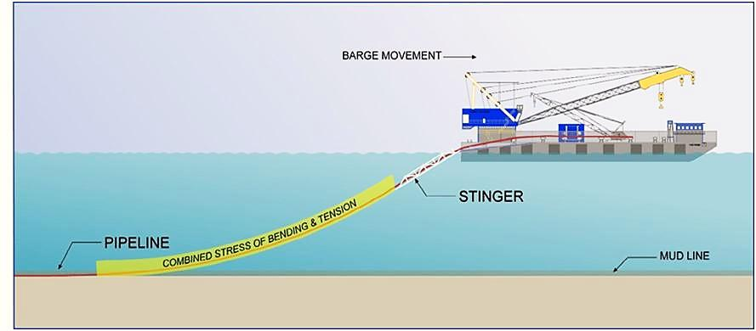

When using reel barges, the welding together of pipe sections is done onshore, reducing installation costs. Reeled pipe is lifted from the dock to the vessel, and the pipe is simply rolled out as installation is performed. There are three main types of pipelay vessels. There are J-lay and S-lay barges that include a welding station and lifting crane on board. The 40 or 80-foot (12 or 24-meter) pipe sections are welded away from wind and water, in an enclosed environment. On these types of vessels, the pipe is laid one section at a time, in an assembly-line method.

Cables and flexible pipelines, such as HDPE (high density polyethylene) or flexible types are usually much easier to install offshore than rigid pipelines. This is because the piping can often be deflected to the bottom of the trench before the pipeline (or cable) touches down and a suction device on the machine is not required, thus reducing the trenching power requirements and the pull force. Trenching for telecommunication cables is usually accomplished by simultaneous plowing and laying, and the cable catenary touches down just behind the plough. This method of trenching is very fast and is suitable for soft cohesive soils and sands with very flexible pipelines or small diameter cables.

Storage Facilities: http://www.petrostrategies.org/images/tank03.JPGCrude oil and refined products are stored in tanks according to API or ASME standards for shipment to other locations or processing into finished products. Generally, there are four basic types of tanks used to store petroleum products; floating roof tanks used for crude oil, gasoline, and naphtha, fixed roof tanks used for diesel, kerosene, catalytic cracker feedstock, and residual fuel oil, bullet tanks used for normal butane, propane, and propylene, and spherical tanks used for isobutane and normal butane. While the actual volume is important, a better index is the number of days of supply available. This number reflects the volume that can be supplied to run refineries (crude oil) or the volume of refined products that are available to meet a demand.

The floating roof tank is commonly an API standard storage tank, used to store large quantities of petroleum products, such as crude oil or condensates. It comprises an open- topped cylindrical steel shell equipped with a roof that floats on the surface of the stored liquid. The roof rises and falls with the liquid level in the tank. The roof has support legs hanging down into the liquid, usually retractable to increase the working volume of the tank. There is a rim seal system between the tank shell and roof to reduce rim evaporation. In principle, this eliminates breathing losses and greatly reduces the evaporative loss of the stored liquid.

The fixed roof tank, also commonly an API standard storage tank, consists of a cylindrical steel shell with a cone or dome-shaped roof that is permanently affixed to the tank shell. These tanks are usually fully welded and designed for both liquid and vapor tight. A breather valve (pressure-vacuum valve), is usually installed on fixed-roof tanks, which allows the tank to operate at a slight internal pressure or vacuum. This valve prevents the release of vapors during small changes in temperature, barometric pressure, or liquid level, and gas emissions.

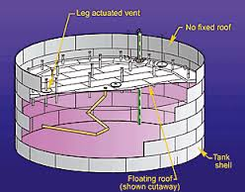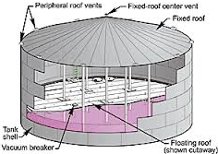
Floating roof tank Fixed roof tank

Horizontal bullet tanks are commonly used for bulk storage of liquefied petroleum gas (LPG), generally safer than other methods of storing the highly inflammable LPG. LPG bullets are horizontal cylindrical steel tanks with dished ends of size ranging between 3.5 to 8.5 diameter and lengths of 35 to 70 meters (115-230 ft) or more, which allow storage of large quantities of LPG. The term “bullet” was given as these tanks were having semi-spherical ends and looked like bullets, and should be designed according to ASME Section VIII Div 1 or 2 design codes. Each welded joint of the LPG tank is radiographed to detect any welding flaw.

Horizontal tanks are constructed the way that the length of the tank is not greater than six times the diameter to ensure structural integrity. Horizontal tanks are usually equipped with pressure-vacuum vents, gauge hatches and sample wells, and manholes to provide accessibility. LNG storage tanks can be found in ground, above ground or in LNG carriers, and the common characteristic of the bullet tanks, is the ability to store LNG at a very low temperature -162°C, where vapors are released, to avoid rising of the pressure and temperature within the tank. Since LNG is a cryogen, the product is kept in its liquid state at very low temperatures.

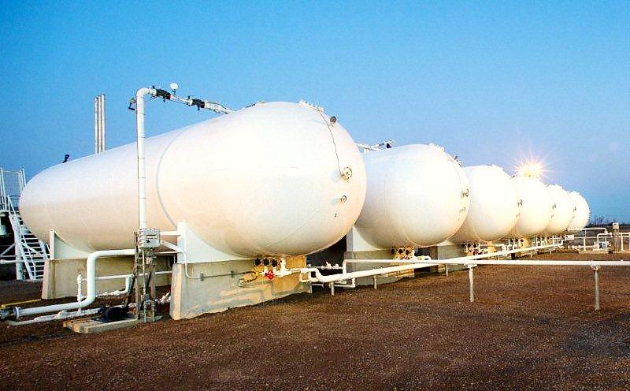

Spherical tanks are storage vessels in format of a sphere, which is a very strong structure, usually preferred for storage of high pressure fluids. The even distribution of stresses on the sphere's surfaces, both internally and externally, generally means that there are no weak points in its construction. However, sphere tanks are much more costly to manufacture than cylindrical, rectangular or horizontal vessels. The storage spheres also need ancillary equipment, similar to tank storage, such as, access manholes, safety valves, access ladders, earthing points, breather valves, etc.
An advantage of spherical storage vessels is that these storage tanks have a smaller surface area per unit volume than any other shape of vessel. This means, that the quantity of heat transferred from warmer surroundings to the liquid in the sphere, will be less than that for cylindrical or rectangular storage vessels. The stresses in a sphere are equal in each of the major axes, ignoring the effects of supports. In terms of weight, the proportions are similar. When compared with a cylindrical vessel, for a given volume, a sphere would weigh approximately only half as much. Thus, gases at normal atmospheric temperatures and pressures, such as butadiene, butane, and many other petrochemical products are stored most economically in spherical pressure tanks.

The other model of spherical storage tank is the double shell spherical tank, where the inner tank is designed with a lesser diameter in relation with the outer one, and the wall thickness may be the sa-me to support a temperature up to -200º C. The most important feature is the double layer, which means there is a carbon-steel sphere outside the stainless-steel inner tank. The space between the two tanks is filled with pearlite for heat insulation.

This type of sphere is commonly used to store liquefied gas such as ethylene, oxygen, nitrogen, etc. at cryogenic temperatures. The major function of this sphere is that, in case of small utilization volume, the natural gas can be put into liquidation for reservation. In case of large utilization volume, the gas can be transformed into gaseous state and delivered into the gas supply network, which could meet the energy demand of the city.

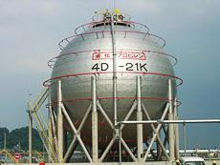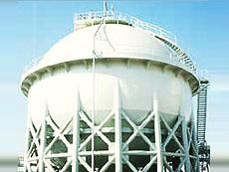
Spherical tank Double shell spherical tank

- OIL & GAS REFINING PROCESSES:

Petroleum refining is the process of separating the many compounds present in crude petroleum. These processes is called fractional distillation where the crude oil is heated, as several of the compounds boil at different temperatures and change to gases; and are later re-condensed back into liquids. The oil refining process starts with a fractional distillation column. The problem with crude oil is that it contains hundreds of different types of hydrocarbons all mixed together. You have to separate the different types of hydrocarbons to have anything useful. There are complex ways to separate these raw-materials, and this is what oil refining is all about.

An oil refinery or petroleum refinery is an industrial process plant where crude oil is processed and refined into more useful products, such as, petroleum naphtha, gasoline, diesel fuel, asphalt base, heating oil, kerosene and liquefied petroleum gas. In many ways, oil refineries can be defined as types of chemical plants, sometimes also designated as petrochemical plants. Different boiling circumstances allow the hydrocarbons to be separated by distillation. Since the lighter liquid products are in great demand for use in internal combustion engines, a modern refinery can also convert heavy hydrocarbons and lighter gaseous elements, into these higher value products.

Oil can be used in a variety of ways because it contains hydrocarbons of varying molecular masses, forms and lengths such as paraffins, aromatics, naphthenes (or cycloalkanes), alkenes, dienes, and alkynes. While the molecules in crude oil include different atoms, such as, sulfur and nitrogen, the hydrocarbons are the most common form of molecules of varying lengths and complexity, made of hydrogen and carbon atoms, and a small number of oxygen atoms. The differences in the structure of these molecules account for their varying physical and chemical properties, and this variety makes crude oil useful in a broad range of several applications.

Crude Oil: Crude oil is the term for "unprocessed" oil, the stuff that comes out of the ground. It is also known as petroleum. Crude oil is a fossil fuel, meaning that it was made naturally from decaying plants and animals living in ancient seas millions of years ago, most places you can find crude oil were once sea beds. Crude oils vary in color, from clear to tar-black, and in viscosity, from water to almost solid. Crude oils are such a useful starting point for so many different substances because they contain hydrocarbons. Hydrocarbons are molecules that contain hydrogen and carbon and come in various lengths and structures, from straight chains to branching chains and rings.

Crude oil, also called petroleum, is a complex mixture of carbon and hydrogen (hydrocarbons), which exist as a liquid in the earth's crust. Crude oil has many compositions; some is black, thick and tar like, while other crude oils are lighter in color and thinner. The carbon and hydrogen in crude oil are defined to have originated from the remains of microscopic marine organisms that were deposited at the bottom of seas and oceans, and were transformed at high temperature and pressure into crude oil and natural gas.

This oil and gas migrates upward through the porous rock, as it is less dense than the water which fills the pores. The oil and gas is trapped by a layer of impermeable rock through which they can't flow. Several different types of oil and gas "traps" exist; a common dome formed by folded sedimentary rocks. Crude oil is obtained by drilling a hole into the reservoir rock (sandstone, limestone etc.) and pumping it out. (See Oil & Gas Drilling). On average, crude oils are made of the following elements or compounds:

- Carbon - 84%;
- Hydrogen - 14%;
- Sulfur - 1 to 3% (hydrogen sulfide, sulfides, disulfides, elemental sulfur);
- Nitrogen - less than 1% (basic compounds with amine groups);
- Oxygen - less than 1% (found in organic compounds such as carbon dioxide, phenols, ketones, carboxylic acids);
- Metals - less than 1% (nickel, iron, vanadium, copper, arsenic);
- Salts - less than 1% (sodium chloride, magnesium chloride, calcium chloride);

Crude oil is generally described as heavy or light according to its API Gravity. The API Gravity index is a relative measure of weight, and the lower the number, the heavier is the crude; the higher the number, the lighter is the crude oil. While there are no exacting definitions for these types of crudes, a general rule of thumb is; heavy crude is less than 30°API, while light crude is greater than 30°API.
If the crude contains a sizable amount of sulfur or sulfur compounds, it is called sour crude; if it has little to no sulfur, it is sweet crude. Sour crude may contain 1%–5% sulfur content, while sweet crudes may have less than 1% sulfur content. Many products derived from crude oil like gasoline, diesel fuel, paraffin wax and so on, can take on many different forms.

Refining Process: The refining process begins with crude oil. Crude oil is unrefined liquid petroleum, which ranges in color from yellow to black, and may have a paraffin, asphalt or mixed base. Crude oil is composed of thousands of different chemical compounds called hydrocarbons, all with different boiling points. For example, a typical crude oil may begin to boil at 104° F to produce petroleum gas used for heating and making plastics, and finish boiling at greater than 1112° F to produce residuals such as petroleum coke, asphalt and tar.

Although all fractions of petroleum find uses, the greatest demand is for gasoline. Petrol or gasoline may be done by cracking, which is, breaking down large molecules of heavy heating oil and residuals by reforming, changing molecular structures of low quality gasoline molecules, and isomerization, rearranging the atoms in a molecule, so that the product has the same chemical formula, but has a different structure, such as converting normal butane to isobutene. Generally, refineries only consist of crude processes, vacuum, reforming, and some hydro-treating capacity, but the next level of complexity adds the cat cracking and some additional hydro-treating.

Generally, the crude oil is heated and changed into a gas. The hot gases are passed into the bottom of a distillation column and become cooler, as they move up to the height of the column. As the gases cool below their boiling point are condensed into a liquid. The liquids are then, drawn-off the distilling column at specific heights, ranging from heavy residuals at the bottom, raw diesel fuels in the mid-sections, and raw gasoline at the top. These raw fractions are then processed further to make several different finished products. The complexity of processes and diversity of products of a complete refinery is shown below:

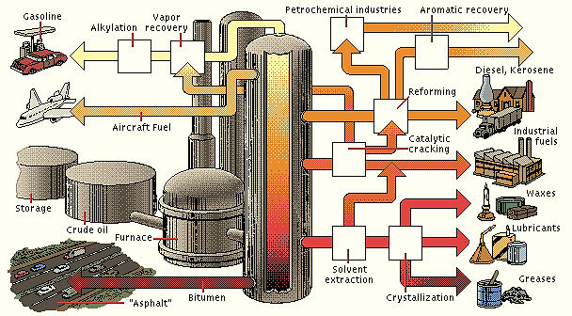

Oil refineries are large scale plants, processing about a hundred thousand to several hundred thousand barrels of crude oil by day. Because of the high capacity, many of the units operate continuously, as opposed to processing in batches. Intermediate products such as, gas oils can even be reprocessed to break a heavy, long-chained oil into a lighter short-chained one, by various forms of cracking, as the fluid catalytic cracking, thermal cracking, and hydrocracking. The final step for gasoline production is the blending of fuels with different octane ratings, vapor pressures, and other properties, to meet higher or lower product specifications.

Although all fractions of petroleum may be converted to gas products, the greatest demand is for gasoline. One barrel of crude petroleum contains only 25-35% gasoline. This is done by the “cra-cking" process, which is, breaking down large molecules of heavy heating oil, or by the "reforming" process, changing molecular structures of low quality gasoline molecules, and the "polymerization" process, forming longer molecules from smaller ones. The most complex refineries add coking, more hydro-treating, hydrocracking, and can separate crude oil into more components used for a variety of purposes, from high-performance fuels to plastics.

For example if decane is heated to about 500º C (932º F) the covalent carbon-carbon bonds begin to break during the cracking process. Decane is an alkane hydrocarbon (C10H22) with 75 structu-ral isomers, which are flammable liquids and components of the gasoline. Many kinds of compounds including alkenes are made during the cracking process. Alkenes are classes of hydrocarbons that contain only carbon and hydrogens, and are unsaturated compounds that contain at least, one carbon-to-carbon double bond. Another term that is often used to describe alkenes is alpha-olefins.

Ron (Research Octane Number), octane rating or octane number is a standard measure of the performance of an engine or aviation fuel. The higher the octane number, the more compression the fuel can withstand before detonating (igniting). In broad terms, fuels with a higher octane rating are used in high performance gasoline engines that require higher compression ratios. In contrast, fuels with lower octane numbers (but higher cetane numbers) are ideal for diesel engines, because diesel engines (also referred to as compression-ignition engines) do not compress the fuel, but compress only air and then inject the fuel into the air, heated up by compression.

Gasoline is motor fuel liquid mix of alkanes and cycloalkanes (5 to 12 carbon atoms) with a boiling range of 104º F to 401º F (40º C to 205º C). Naphtha or Ligroin is an intermediate that will be further processed to make gasoline mix (5 to 9 carbon atoms) with a boiling range of 140º F to 212º F (60º C to 100º C). Kerosene is fuel for jet engines of alkanes (10 to 18 carbon atoms) with a boiling ran-ge of 350º F to 617º F (175º C to 325º C). Gasoil or diesel distillate is used for diesel fuel and heating oil, (12 or more carbon atoms) with a boiling range of 482º F to 662º F (250º C to 350º C.

Heavy gas or fuel oil is used for industrial fuel, (20 to 70 carbon atoms) are alkanes, cycloalkanes, aromatics with a boiling range of 700º F to 1112º F (370º C to 600º C). Lubricating oil is used for motor oil, grease, and other lubricants liquid with long chains (20 to 50 carbon atoms), are also alkanes, cycloalkanes, aromatics with a boiling range of 572º F to 700º F (300º C to 370º C). Coke, asphalt, tar, waxes are solid multiple-ringed compounds have 70 or more carbon atoms, with a boiling range greater than 1112º F (600º C). All these products have different sizes and boiling ranges.
Chemical Processing: Are newer techniques used on some of the fractions to make other produ-cts, in a process called conversion (molecules rearranging). The chemical processing can break longer chains into shorter ones, and allows a refinery to turn diesel fuel into gasoline, depending on the demand for gasoline. The oldest and most common way, to separate crude oil into various components (fractions), is using the differences in boiling temperatures. This process is called fractional distillation. Basically the crude oil is heated up, vaporized and then the vapor is condensed.

Refining Process Definitions: Refineries combine the various fractions (processed, unprocessed) into mixtures to make desired products. For example, different mixtures can create gasoline with different octane ratings. The main units and processes found in a refinery are:

- Coker Unit: Installation that processes vacuum residuals heated to over 900° F and put into coke drums, where it undergoes thermal cracking, as the oil decomposes under the extreme heat. Products include butane and lighter material, naphtha for reforming, turbine and diesel fuel, gas oil for cat cracking, and fuel grade petroleum coke.
- Reformer Unit: Equipment using heat, catalyst and moderate pressure, the reformer unit changes the molecular structure of the oil crude and coker naphthenes to produce a high octane primary gasoline blend stock called reformate.
- Alkylation Unit: Is complex equipment that use acid and catalyst to combine small molecules into larger ones collectively called alkylates, which have a high octane, and the cleanest burning of the gasoline blend stocks.
- Fluid Catalytic Cracking Unit: Is a complex installation that uses heat and a catalyst to bre-ak or “crack” the gas oil molecules into a range of smaller ones, specifically gasoline, low quality diesel stocks, and a residual oil called slurry (industrial fuel oil).
- Desulfurization Unit: Is a complex equipment used to remove sulfur from petroleum oil.
- Hydrotreating Unit: Removes impurities by using hydrogen to bind with sulfur and nitrogen.
- Hydrocracking Unit: Breaks or “cracks” the diesel stocks into gasoline blending stocks, using heat, catalyst and hydrogen under very high pressure.
- Isomerization Unit: Rearranges the atoms in a molecule, so that products have the same chemical formula with a different structure, such as converting normal butane to isobutane.

Fractional Distillation: Distillation is defined as, “a process in which a liquid or vapour mixture of two or more substances is separated into many component fractions of desired purity, by the application or removal of heat”. Due different boiling temperatures, different sizes, and weights crude oil components can be separated by a complex process called fractional distillation. Thus, the fractional distillation is also a technique for separating a mixture of substances with narrow differences in boiling points, and is the most important step in the crude oil refining process.

Distillation columns are designed to achieve this separation efficiently. Distillation is based on the fact that the vapour of a boiling mixture may be richer in the components that have lower boiling points. Therefore, when this vapor is cooled and condensed, the condensate will contain more volatile components. Distillation is the most common separation technique, both in terms of cooling and heating requirements. The steps of fractional distillation are as follows:

- The mixtures of two or more substances are heated up with different boiling points to a high temperature. Heating is usually done with high pressure steam, generated from a boiler, rea-ching temperatures of about 1112º F (600º C).
- The mixture boils, forming vapor (gases); most substances go into the vapor phase.
- The vapor enters the bottom of a long column (fractional distillation column), filled with trays or plates. The trays have many holes or bubble caps, to allow the vapor to pass through. This system increases the contact time between the vapor and the liquids in the column, and help to collect all liquids that form at various heights in the column. There is a temperature difference across the column (hot at the bottom, cool at the top). The vapor rises in the column. As the vapor rises through the trays in the column, it consequently cools.
- When a substance in the vapor reaches a height where the temperature of the column is equal to that substance's boiling point, it will condense to form a liquid. That is, the substance with the lowest boiling point will condense at the highest point in the column, and the substances with higher boiling points will condense at the lower in the column.
- The trays collect the various liquid fractions. The collected liquid fractions pass to condensers, and when further cooled, go to storage tanks, or may go to other areas for further chemical processing.

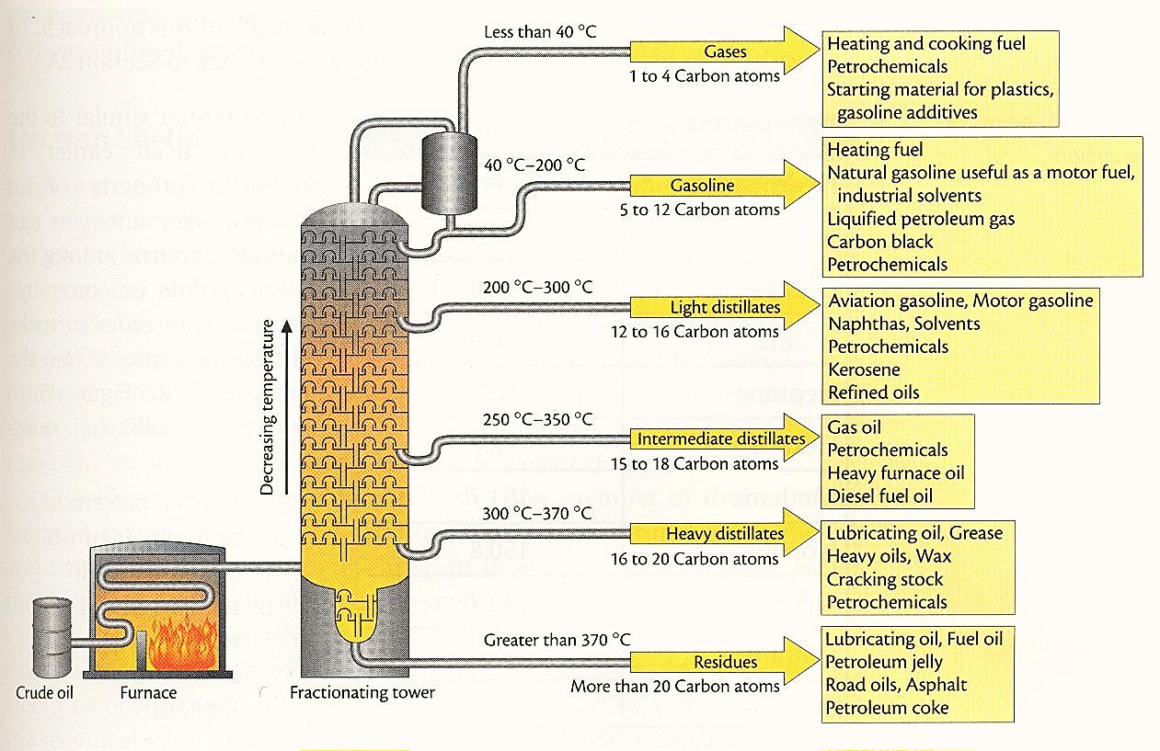

Fractional distillation, also known as refinery distillation is performed in very large and vertical columns or towers with the diameter of around 8 meters (26 ft) and the height of fractional between 10 m (33 ft) to 70 m (230 ft), depending upon the requirements of crude oil to be taken in the column. Oil contains a complex mixture of hydrocarbons. The first step in obtaining something of value is to desalt and dewater the hydrocarbons. Then, the oil is heated and sent into a huge distillation colu-mn, operating at atmospheric pressure. Heat is added at the reboiler, and removed at the condenser, thereby separating the oil into fractions based upon boiling points. A typical atmospheric column can separate about 4,000 cubic meters (25,000 barrels) of oil per day.

The bottom fraction is sent to another column operating at a pressure of about 75 mm Hg (one tenth of the atmospheric pressure). This column can separate the heaviest fraction without thermally degrading (cracking) it. Where atmospheric columns are thin and tall, vacuum columns are thick and short, to minimize pressure fluctuations along the column. The mixture of substances used in the column is directly proportional with the temperature, in a way that the low boiling point liquids are on the top side of the column and extracted from the top, and the liquids with high boiling point remain in the lower side of the column and extracted from the bottom side of the distillation column.

Then, fractional distillation is the separation of a mixture into its component parts (“fractions”) by heating them to a temperature at which several components evaporate. As the temperature of crude oil increases, different hydrocarbons are separated. Those with the lowest boiling points evaporate first and those with the highest boiling points, last. A condenser is used to condense and capture each evaporated component. A laboratory distillation process, can be seen below:

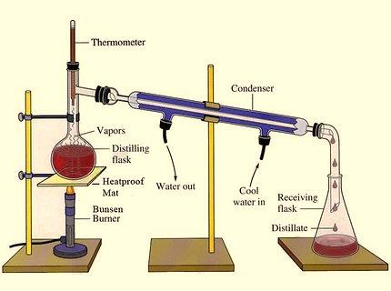

Boiling Point Principle: Generally, a liquid boils when its vapor pressure is equal to the atmospheric pressure. Vapor pressure is caused by an equilibrium between molecules in the gaseous state and molecules in the liquid state. Molecules with the most independence in individual motions achieve sufficient kinetic energy (velocities) to escape at lower temperatures. The vapor pressure will be higher and therefore the compound will boil at a lower temperature. The lighter substances that rise in the column have less carbon atoms, as the carbon chain is not too much long, with less molecular mass and less viscosity, then also having low ignition temperature.

Molecules which strongly interact or bond with each other through a variety of intermolecular forces cannot move easily or rapidly and therefore, do not achieve the kinetic energy necessary to escape the liquid state. Therefore, molecules with strong intermolecular forces will have higher boiling points. This is a consequence of the increased kinetic energy, which is necessary to break the intermolecular bonds so that individual molecules may escape the liquid as gases. The boiling points of organic compounds can give important clues to other physical properties.

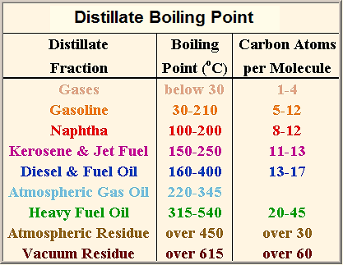

Vapor pressure is determined by the kinetic energy of molecules. Kinetic energy is related to temperature and the mass and velocity of the molecules. When the temperature reaches the boiling point, the average kinetic energy of the liquid particles is sufficient to overcome the forces of attraction that hold molecules in the liquid state. Then, these molecules break away from the liquid forming the gas state. When molecules in the liquid state have sufficient kinetic energy, they may escape from the surface and turn into a gas.
The Boiling Point is a rough measure of the amount of energy necessary to separate a liquid molecule from its nearest neighbors. The molecular weight and chain length trends in Boiling Points. A series of alkanes demonstrates, in a general principle, that their boiling points increase, as molecular weights or chain lengths increase. The table below shows the “Boiling Points of Alkanes”:

Formula | Designation | Boiling Point  (ºC - ºF) | Room Temperature  +20º C (68º F)
CH4 | Methane | -161º C (-258º F) | gas
CH3CH3 | Ethane | - 89º C (-128º F)
CH3CH2CH3 | Propane | - 42º C (-43º F)
CH3CH2CH2CH3 | Butane | -0.5º C (-31º F)
CH3CH2CH2CH2CH3 | Pentane | + 36º C (97º F) | liquid
CH3(CH2)6CH3 | Octane | +125º C (257º F)

Obs.: It can be noted that when the boiling point is below 20º C (68º F), the liquid has already boiled and the compound is a gas. The reason that longer chain molecules have higher boiling points is that longer chain molecules become wrapped around and enmeshed in each other much like the strands of spaghetti. More energy is needed to separate them than short molecules, which have only weak forces of attraction for each other.

Note: The suffix –“ane” is alkane and contains only carbon-carbon single bonds. The suffix –“ene” is alkene and contains at least one C=C. The suffix –“yne” is alkyne and contains at least one C=C. The difference between alkanes and alkenes is that alkanes are saturated, and have only single bonds. Alkenes are unsaturated, and have double bonds. Alkenes react with brown bromine water and decolorize it, but alkanes do not. Alkenes can also act as monomers, and under high pressure in the presence of a catalyst monomer, molecules join together to make polymer molecules.

Hydrocarbons are compounds made from carbon and hydrogen atoms joined by covalent bonds. For example, if pentane is heated to about 500º C (932º F) the covalent carbon-carbon bonds begin to break during the cracking process. Many kinds of compounds including alkenes are made during the cracking process. Alkenes are formed because there are not enough hydrogens to saturate all bonding positions after the carbon-carbon bonds are broken. The number of hydrogen atoms in an alkene is double the number of carbon atoms. For example, ethene is (C2H4), propene is C3H6 and butene is C4H8.

Monomers and Polymers: Polymers, simply known as common plastics, are very large molecules made from many smaller molecules called monomers. Alkenes are able to act as monomers due to contain a double bond. Alkenes can join end-to-end in a reaction called addition polymerization. The polymers they form are called addition polymers. In general, a lot of monomers form a polymer molecule, for example, Ethene → polyethene; Propene → polypropene; Chloroethene → polychloroethene, also called polyvinylchloride or PVC.

Vacuum Distillation Unit: In a fractionation tower the vapour flows upwards through trays perforations (the upward flow maintains a pressure drop between the bottom and top of the column). Heavy hydrocarbon residues are sent to a Vacuum Distillation Column for further separation of hydrocarbons under reduced pressure. Two different cuts of hydrocarbons, “light vacuum gas oil” and “heavy vacuum gas oil” are separated in the Vacuum Distillation Column at different stages, based on the difference between their boiling point ranges. The “light vacuum gas oil” is sent to a hydrotreating unit and then to the “catalytic cracking” installation to obtain smaller chain hydrocarbons.

The “heavy vacuum gas oil” is also sent for cracking using hydrogen in a “hydrocracking unit” to produce smaller chain hydrocarbons. Some heavy hydrocarbons cannot be boiled at the operating temperature and pressure conditions in the atmospheric distillation column, and even under reduced pressure remain at the bottom of the column and are pumped out as “vacuum residue”. These residues exit the bottom of the column in liquid state and sent to the Vacuum Distillation Column, and boiled at a lower temperature. This bottom residue can only be used for producing coke in a “coker unit” or to produce bitumen.

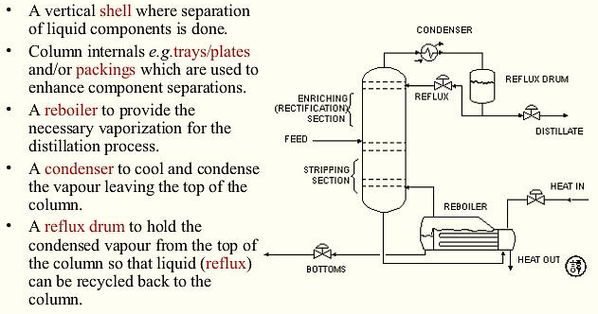

Trays and Plates: Trays are a series of plates arranged vertically up the column. Vapours condense on a tray when they reach the part of the column, which is cooler than their boiling point. The terms "trays" and "plates" are used interchangeably. The simplest tray is the sieve tray where vapour simply flows through holes in the plate. The most complicated designs are the valve and bubble caps, which have a wider operating range as they reduce leakage of liquid through the hole at low vapour flows. The spacing between trays is typically around 60 cm (~2.5 inches). Each tray has 2 conduits, one on each side, called “downcomers”.

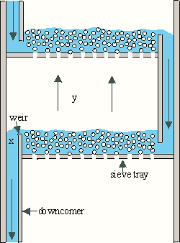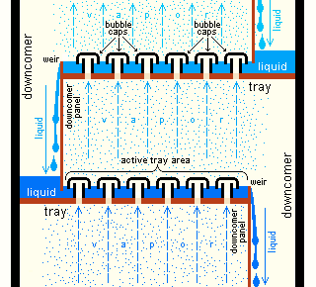

The liquid falls through the downcomers by gravity from one tray to the one below it. The flow across each plate is shown in the above diagram on the right above. The liquid flows along each plate, over a weir and then under gravity flows down a downcomer to the tray below. The height of the weir determines the quantity of liquid held on each tray. The downcomer is taken beneath the liquid surface on the tray below to create a vapour seal. The most common ones are:

Sieve Trays: Sieve trays are simply metal plates with holes, where vapour passes straight upward through the liquid on the plate. The arrangement, number and size of the holes on the sieve tray are design parameters.

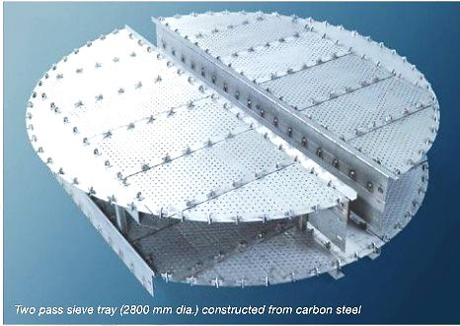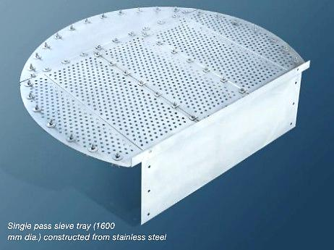

Bubble Cap Trays: Bubble cap trays have risers or chimneys over each hole, and a cap that covers the risers. The cap is mounted so that there is a space between the riser and cap to allow the passage of vapour. Vapour rises through the chimney and is directed downward by the cap, finally discharging through slots in the cap, and finally bubbling through the liquid on the tray. Vapour rises through the chimney and is directed downward by the cap, finally discharging through slots in the cap, and finally bubbling through the liquid on the tray.

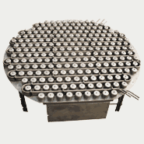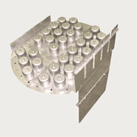

Valve Trays: Valve trays are perforated sheet metal decks on which round, liftable valves are mounted. The vapour flows through valves, installed parallel to the outlet weir. The lifting cap directs the vapour to flow horizontally into the liquid, thus providing better mixing, than in sieve trays. Due this efficiency, wide operating range, ease of maintenance and cost factors, sieve and valve trays have replaced the once high bubble cap trays in many applications.

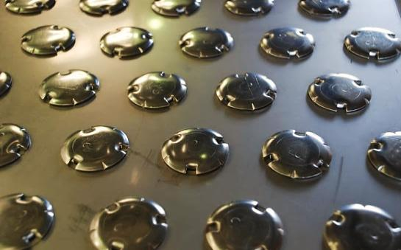

Because of its high cost and complexity, most modern column designs favor the use of sieve or valve trays over bubble-cap trays. Bubble-caps should only be used where very low vapour rates have to be handled, or adequate residence time is necessary for separation and/or chemical reaction, or in applications where a positive liquid seal is essential at all flow rates. Sieve trays have almost the opposite characteristics of the bubble-cap trays. With proper design, a sieve tray has low pressure drop, fairly good capacity and efficiency.

However, the down ratio of sieve trays, often does not meet the necessary flexibility demanded by an operating facility plant. The tray essentially acts as a mini-column, each accomplishing a fraction of the separation task. Each tray has 2 conduits, one on each side, called “downcomers”. The liquid falls through the downcomers by gravity from one tray to the other below it. The flow across each plate is shown in the above diagram on the right. The weir on the tray ensures that there is always some liquid (holdup) on the tray, designed such that the holdup is at a suitable height, in a way that the bubble caps are always covered by liquid.

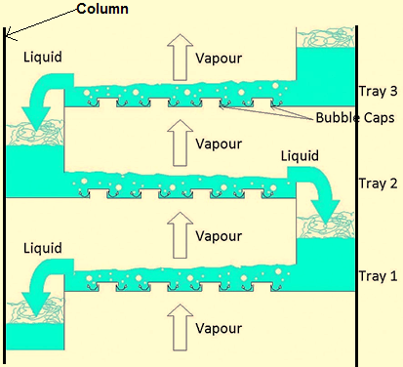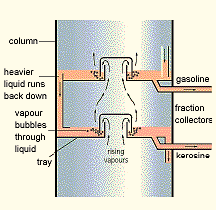

Due the heat input from the vapour, the liquid on the tray boils, generating more vapour. This vapour, which moves up to the next tray in the column, is richer in the more volatile components. Being lighter, vapour flows up the column and is forced to pass through the liquid, via the openings on each tray. The area allowed for the passage of vapour on each tray is called the active tray area. This continuous contacting between vapour and liquid occurs on each tray in the column and brings about the separation between low boiling point components and those with higher boiling points.

As the hotter vapour passes through the liquid on the tray above, it transfers heat to the liquid. In doing so, some of the vapour condenses adding to the liquid on the tray. The condensate, however, is richer in the less volatile components than is in the vapour. From this we can deduce that the more trays there are, the better the degree of separation, and that overall separation efficiency, depends significantly on the design of the tray. Trays are designed to maximize vapour-liquid contact by considering the liquid distribution and vapour distribution. Fractionation trays can be fabricated from a wide variety of materials.

When corrosion is expected to be extremely low, and design temperatures are not excessive, carbon steel is a logical choice because of its favorable mechanical design properties, malleability and low cost. However, since the material of construction is dictated by the process of a particular system for which the tray will be used, many different material types may be required due the unique properties that allow some materials to have resistance to corrosion and to maintain their mechanical strength at elevated temperatures. The most common tray materials are listed below starting from the least expensive:

- Carbon Steel -Type 410s stainless steel
- Type 304 Stainless steel - Type 316 Stainless steel
- Type 304L stainless steel -Type 316L stainless steel
- Type 317 stainless steel -Type 317L stainless steel
- Type 321 stainless steel - Type 347 stainless steel
- Type 904L stainless steel - Type 254 SMO

Distillation Principles: Industrial distillation is typically performed in large, vertical cylindrical columns known as distillation towers or distillation columns. When the process feed has a diverse composition, as in distilling crude oil, the outlets at intervals up the column, allow the withdrawal of different fractions or products, having different boiling points or boiling ranges. The "lightest" products (the lowest boiling point) exit from the top of the columns and the "heaviest" products (the highest boiling point) exit from the bottom of the column (often called the bottoms). Therefore, distillation processes depends on the vapour pressure characteristics of liquid mixtures.

Large-scale industrial towers use a reflux to achieve a more complete separation of products. Reflux refers to the portion of the condensed overhead liquid product from a distillation or fractionation tower that is returned to the upper part of the tower. Inside the tower, the down-flowing reflux liquid provides cooling and condensation of the up-flowing vapors thereby increasing the efficacy of the distillation tower. The more reflux is provided for a given number of theoretical plates, the better is the tower's separation of lower boiling materials from higher boiling materials.

However, the more reflux is provided for a given desired separation, the fewer theoretical plates are required. Such industrial fractionating towers are also used in air separation, producing liquid oxygen, liquid nitrogen, and high purity argon. Distillation of chlorosilanes also enables the production of high-purity silicon for use as a semiconductor. Chlorosilanes are a group of reactive, chlorine con-taining chemical compounds, related to silane, used in many chemical processes. Each chemical ring has at least, one silicon-chlorine bond.

Design and operation of a distillation tower depends on the feed and desired products. Given a simple, binary component feed, analytical methods such as the McCabe-Thiele method or the Fenske equation can be used. For a multi-component feed, simulation models are used both for design and operation. Moreover, the efficiencies of the vapor-liquid contact devices (referred to as "plates" or "trays") used in distillation towers are typically lower than that of a theoretical 100 percent efficient equilibrium stage. Hence, a distillation tower needs more trays than the number of theoretical vapor-liquid equilibrium stages.

The vapour pressure of a liquid at a particular temperature is the equilibrium pressure exerted by molecules leaving and entering the liquid surface. Here are some important points regarding vapour pressure, such as, energy input raises vapour pressure; vapour pressure is related to boiling; a liquid is said to “boil” when its vapour pressure equals the surrounding pressure, the ease with which a liquid boils depends on its volatility; liquids with high vapour pressures (volatile liquids) will boil at lower temperatures; the vapour pressure and hence the boiling point of a liquid mixture depends on the relative amounts of the components in the mixture; distillation occurs because of the differences in the volatility of the components in the liquid mixture.

Number of Stages and Trays: Each section will be equivalent to a stage of the distillation process, and calculating the graphical construction repeatedly, will give rise to a number of “corner sections”. This is the basis for sizing the distillation columns using the McCabe-Thiele graphical design methodology, as shown in the following illustration.

This particular example shows that seven theoretical stages are required to achieve the desired se-paration. Given the operating lines for both stripping and rectification sections, the graphical construction described above may be applied. The required number of trays (as opposed to stages) is less than the number of stages, since the graphical construction includes the contribution of the reboiler in carrying out the separation. The actual number of trays required is given by a simple formula: (number of theoretical trays)/(tray efficiency).

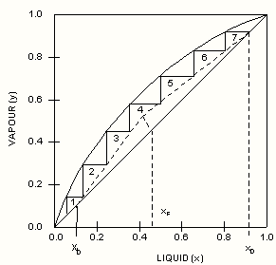

Determining the number of stages required for the desired degree of separation, and the location of the feed tray, is merely the first steps in producing an overall distillation column design. Other things that need to be considered are tray spacings, column diameter, internal configurations, heating and cooling duties. All of these may lead to conflicting design parameters. Thus, distillation column design is often an interactive procedure. If the conflicts are not resolved at the design stage, then the column will not perform well, in practice.

Column Reboilers: Are heat exchangers typically used to provide heat to the bottom of refining distillation columns, and boil the liquid from the bottom of a distillation column to generate vapors that are returning, to drive the distillation separation. Thus, the reboiler must be appropriately sized to ensure that enough vapour can be generated during cold and windy seasons, and that it can be turned down sufficiently during the hot weather. The same applies to condensers. The following are examples of typical reboiler types.
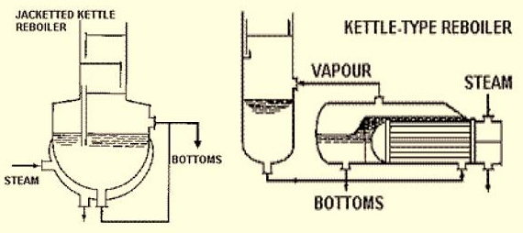

Basic Operation and Terminology: Distillation columns are made up of several components, commonly used either to transfer heat energy or enhance material transfer. A typical distillation contains several components, such as, a vertical shell where the separation of liquids is carried out, co-lumn internals, (trays, plates and packings), used to enhance component separations, a reboiler to provide the necessary vaporization of the distillation process, a condenser to cool and condense the vapour leaving the top of the column, and a reflux drum to hold the condensed vapour from the top of the column, so that the refluxed liquid can be recycled back to the column.

Heat is supplied to the reboiler to generate vapour. The source of heat input can be any suitable fluid, normally steam in most chemical plants. In refineries, the heating source may be the output ther-mo streams of other columns. The vapour raised in the reboiler is re-introduced into the unit at the bottom of the column. The liquid removed from the reboiler is known as the bottoms product or sim-ply, bottoms. Most distillation columns are open to the atmosphere, and usually all columns are insulated, but the changing of weather conditions can also affect column operations.

The vapour moves up the column, and at the output, on the top of the unit, it is cooled by a condenser. The condensed liquid is stored in a holding vessel known as the reflux drum. The reflux is performed when some of this liquid is recycled back at the top of the column. The condensed liquid, which is removed from the system, is known as the distillate or top product. Thus, there are internal flows of vapour and liquid within the column, as well as, external flows of feeds and product streams into and out the column.

Refineries depend largely on crude oil, the gases associated with it, and natural gas (mainly methane), as sources for liquid fuels (petrol, diesel) and the feedstock for the chemical industry. Oil and gases associated consist of a mixture of hundreds of different hydrocarbons, containing any number of carbon atoms from one to over a hundred. Most of these hydrocarbons are straight chain, or saturated rings which, except for burning, have relatively little direct use in the chemical industry, or as fuel for cars.

Thus the various fractions obtained from the distillation of crude oil and the associated gases have to be treated further in oil refineries to make them useful. The most valuable fractions for refineries and chemical industries are Liquefied Petroleum Gas (LPG), naphtha, kerosene and gasoil, for producing petrol or gasoline. These processes occur in most operating areas, Crude, Aromatics, Cracking, Coker, and at the Sulfur Recovery Unit. Most refineries, regardless of complexity, perform a few basic steps in the refining process, as Distillation, Cracking, Treating and Reforming.

1. Distillation: Modern distillation involves pumping oil through pipes in hot furnaces, to separate the light hydrocarbon molecules in downstream distillation towers, which is a tall and narrow colu-mns that give refineries their distinctive skylines. The refining process begins, when crude oil is distilled in two large crude units that have distillation columns, usually one that operates near the atmospheric pressure and two others that operate less than the atmospheric pressure. Sometimes, distillation columns are operated at less than the atmospheric pressure (vacuum) to lower the temperature, at which a hydrocarbon mixture boils.

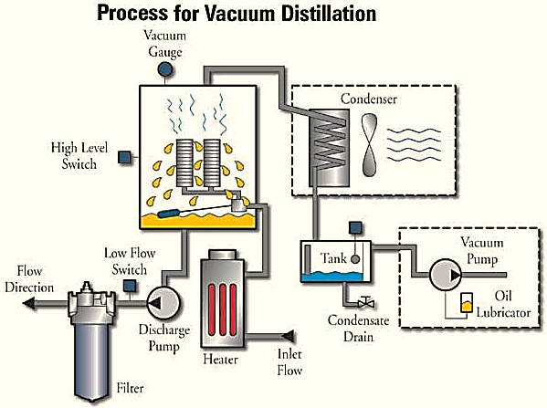

This "vacuum distillation" (VDU) reduces the chance of thermal decomposition (cracking), overheating the mixture. These and other distillation columns upgrade improved gas oil recovery and decrease the residuum volume. Using the most up-to-date computer control systems, refinery operators precisely control the temperatures in distillation columns, commonly designed with piping gutters to withdraw the various types of products where they condense. Products from the top, middle and bottom of the column, travel through these piping gutters to different plants for further refining.

During this process, the lightest materials, like propane and butane, vaporize and rise to the top of the first atmospheric column. Medium weight materials, including gasoline, jet and diesel fuels, condense in the middle. Heavy materials, called gas oils, condense in the lower portion of the atmospheric column. The heaviest tar-like material, called residuum, is referred to as the "bottom of the barrel" because it never really rises. This distillation process is repeated in many other plants as the oil is further refined to make various products.

2. Cracking: Is the technique that takes large hydrocarbons and breaks them into smaller ones. Some refineries convert middle distillate, gas oil and residuum into primarily gasoline, jet and diesel fuels by using a series of processing plants that literally "crack" large, heavy molecules into smaller, lighter ones. Generally, heat and catalysts are used to convert the heavier oils to lighter products, using the "cracking" methods. There are several types of cracking:

- Thermal Cracking: Large hydrocarbons are heated at high temperatures (and high pressures as well) until they break apart. High temperature steam (1500º F - 816º C) is commonly used to break ethane, butane and naptha into ethylene and benzene that are used to manufacture chemicals.
- Visbreaking: Residual from the distillation tower is heated up to 900º F (482º C), then is cooled with gasoil and rapidly burned (flashed) in a distillation tower. This process reduces the viscosity of heavy weight oils and produces a residuum designated as tar to manufacturing of asphalt.
- Coking: Residual from the distillation tower is heated to temperatures above 900º F (482º C) until it cracks into heavy oil, gasoline and naphtha. When this process is done, a heavy, almost pure carbon residue is left (coke); then, the coke is cleaned from the cokers.
- Catalytic Cracking: In fluidized catalytic cracking, the gasoil is vaporized and passed through a zeolite, (catalyst produced as a fine powder), heated to about 800º-980º F in the reactor. The catalyst allows lower reaction temperatures. After cracking, the catalyst is separated from the products, regenerated by burning, and subsequently recycled. Catalysts include zeolite, aluminum hydro-silicate, bauxite and silica-alumina.
- FCC (Fluid Catalytic Cracking): Is a hot fluid catalyst (1000º F - 538º C), which cracks the heavy gasoil into diesel oils and gasoline.

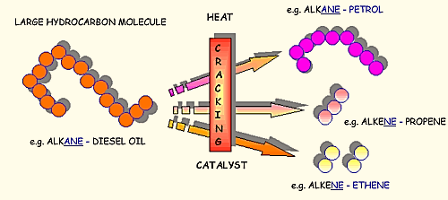

3. Hydrocracking: Is similar to FCC, but uses a different catalyst, lower temperatures, higher pressure, and hydrogen gas. The cracking is carried out with hydrogen at a pressure of 80 atm (1175 psi) and a catalyst of finely divided platinum on silica or alumina. It takes heavy oil and cracks it into gasoline and kerosene (jet fuel). Hydrocracking is also used to crack heavy gas oils (which have over 20 carbon atoms in the hydrocarbon molecule) to shorter chain molecules similar to those in naphtha, which can then be steam cracked to form alkenes.

Sometimes, the hydrocarbon molecule structures of a fraction are rearranged to produce another. Commonly, this is done using a process called alkylation. In alkylation, low molecular weight compounds, such as propylene and butylene, are mixed in the presence of a catalyst, such as hydrofluoric acid or sulfuric acid (a by-product from removing impurities from many oil products). Petrol (gasoline) contains a mixture of hydrocarbons, with 5 to 10 carbon atoms. This mixture of C5-C10 hydrocarbons obtained directly from the distillation of crude oils, generally contains a high proportion of straight-chain alkanes.

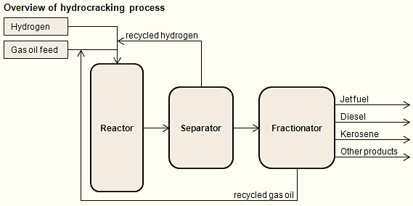

4. Alkylation: Is the transfer of an alkyl group from one molecule to another. In a refinery, the alkylation process refers to the alkylation of alkanes, for example, 2-methylpropane (isobutane) with alkenes, in the presence of a strong acid catalyst, such as hydrofluoric acid or sulfuric acid. The product from 2-methylpropane and 2-methylpropene (isobutene) becomes a mixture of branched-chain alkanes, mainly 2,2,4-trimethylpentane (isooctane). The reaction is carried out at mild temperatures, because cooling is necessary, as the reaction is exothermic.

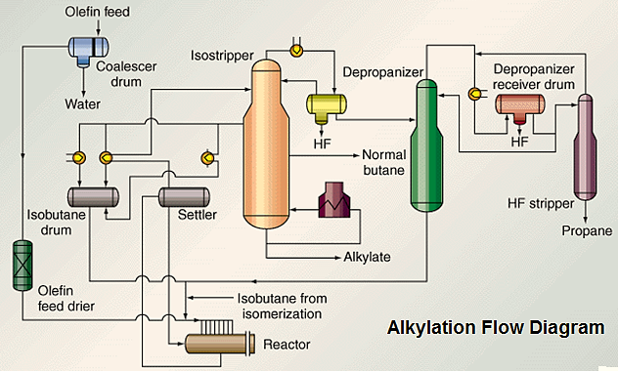

The main products of alkylation are high octane hydrocarbons generally used in gasoline blends, to reduce the “knocking”, which is a sharp metallic sound produced in internal combustion engines, due the low octane number of gasoline. Severe “knocking” can cause serious engine damage, in all vehicles that use explosion engines. Petrol containing a high proportion of straight-chain alkanes tends to ignite in the cylinder of an explosion engine, before the cylinder reaches the optimum position, as the piston increases the pressure. When this crude mixture is used as petrol, it can bring serious damage to a car's engine.

Propane is catalytically cracked to form propene, using the same cracker to crack gas oil. With propene, the 2-methylpropane forms a mixture containing a high proportion of 2,3- and 2,4- dimentyl-pentanes. These mixtures have very good anti-knock properties and are added to petrol to increase the octane rating. When sulfuric acid is used as a catalyst, many refineries must have a dedicated plant to re-use the sulfuric acid waste from the alkylation plant. In the recycling of sulfuric acid, the diluted acid is heated strongly to form the sulfur dioxide, regenerating pure acid, which is then fed into a contact process plant.

5. Reforming: Is another process in which hydrocarbon molecules are rearranged into other molecules, usually with the loss of a small molecule, such as hydrogen. The hydrogen is used throughout the refinery in various cracking (hydrocracking) and treating (hydrotreating) units. These reforming units employ precious-metal catalysts, platinum and rhenium, and thereby get the name "rhenifor-mers." For example, methyl-cyclohexane can be reformed into toluene, or the conversion of an alkane molecule into a cycloalkane or an aromatic hydrocarbon.

The cracking-reforming process happens when large quantities of hydrogen are used to modify the structure of the cracked molecules, and reform them into the molecules wanted. The hydrogen is usually generated from steam reforming, and commonly used to change the chemical structure of crude oil. The reforming process actually removes hydrogen from low-octane gasoline. In the refor-ming process, hydrocarbon molecules are "reformed" into high octane gasoline components. Then, the gasoline process streams in a refinery that has fairly low octane ratings, are sent to a reforming unit, where the octane levels are boosted.

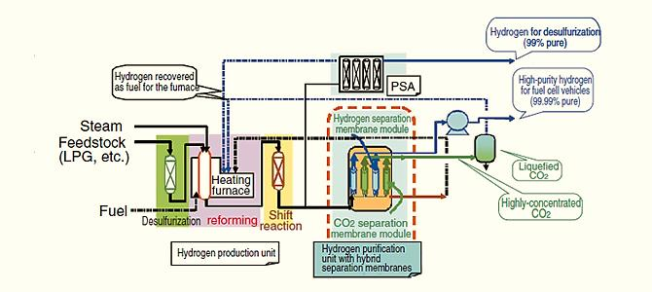

6. Unification: Is used to combine smaller hydrocarbons to make larger ones. The major unification process is the catalytic reforming, which uses a catalyst (platinum, platinum-rhenium mix) to combine low weight naphtha into aromatics, used in making chemicals and in blending gasoline. A significant by-product of this reaction is hydrogen gas, which is then either used for hydrocracking.
In reactors, sulfur and nitrogen are removed from the FCC feed stream. The sulfur is converted to hydrogen sulfide and sent to a sulfur unit, where it is converted into elemental sulfur. Then, the low sulfur vacuum gas oil, is fed to the FCC (Fluid Catalytic Cracker), which is cracked into high value products, such as gasoline and diesel. Nitrogen is transformed into ammonia, which is removed from the process by water-washing. Later, the water is treated to recover the ammonia, as a pure product for use in the production of fertilizers.

7. Treating (Removing Impurities): Products from the crude units to other units contain some na-tural impurities, such as sulfur and nitrogen. Using a process called hydrotreating (this is a milder version of hydrocracking), these impurities are removed to reduce air pollution, when fuels are used. Sometimes, about 80 percent of the crude processed by a refinery, is heavier oils with a high percent of sulfur and nitrogen, then various treating units, work to remove these impurities.

The final and critical step is the blending of products. Gasoline, for example, is blended from treated components in several processing units. Blending and shipping area operators, combine these components to ensure that the blend has the right octane level, vapor pressure rating and other important specifications. Distillated and chemically processed fractions are treated to remove impurities, such as organic compounds containing sulfur, nitrogen, oxygen, water, dissolved metals and inorganic salts. Treating is usually done by passing the fractions through the following:

The column of sulfuric acid removes unsaturated hydrocarbons (carbon-carbon double-bonds), nitrogen compounds, oxygen compounds and residual solids (tars, asphalt). The absorption column is filled with drying agents to remove water sulfur treatment, and the hydrogen-sulfide scrubbers are used to remove sulfur and sulfur compounds. After the fractions have been treated, they are cooled and then blended together to make various products, such as:

- Gasoline of various grades, with or without additives;
- Lubricating oils of various weights and grades (e.g. 10W-40, 5W-30);
- Kerosene of various grades;
- Jet fuel, diesel fuel and heating oil;
- Chemicals of various grades for making plastics and other polymers.

8. Isomerization: Isomerization is a process that converts n-butane, n-pentane and n-hexane in isoparaffins of substantially higher octane number, or the process in which hydrocarbon molecules are rearranged into a more useful isomer. Isomerization is similar to catalytic reforming where hydrocarbon molecules are rearranged, however, isomerization just converts normal paraffins to isoparaffins. There are two distinct isomerization processes, butane (C4) and pentane/hexane (C5/C6). Butane isomerization, basically produces the feedstock for alkylation.

Pentane/hexane isomerization increases the octane number of the light gasoline components into n-pentane and n-hexane, which are found in abundance in straight-run gasoline. An important example is the isomerization of butane (LPG) to 2-methylpropane (isobutane). The butane vapour is pas-sed over a solid catalyst, as aluminium chloride. The two alkanes are separated by distillation or by passing through an alumino-silicate molecular sieve. The branched chain alkane is trapped and the straight-chain alkane passes through, recirculated into the reactor. The 2-methylpro-pane is subsequently released and used to make a branched alkane, 2,2,4-trimethylpentane (isooctane, for petrol.

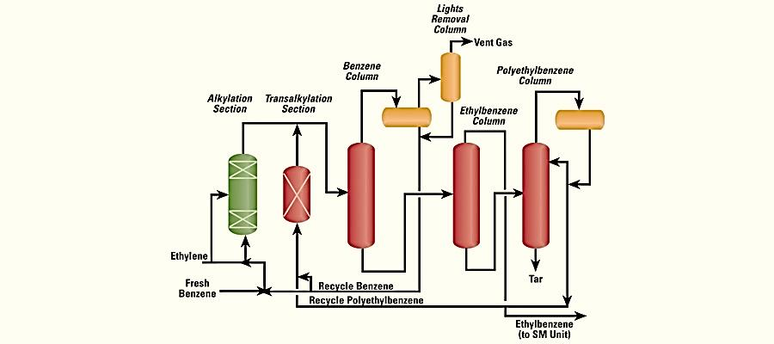

9. Polymerization: In polymer chemistry, polymerization is a process of reacting monomer molecules together in chemical reaction to form polymer chains or three-dimensional networks. Then, when many molecules of a simple compound join together, the product is called a polymer and the process is termed polymerization. Several simple compounds are usually produced in the oil & gas refinery and the polymers, such as poly(ethene) and poly(propene) are often and commonly manufactured in petrochemical plants.

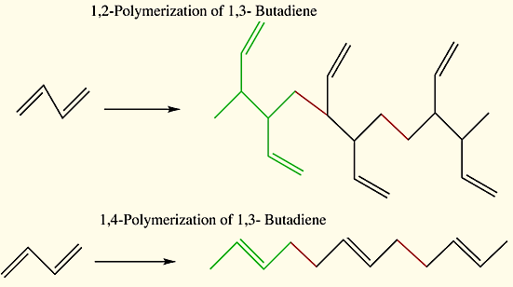

As alkenes can be formed in somewhat straightforward reaction mechanisms, they form useful com-pounds, such as polyethylene and polyvinyl chloride (PVC), due to their usefulness in manufacturing processes of commercial products, such as piping, insulation and packaging. Small polymers, known as oligomers, are also produced from refinery products. One important example is the production of alkenes with 10-14 carbon atoms from ethene, used in the manufacture of alkyl sulfonates, an important surfactant, when undergoing radical reactions.

10. Dealkylation: Dealkylation is a chemical process through which alkyl groups are removed from a given compound. Alkys are a very general class of molecular components that contain a number of different hydrogen-carbon combinations, or basically, molecular structures made up of hydrogen and carbon, usually arranged in a circular fashion. In basic level, the alkyl group is an organic molecule group, which is derived from an alkane that has lost a hydrogen atom, made up of straight or branched-chains of carbon and hydrogen atoms where the carbon-carbon atoms are joined exclusively by single bonds.

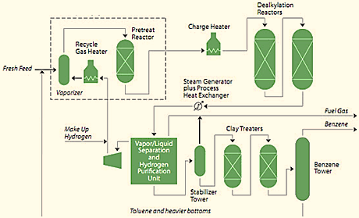

As an example, the dealkylation of methylbenzene, produces benzene, which is a more valuable product in the chemical industry. The opposite of alkylation occurs when methylbenzene is heated with hydrogen over a catalyst. The methylbenzene vapour and hydrogen are passed over a catalyst of chromium, platinum or molybdenum, supported on silica or aluminium oxide at 820-920 K at 40-60 atm pressure. Sometimes alkyl removal happens naturally, usually as a consequence of temperature shifts and decomposition processes.

11. Disproportionation: Is a specific type of redox reaction in which a species is simultaneously reduced and oxidized to form two different products, that is, occurs when a reactant is transformed into two or more dissimilar products. A similar type of reaction, in which no element changes oxidation number, is the acid-base disproportionation reaction observed when an amphiprotic species reacts with itself. Hydrogen peroxide converting into water and oxygen is a disproportionation reaction.

For example, methylbenzene is converted by disproportionation to more valuable products in the chemical industry, benzene and the dimethyl-benzenes. During this process, methylbenzene and hydrogen are passed over a zeolite catalyst at 15-25 atm and 700-750 K. Hydrogen is not itself consumed in this process, but suppresses undesirable side reactions, and facilitates the transfer of the methyl group. Today, by using specific zeolite catalysts, this process is highly selective towards 1,4-dimethylbenzene.

Column Packings: Are types of packed beds used to perform separation processes, such as absorption, stripping and distillation that can be made in a range of material including ceramics, metal, glass and plastics. Packed columns are better in handling corrosive or foaming liquids. In a packed column, liquid-vapour mixing is promoted through a packed bed. Packed beds provide true counter-current flow as vapour flows up and liquid flows down the bed simultaneously. Selection of materials is based on the need for corrosion resistance and weight limitations. Equalizing the distribution of the liquid and vapour flows is a key to good operation of these types of columns.

Packing material is another way of improving the separation in a distillation column instead of trays, especially when low pressure drops across the column are required, as when operating under vacuum. If a distillation tower uses packings instead of trays, the number of necessary theoretical equilibrium stages is first determined, that is, the packing height equivalent to a theoretical equilibrium stage, is known as the height equivalent to a theoretical plate (HETP). This packing material can either be random dumped packing (1-3" wide) such as Raschig rings or structured sheet metal.

Liquids tend to wet the surface of the packing and the vapors pass across this wetted surface, whe-re mass transfer takes place. The actual number of trays required for a particular separation duty is determined by the efficiency of the plate, when packings are used. Thus, the factors that cause a decrease in trays efficiency, can also change the performance of the column. Tray efficiencies are affected by fouling, wear, tear and corrosion, and the rates at which these occur depends on the properties of the liquids being processed. Thus, all appropriate materials should always be well specified for the tray construction.

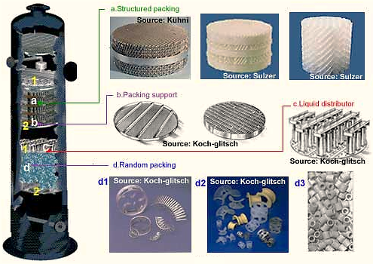

Unlike conventional distillation, in which every tray represents a separate point of vapor-liquid equilibrium, the vapor-liquid equilibrium curve in a packed column is continuous. However, when modeling packed columns, it is useful to compute a number of "theoretical stages", to denote the separation efficiency of the packed column with respect to more traditional trays. Differently shaped packings have different surface areas and void space between packings. Both of these factors affect the packings performance.

Packings versus Trays: A tray distillation column that is facing throughput problems, an entire section of trays may be replaced with packings. This is because, packings provide extra inter-facial area for liquid-vapour contact, the efficiency of separation is increased for the same column height, and packed columns are shorter than trayed columns. Packed columns are called continuous-contact columns while trayed columns are called staged-contact columns because of the manner in which vapour and liquid are contacted.

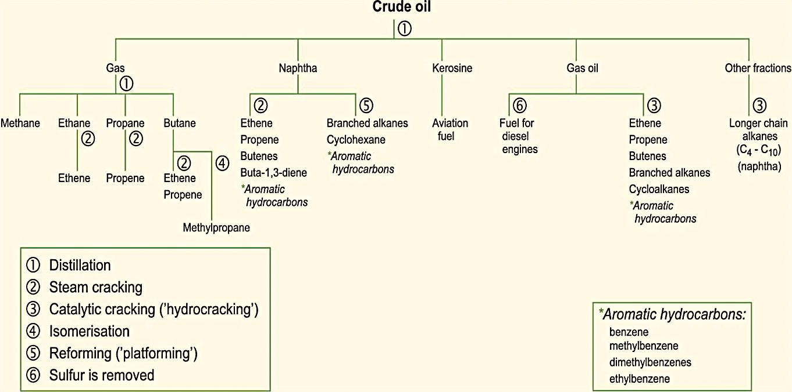

Petrochemical Plants: The main function of a petrochemical plant is generally to convert natural gas or petroleum liquids (feedstocks) into fertilizers and/or other intermediate and final products, such as olefins, adhesives, detergents, solvents, rubber and elastomers, films and fibers, polymers, resins and other products. Petrochemical plants have an infinite variety of configurations depending on the produced products. Some of the main categories are:

- Ethylene Plants;
- Fertilizer Plants;
- Methanol Plants and Other Alcohols;
- Plastic Production Plants;
- Plants like Acetylene, Butadiene, Sulfuric Acid, Nitric Acid, Chlorine and Ethylene Glycols.

Aviation (Jet) Fueling: Aviation fuel is a specialized type of petroleum-based fuel used to power aircraft. It is generally of a higher quality than fuels used in less critical applications, such as heating or road transport, and often contains additives to reduce the risk of icing or explosion due to high temperatures, amongst other properties. The most common fuels are Jet A and Jet A-1, both of which are kerosene-based and are produced to an internationally standardized set of specifications.

Biodiesel: Biodiesel fuels are made through a chemical process called transesterification, where the glycerin is separated from the fat or vegetable oil. This process leaves behind two products: methyl esters (the chemical name for biodiesel), and glycerin that is (a valuable byproduct usually sold to be used in soaps and other products). Transesterification is the conversion of a carboxylic acid ester, and involves vegetable or animal fats and oils reacted with chain alcohols, in the presence of an acid catalyst. Glycerides are fatty acid esters of glycerol, one of the main classes of lipids.

Other types of alternative fuels include hydrogen, ethanol, and methanol, and many other refining products. One way of creating alternative fuels is through fuel blending, which involves blending amounts of alternative fuels through other conventional fuels. There are various alternative fuels that can be used in place of gasoline and diesel, generally produced from renewable sources, such as biodiesel. Biodiesel is a clean burning alternative fuel, which is made from renewable resources such as animal fats and vegetable oils. In fact, biodiesel is meant to be used in standard diesel engines and can also be used alone or blended with petrodiesel.

Azeotropic Distillation: Azeotropic means a mixture of two or more liquids whose proportions cannot be altered by simple distillation. In chemical engineering, the azeotropic distillation usually refers to the specific technique of adding another component to generate a new one. The most common example of azeotropic distillation is using the dehydrating ethanol and water mixtures. For this process, a near azeotropic mixture is sent to the final column where azeotropic distillation takes place.

The addition of a material separation agent, such as benzene to an ethanol/water mixture, changes the molecular interactions of the azeotropes formation. To form azeotropes with more than one com-ponent, a material separation agent is selected, referred to as an entrainer. Then, several entrainers can be used for this specific process, such as, benzene, pentane, cyclohexane, hexane, heptane, isooctane, acetone, and diethyl ether, are all options as the ethanol/water mixture. Added in the liquid phase, the new component can alter the activity coefficient in different ways, thus, altering a mixture's relative volatility to a higher or lower boiling points.

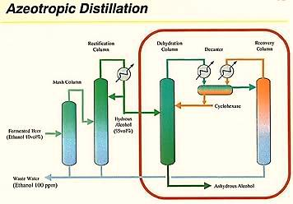

As an example, in distillation of ethanol for gasoline addition, the most common means of breaking the azeotropes is the use of molecular sieves. The concentration can reach above 96%, and can be further distilled. Then, ethanol is distilled with a molecular sieve that adsorbs the water from the mixture. The molecular sieve is a material with very small holes of precise and uniform size, small enough to block large molecules, while allowing small molecules to pass. Many molecular sieves are used as desiccants, such as, activated charcoal and silica gel.

- GAS REFINERIES:

Oil & gas refineries deal every day with chemistry. The crude petroleum is heated and changed into gases, when crude oil is broken into various petroleum products. The mixtures of these gases are also generated during the refinery process. As described before, a fractionation column is a modulated tower used in distillation of liquid mixtures to break the crude oil and separate the mixtures into several components, or fractions, based on the differences in volatilities or boiling points. The gases that pass through a distillation column, become cooler, as the column height increases. The most common gases components include butanes, butylenes, methane, ethane, and ethylene.

The composition of these gases varies, depending on the composition of the crude, and from the processes types that these gases have been subjected to. The liquids may be drawn-off the distilling column at various heights. Smaller molecules, as isobutene and propylene (or butylene) can be recombined to meet the specific octane requirements by the alkylation process or more commonly, dimerization. The octane grade of gasoline can also be improved by catalytic reforming, which involves removing the hydrogen from hydrocarbons, then producing compounds with higher octane ratings, such as aromatics. Some products found in refinery gas are subject to weather controls as a result of programs, designed to address climate change.

In chemistry, when a compound in gaseous state cools below its boiling point, it condenses into a liquid. Chemistry is a branch of physical science that studies the composition, structure, properties and change of matter, sometimes called the central science because it bridges other natural sciences like physics, geology and biology. Chemistry deals with topics as the properties of individual atoms, the manner in which form chemical bonds in the formation of compounds, the interactions of substances through intermolecular forces, and the interactions between substances through che-mical reactions to form different substances.

Obs.: Dimerization is a chemical reaction where two monomers react to form a dimer. A dimer is an oligomer consisting of two structurally similar monomers joined by bonds that can be strong or weak, covalent or intermolecular. The term homodimer is used when two molecules are identical and heterodimer when are not identical.

Natural Gas Processing: Is a complex industrial process designed to clean raw natural gas, by se-parating impurities and various non-methane hydrocarbons and fluids, to produce what is known as pipeline quality or dry natural gas. Natural gas processing begins at the wellhead, but oil and natural gas are often found together in the same reservoir. The composition of the raw natural gas, which is extracted from producing wells depends on the type, depth, and location of the underground deposit and the geology of the area. The natural gas produced from oil wells is generally classified as associated-dissolved, meaning that the natural gas is associated with or dissolved in crude oil.

Most natural gas contains, to varying degrees, low molecular weight hydrocarbon compounds, such as methane (CH₄), ethane (C₂H₆), propane (C₃H₈) and butane (C₄H₁₀). Natural gas is an exception, when extracted from coal reservoirs and mines (coalbed methane), being essentially a mix of more methane and about 10 percent carbon dioxide (CO₂). Natural-gas processing plants purify the raw natural gas by removing common contaminants, as water, carbon dioxide (CO₂), and hydrogen sulfide (H₂S). Some of the substances which contaminate natural gas have economic value and are further processed. A fully operational plant delivers pipeline-quality or dry natural gas to be used as fuels by residential, commercial and industrial consumers.

The image below is a schematic flow diagram of a typical oil refinery portraying various unit production and processes, and the flow of gases between the inlet crude oil feedstocks and basic products. This diagram depicts only some of hundreds of different configurations. It does not include any of the usual facilities providing utilities, such as boilers, heating/cooling water, electric power, compres-sed air facilities, terminals and storage tanks for final products.

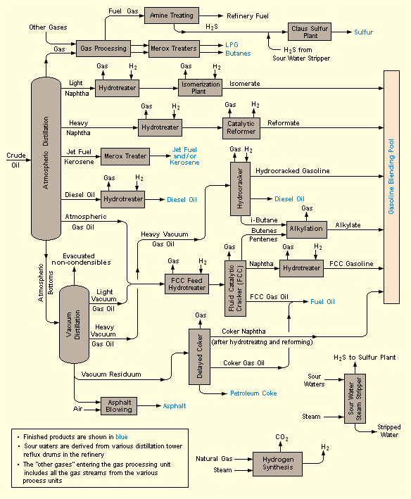

Natural gas is called sweet gas when relatively free of hydrogen sulfide, however, gas that contains hydrogen sulfide is called sour gas. Natural gas, or any other gas mixture, containing significant quantities of hydrogen sulfide, carbon dioxide or similar acidic gases, is called acid gas. Raw natural gas can also come from methane deposits in the pores of coal seams, and sometimes in a more concentrated state on surface of coal beds. Such gas is referred to as coalbed gas or coalbed methane. Coalbed gas has become an important source of energy in recent decades.

Raw natural gas is commonly collected from a group of wellheads, as crude oil, and processed at that same collection point for removal of free liquid water and natural gas condensate. The condensate is then transported to an oil refinery, and the water is disposed of as wastewater. The raw natural gas is then pipelined to a gas processing plant where the initial purification is usually the removal of acid gases (hydrogen sulfide and carbon dioxide). Amine gas treating, also known as amine, scrubbing, gas sweetening and acid gas removal, refers to a group of processes that use aqueous solutions of various alkylamines to remove hydrogen sulfide (H2S) and carbon dioxide (CO2).

However, due to environmental constraints of the amine process, a newer technology based on polymeric membranes is being used to separate the carbon dioxide and hydrogen sulfide from the na-tural gas stream, and has gained increasing acceptance. The Claus Process is the most well-known for recovering elemental sulfur, using technologies as the Contact Process and the WSA (Wet Sulfuric Acid Process) for recovering sulfuric acid. The processing of the raw natural gas also gives to consumers these by-products:

- Natural-gas condensate;
- Sulfur and ethane;
- Natural-gas liquids (NGL) as: propane, butanes and C5+ (which is the commonly used term for pentanes plus higher molecular weight hydrocarbons).

When processed into finished by-products, heavier hydrocarbons are collectively referred to as NGL (Natural Gas Liquids). Thus, the next step is to recover the natural gas liquids (NGL), and modern gas processing plants use a cryogenic low temperature distillation process, which involves the expansion of the gas through a turbo-expander, then followed by distillation system in a demethani-zing fractionating column. However, some gas processing plants use another system, lean oil absorption process, rather than the cryogenic turbo-expander system.

Natural Gas Liquids (NGLs): Are hydrocarbons of the same family of crude oil, composed exclusively of carbon and hydrogen, such as ethane, propane, butane, isobutane, and pentane (see table below). The extraction of NGLs often involves a turbo-expander and a low-temperature distillation column (called as demethanizer). The inlet gas that enters into the demethanizer is first cooled to about −51 °C in a heat exchanger (referred to as a cold box) which partially condenses the inlet gas. The resultant is a gas-liquid mixture, which is then separated into a gas stream and a liquid stream, processed in the following way:

- The liquid stream from the gas-liquid separator flows through a valve and undergoes an enthalpy expansion, from an absolute pressure of 62 bar to 21 bar (900 psi to 305 psi), and lowers the liquid stream from about −51 °C to about −81 °C, as the liquid stream enters the demethanizer.

- The gas stream enters the turbo-expander where undergoes to an isentropic expansion, from an absolute pressure of 62 bar to 21 bar (900 psi to 305 psi) and lowers the gas stream temperature from about −51 °C to about −91 °C, as it enters the demethanizer to serve as distillation reflux.

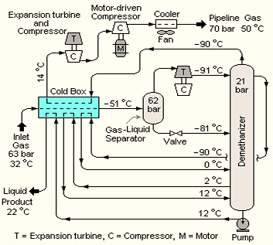

The overhead gas product from the demethanizer (at about −91 °C) is processed natural gas that is of suitable quality for distribution to end-use consumers by pipeline. It is routed through the cold box where it is warmed as it cools the inlet gas. It is then compressed in the gas compressor which is driven by the turbo expander and further compressed in a second-stage gas compressor driven by an electric motor before entering the distribution pipeline. The residue gas from the NGL recovery section is the final, purified sales gas which is pipelined to the end-user markets.

The recovered NGL stream is sometimes processed through a fractionation train consisting of three distillation towers in series: a demethanizer, a depropanizer and a debutanizer. The overhead pro-duct from the demethanizer is ethane and the bottoms are fed to the depropanizer. The overhead product from the depropanizer is propane and the bottoms are fed to the debutanizer. The overhead product from the debutanizer is a mixture of normal NGL and isobutane, and the bottoms product is a C5+ mixture. The recovered streams of propane, butanes and C5+ may be "sweetened" in a Merox process unit and, along with the recovered ethane, are the final NGL by-products from the gas processing plant.

The applications of these hydrocarbons are similar, but vary widely. Ethane occupies the largest share of NGL field production, used almost exclusively to produce ethylene, which is then turned into plastics. Propane is burned for heating, although a substantial amount is used as petrochemical feedstock and a blend of propane and butane, sometimes referred to as "autogas," is a popular fuel in some parts of Europe, Asia and Australia. Natural gasoline (pentanes plus) can be blended into various kinds of fuel for combustion engines, and is useful in energy recovery from wells and oil sands. The main applications of NGL by-products can be seen in table below:

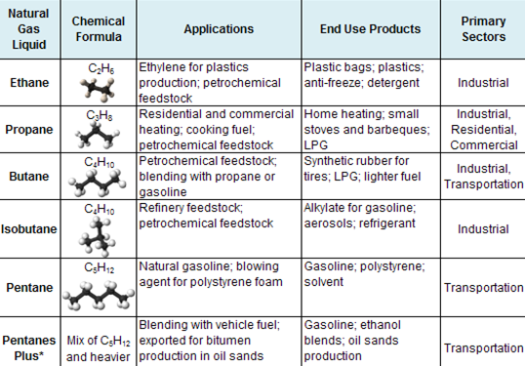

By chemically crosslinking hydrocarbon chains, the chemistry inside oil & gas refineries gets everything, since synthetic rubber to engineering products as nylon and plastics. The straight or branched chain molecules can be gases or liquids, depending upon the molecule rings as, methane, ethane, propane, butane, isobutane, pentane, and hexane. The smallest hydrocarbon is methane (CH₄), which is a gas that is a lighter than air. Longer chains with five or more carbons are liquids, but much longer chains are solids like wax or tar.

Basically, aromatics ringed structures with one or more rings contain six carbon atoms, with alternating double and single bonds between liquid chains, such as, benzene and naphthalene. Naphthe-nes or cycloalkanes structures, such as cyclohexane and methyl-cyclopentane with one or more rings, contain only carbon single bonds, and typically liquids at room temperature. Other hydrocarbons as alkenes and linear or branched-chain molecules containing carbon double-bonds can be li-quids or gases, such as ethylene, butane, isobutene, acetylene and butadienes.

Stages in the Production of Natural Gas: The number of steps and techniques used in the process of creating pipeline-quality natural gas, most often depends upon the source and make-up of the wellhead production stream. Among the several stages of gas processing and treatment are:
a) Gas-Oil Separators: The gas-oil separation process is needed to separate the gas stream from the crude oil, commonly in cylindrical shells, horizontally mounted with inlets at one end, an outlet at the top for removal of gas, and an outlet at the bottom for removal of oil. Pressure reliefs at the wellhead cause a natural separation of gas from oil (within a conventional tank, where gravity separates the gas hydrocarbons from the heavier oil). The separation is accomplished by alternately heating and cooling (by compression) the flow stream through multiple steps. Water and condensates are also extracted, as the process proceeds.

b) Condensate Separator: Often removed from the gas stream at the wellhead through the use of mechanical separators. The gas stream enters the processing plant at high pressure (600 psig or greater) through an inlet slug catcher where free water is removed, after which it is directed to a condensate separator. The extracted condensate is routed to on-site storage tanks.

c) Dehydration: Is a process to eliminate water from natural gas, which may cause the formation of hydrates. Hydrates form, when a gas or liquid containing free water enters in specific temperature/pressure conditions. Dehydration is the removal of water from produced natural gas using ethylene glycol (glycol injection) systems as an absorption mechanism. Alternatively, adsorption dehydration can also utilize dry-bed dehydrators towers, which contain desiccants, such as silica gel and activated alumina, to perform the extraction.

d) Contaminant Removal: Is the elimination of hydrogen sulfide, carbon dioxide, water vapor, helium, and oxygen, and the most used technique is to direct the flow though a tower containing an amine solution. Amines absorb sulfur compounds from natural gas and can be reused repeatedly. After desulphurization, the gas flow is directed to a series of filter tubes, and as the velocity of the stream is reduced in the unit, the primary separation of contaminants occurs due to gravity. Separation of smaller particles occurs through the filter tubes, as larger particles flow to the lower section of the unit. Further, a centrifugal force is generated to remove any remaining water and small solid particulate matters.

e) Nitrogen Extraction: After hydrogen sulfide and carbon dioxide are processed to acceptable levels, the stream is routed to a Nitrogen Rejection Unit (NRU), to be dehydrated using molecular sieve beds. In the NRU, the gas stream is routed through a series of passes through a column and a brazed aluminum plate fin heat exchanger, and by cryogenic process the nitrogen is separated and vented. Another type of NRU unit separates methane and heavier hydrocarbons from nitrogen using an absorbent solvent. The absorbed methane and heavier hydrocarbons are flashed off from the solvent by reducing the pressure in multiple gas decompression steps. The liquid from the flash regeneration step is returned to the top of the methane absorber as a lean solvent. Helium, if any, can be extracted from the gas stream in a Pressure Swing Adsorption (PSA) unit.

f) Methane Separation: Cryogenic processing and absorption methods are some of the ways to separate methane from NGLs. Essentially, cryogenic processing consists of lowering the temperature of the gas stream to around -120º F, using external refrigerants to chill the gas stream. The quick drop in temperature condenses the hydrocarbons in the gas stream, but maintains methane in its gaseous form. The gas stream passes through an absorption tower and the oil soaks up a large amount of the NGLs, then the “enriched” absorption oil, containing NGLs, exits the tower at the bottom. The oil is recycled while the NGLs are cooled and directed to a fractionator tower. Another method is the refrigerated oil absorption method, where the lean oil is chilled not heated, which enhances the recovery rates.

g) Fractionation: Is the process of separating the various NGLs present in the remaining gas stream using the varying boiling points of the individual hydrocarbons in the stream. The process occurs in stages, as the gas stream rises through several towers, where heating units raise the temperature of the stream, causing the separation of various liquids and exiting into specific holding tanks.

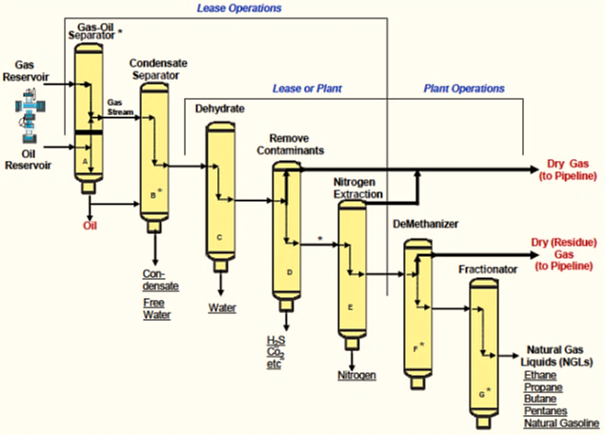

Liquefied Natural Gas (LNG): Is a clear natural gas colorless, non-toxic and non-corrosive liquid (predominantly methane, CH4) that has to be converted to liquid form, cooled to -162º C (-260º F) to shrink the volume of the gas 600 times, making it easier for storage and transport when pressure is set at around 25 kPa (4 psi). The liquefaction process of natural gas involves removal of certain components, such as dust, acid gases, helium, water, and heavy hydrocarbons, which could cause difficulty downstream. The gas may contain heavier hydrocarbons such as pentane, hexane, and heptane in the gaseous state.

A gas well produces predominantly natural gas, at ambient conditions the gas condensates to form natural gas. This condensate resembles petrol in appearance and is similar in composition to volatile light crude oils, as the temperature bottom pressure is higher than at the surface. The exact molecular composition varies widely and the proportions of chemical elements also vary over fairly narrow limits. One of the risks of LNG is a rapid phase transition explosion (RPT), which occurs when cold LNG comes into contact with water.

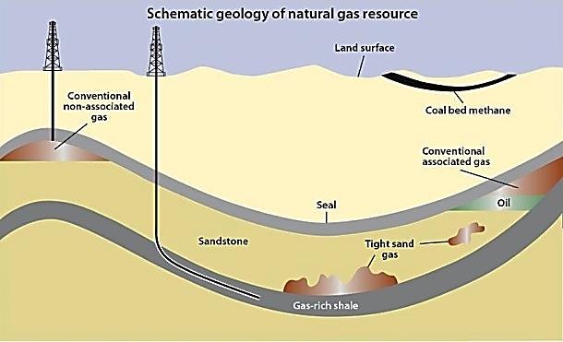

LNG achieves a higher reduction in volume than compressed natural gas (CNG). The (volume-tric) energy density of LNG is 2.4 times greater than that of CNG or 60 percent of diesel fuel. This makes LNG cost efficient to transport over long distances where pipelines do not exist, and only designed cryogenic sea vessels (LNG carriers) or cryogenic road tankers are used for its transport. LNG is principally used for transporting natural gas to storage plants, where it is degasified and distributed to the users through natural gas pipelines.

There are basically two processes for liquefying natural gas in large quantities. One is a cascade process, in which the natural gas is cooled by another gas, which in turn has been cooled by still another gas, hence a cascade. The other method is the Linde process and variation of the Linde process, called the Claude process, is sometimes used. In this process the gas is cooled in a rege-neratively way, by continually passing it through an orifice until is cooled to temperatures, at which it liquefies. The cooling of gas by expanding through an orifice was developed by James Joule and William Thomson and is known as the Joule-Thomson effect.

Modern LNG storage tanks are typically full containment type, which has a pre-stressed concrete outer wall and a high-nickel steel inner tank, with extremely efficient insulation between the walls. Storage pressure in these tanks is very low, less than 10 kPa (1.45 psig). Smaller quantities as 700 m³ (190,000 US gallons) and less, may be stored in horizontal or vertical, vacuum-jacketed, pressure vessels. These tanks may be at pressures anywhere from less than 50 kPa to over 1,700 kPa (7 psig to 250 psig).

The insulation, as efficient as it is, may not keep the LNG cold enough by itself, as heat leakage will warm and vaporize the LNG. Industry practice is to store LNG as a boiling cryogen. That is, the li-quid is stored at its boiling point for the pressure (atmospheric pressure). When the vapor boils off, the heat for the phase changes and cools the remaining liquid. The insulation should be very efficient and only a relatively small amount of boil off is necessary to maintain temperature, also called auto-refrigeration. Boil off gas from LNG storage tanks is usually compressed and fed to na-tural gas pipeline networks.

LNG (Liquefied Natural Gas) is combustible, composed almost entirely of methane, to be used by consumers. However, raw natural gas found at the wellhead, although still composed primarily of methane, is not pure. Raw natural gas comes from three types of wells: oil wells, gas wells, and condensate wells. Natural gas that comes from oil wells is typically termed “associated gas”. This gas exists separated from oil in the formation (free gas), or dissolved in the crude oil (dissolved gas). Natural gas from wells, in which there is little or no crude oil, is termed “non-associated gas”.

Gas wells typically produce raw natural gas by itself, while condensate wells produce free natural gas along with a semi-liquid hydrocarbon condensate. Whatever the source of the natural gas, once separated from crude oil (if present) it commonly exists in mixtures with other hydrocarbons; principally ethane, propane, butane, and pentanes. In addition, raw natural gas (NGL) contains water vapor, hydrogen sulfide (H2S), carbon dioxide, helium, nitrogen, and other compounds.

Electricity from Natural Gas: The natural gas power production process begins with the extraction of raw natural gas. Then, it is treated at gas plants to remove impurities such as hydrogen sulfide, helium, carbon dioxide, hydrocarbons, and moisture. Pipelines then transport the natural gas from the gas plants to power plants, and ends with its combustion in boilers and turbines to generate electricity. Natural gas-fired boiler and combined cycle systems require water for cooling purposes; however, the burning of natural gas in combustion turbines requires very little water, and the use of natural gas to create electricity does not produce substantial amounts of solid waste.

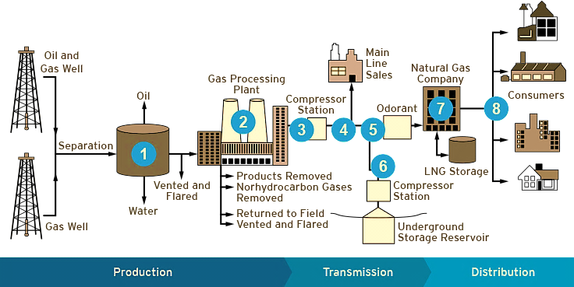

Power plants use several methods to convert gas to electricity. One method is to burn the gas in a boiler to produce steam, which is then used by a steam turbine to generate electricity. A more common approach is to burn the gas in a combustion turbine to generate electricity. Another technology, growing in popularity, is to burn the natural gas in a combustion turbine and use the hot combustion turbine exhaust to make steam to drive a steam turbine. This technology is called "combined cycle" and achieves a higher efficiency by using the same fuel source twice.

New Applications for Natural Gas: The fast growth of natural gas production from unconventional sources is creating a need to develop technologies for its efficient use. There is a clear goal to find solutions for reduced flaring and venting, and enhanced gas conversion may play a key role in this respect. The most efficient use of natural gas is direct conversion to electric power or use as a fuel for domestic needs, such as home heating. Once these needs are met, or the excess gas is in the area where infrastructure is not available, supplier companies are considering alternatives.

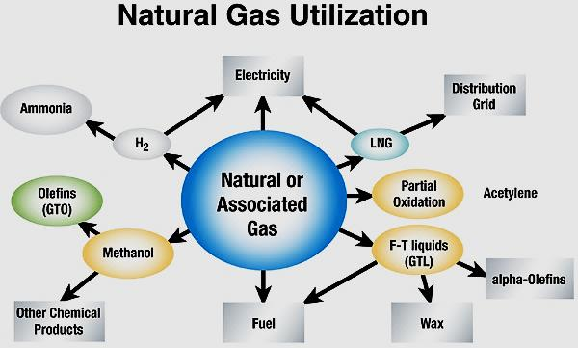

Chemical conversion to acetylene, ammonia, methanol and refinery hydrogen is widely practiced but, although there are large markets for these base chemicals in terms of gas commercialization, it represents only approximately 5 percent of global annual gas consumption. Alternatives for use of large amounts of raw natural gas (NGL) include conversion to clear natural gas Liquefied Natural Gas (LNG), conversion to liquid fuel products (GTL), conversions to olefins (GTO) and further to polymers (GTP). Of these products, polymers are the largest value added products.

Natural gas has more volume than oil to transport, and most gas is transported by pipelines, designated as “gas ducts”. There are natural gas pipeline networks in Russia, Europe, North America and South America. Natural gas is less dense, even at higher pressures, and travels faster than oil through a high-pressure pipeline, but can transmit only about a fifth of the amount of energy per day due to its lower density. Natural gas is usually liquefied to LNG at the end of the pipeline, prior to shipping, and can be transported using tanker trucks, railway tankers, and ships (LNG carriers).

Natural gas is considered the most environmentally friendly fossil fuel, because it has the lowest CO₂ emissions per unit of energy. In its liquid state, LNG is not explosive and cannot burn. For LNG to burn, it must first vaporize, then mix with air in the proper proportions (the flammable range is 5 percent to 15 percent), and then be ignited. In the case of a leak, LNG vaporizes rapidly, turning into a gas (methane plus trace gases), and mixing with air. If this mixture is within the flammable range, there is risk of ignition which would create fire and thermal radiation hazards.

Liquefied Petroleum Gas or Liquid Petroleum Gas (LPG): Is derived 60% from raw natural gas and 40% from refining crude oil; are flammable mixtures of hydrocarbon gases used as fuel in heating appliances, cooking equipment, and vehicles, also known as common kitchen gas. LPG is marketed as propane, butane or a combination of the two, and can also be used in power generation and industrial applications, such as burners and welding. Considered a clean-burning fossil fuel, LPG burns completely, leaving no waste and emitting significantly less pollutants into the environment than other hydrocarbons.

LPG may be manufactured during the refining of petroleum (crude oil), or extracted from petroleum or raw natural gas streams, as this hydrocarbon gas emerges from the ground. LPG was first produced in 1910 by Dr. Walter Snelling, and the first commercial products appeared in 1912. LPG is heavier than air, evaporates quickly at normal temperatures and pressures, and is usually supplied in pressurized steel vessels, when typically filled to 80–85% of their capacity, to allow thermal expansion of the contained liquid. The ratio between the volumes of the vaporized gas and the liquefied gas varies depending on composition, pressure, and temperature, but is typically 250:1.

The pressure at which LPG becomes liquid, is also called vapour pressure, depending on composition and temperature; for example, for pure butane, the vapor pressure is approximately 220 kPa (32 psi) at 20° C (68° F), and for pure propane, approximately 2,200 kPa (320 psi) at 55° C (131° F).
LPG is used for heating, cooking, and making of plastics by small alkanes (1 to 4 carbon atoms) commonly known by the names of methane, ethane, propane, and butane with a boiling range, less than 104º F (40º C). LPG is also increasingly used as an aerosol propellant and as refrigerant, replacing chloro-fluorocarbons, in an effort to reduce several damages to the ozone layer.

When specifically used as a vehicle fuel it is often referred to as autogas. Varieties of LPG include mixtures that are primarily propane (C3H8), primarily butane (C4H10) and most commonly include both propane and butane. In winter, these mixes contain more propane; while in summer contain more butane. Propylene, butylenes and other hydrocarbons are also present in small concentrations. When LPG is used as fuel combustion engines, is often referred to auto gas or auto propane. In some countries, has been used since the 1940s as petrol alternative for spark ignition engines. In some countries, there are additives to extend engine life, and the ratio of butane to propane is kept quite precise.

The advantage is that it is non-toxic, non-corrosive, and free of tetraethyl lead or any additives, with a high octane rating (102–108 RON) depending on local specifications. It burns more cleanly than petrol or fuel-oil and is especially free of particulates. These specifications are published by the Gas Processors Association (GPA) and the American Society of Testing and Materials (ASTM). As the most widely used fuel alternative, LPG is used to power internal combustion engines, as well. Millions of cars and buses in Europe and Brazil are actually powered by LPG today, where there are filling stations that provide LPG to domestic users.

The conversion of methanol to olefins and other hydrocarbons products has been widely studied, and in early 1980s focused on conversion of methanol to gasoline, employing zeolites (hydrated alumino-silicates of sodium, potassium, calcium, and barium), that can be readily dehydrated and rehydrated, used as cation exchangers and molecular sieves. More recently, China has taken a lead in conversion of coal to chemicals, and two commercial plants came on employing coal to methanol, and several more units are in construction. Recent development makes it possible to economically convert methanol to ethylene and propylene, which then can be converted to polyethylene and polypropylene for the ultimate end-use in numerous fibers, plastics and polymer products.

Gas to Liquids (GTL): Is a refinery process to convert natural gas or other gaseous hydrocarbons into longer-chain products, such as gasoline or diesel fuel. Methane-rich gases are converted into li-quid synthetic fuels via direct conversion, using non-catalytic processes that convert methane to me-thanol in one step, or via syngas, as an intermediate to gasoline, using the Fischer-Tropsch and Mobil processes. The Fischer-Tropsch process starts with a partial oxidation of the methane (natural gas) to carbon dioxide, carbon monoxide, hydrogen gas and water. Removing the water produces the synthesis gas (syngas), which is chemically reacted with an iron or cobalt catalyst to produce liquid hydrocarbons and other by-products.

In the early 1970s, Mobil developed an alternative procedure in which natural gas is converted to syngas, and then methanol, which is polymerized over a zeolite catalyst to form alkanes. First the methanol is dehydrated to give dimethyl ether, which is then further dehydrated over a zeolite catalyst, which would theoretically yield ethylene that is polymerized and hydrogenated to give a gasoline with hydrocarbons and five or more carbon atoms, making up 80% of the fuel by weight.

Note: Zeolites are micro-porous, alumino-silicate minerals commonly used as commercial adsorbents and catalysts. Dehydration reaction is usually defined as a chemical reaction that involves the loss of water molecules from the reacting molecule. Dimethyl ether is a low-temperature solvent and extraction agent, but the same properties facilitate its removal from reaction mixtures.

The STG+ (Syngas to Gasoline + Processes) is a third gas-to-liquids process that converts natural gas directly into drop-in gasoline and jet fuel via a thermochemical single-loop process. This process consists of four fixed bed reactors in series, in which syngas is converted to synthetic fuels. The ste-ps for producing high-octane synthetic gasoline are as follows:

- Methanol synthesis: Syngas is converted to methanol (CH3OH) when passing through a catalyst bed.
- Dimethyl ether synthesis: The methanol is exposed to a catalyst and is converted to dimethyl ether, through a dehydration method.
- Gasoline synthesis: A catalyst process converts the dimethyl ether to hydrocarbons including paraffins (alkanes), aromatics, naphthenes (cycloalkanes) and small amounts of olefins (alkenes), mostly from C6 (number of carbon atoms in the hydrocarbon molecule) to C10.
- Separator: Finally, the mixture is condensed to obtain gasoline. The non-condensed gas and gasoline are separated in a conventional condenser/separator, leaving the synthetic gasoline product composed of paraffins, aromatics and naphthenes.

Gas to Oil (GTO): This system incorporates three tubular reactors that can be configured as requi-red to operate in a strictly parallel fashion or in a cascade arrangement where the products from one reactor are immediately directed to a second reactor. This type of system can support reaction sche-mes including but not limited to the Fisher-Tropsch process, methanation reactions, steam reforming and other similar processes.

The Fisher-Tropsch process converts carbon monoxide and hydrogen into oils or fuels that can substitute for petroleum products. The reaction uses a catalyst based on iron or cobalt and is fueled by the partial oxidation of coal or wood-based materials such as ethanol, methanol, or syngas. This reaction scheme offers a promising route to producing economical renewable transportation fuels. By carefully controlling the temperature and oxygen content, resulting products can range from syngas to “green diesel”.

Compressed Natural Gas (CNG): Is a natural gas under pressure which remains clear, odorless, and non-corrosive, compressed to pressures above 3,100 psi, to be used in vehicles that can use natural gas as either a liquid or a gas; however, most vehicles use the gaseous form. Variations include storage at high pressure (over 250 bar or ~3625 psi) at atmospheric temperature, moderate pressure or reduced temperature (~-30º C or -86º F), in horizontal or vertical large diameter pipes, or steel pressure vessels, also transported in FPSOs. Natural gas comes from three types of wells; natural gas-and-condensate wells, oil wells, and coal bed methane wells.

The Compressed Natural Gas (CNG) is made by compressing natural gas (mainly composed of methane, CH4), and less than 1 percent of the volume is at standard atmospheric pressure. It is usually stored and distributed in hard containers at a pressure of 20–25 MPa (2,900–3,600 psi), in cylindrical or spherical shapes. Methane stored at high pressure can also be used in place of gasoline, diesel and propane/LPG. CNG combustion produces fewer undesirable gases than the fuels mentioned above. It is safer than other fuels in the event of a spill, because natural gas is lighter than air and disperses quickly when released. CNG may be found above oil deposits, or may be collected from landfills or wastewater treatment plants where it is known as biogas.

Heavy Liquefied Gas (HLG): Is natural gas that is condensed at a pressure of 10-20 bar, corresponding to a temperature of 100 to 120°C. This technology combines the LNG technology with the CNG process and involves condensing pressurized gas at a temperature significantly above the LNG liquefaction temperature. This lessens the cost of liquefaction, and reduces the need to remove feed gas components such as CO2 and LPGs.

Natural Gas Hydrate (NGH): Is a solid clathrate compound (also called methane hydrate, hydromethane, natural gas hydrate, or gas hydrate), trapped within a crystal structure of water, forming a solid similar to ice. Gas may be mixed with water at a pressure of 80-100 bar (1160~1450 psi) at normal temperatures for the gas hydrates to appear. Each cubic meter of hydrate contains 160-180 m³ (5650 ~ 7062 ft³) of gas. Alternative methods for storing and transporting hydrates have been proposed, for example, as solid crystals or as a mixture of solid hydrates and oil (slurry).

The oil/hydrate slurry can be produced by mixing the hydrates with oil, and then cooling the mixture to a temperature somewhat below the freezing point of water. The oil/hydrate mixture may consist of up to fifty percent gas hydrate, the rest is crude oil. Then, the mixture (slurry) is pumped to storage tanks onboard of a floating production unit for subsequent transportation by tanker to a receiving terminal. At the terminal the mixture will be heated in order to melt the hydrates.

Gas to Propylene (GTP): Propylene (C₃H₆) is a colourless fuel gas with a naturally pungent smell. Although similar to propane, it has a double bond which gives it a combustion advantage. Propylene can be obtained during the refining of gasoline, but it can also be produced by splitting, cracking and reforming hydrocarbon mixtures. This fuel gas is extremely flammable and non-toxic. Propylene is an attractive alternative to propane for heating and cutting due to its superior combustion performance. It is also widely used as a fuel gas for high-velocity oxygen fuel (HVOF) processes. In addition, the chemical and plastics industries rely on propylene as a fuel gas.

Non-fuel applications include organic synthesis to produce materials such as acetone. Propylene can be polymerized to form polypropylene plastic, and can also be employed as a refrigerant, in calibration mixtures and chemical intermediates. It can also be used for testing of gas burners and engines. An original two-stage process for producing ethylene and propylene from natural gas via the catalytic pyrolysis of methyl chloride produced by methane catalytic chlorination is investigated.

Industrial Gases: Are a group of gases that are specifically manufactured for use in a wide range of industries, which include oil and gas, petrochemicals, chemicals, power, mining, steelmaking, me-tals, environmental protection medicine, pharmaceuticals, biotechnology, food, water, fertilizers, nuclear power, electronics and aerospace. Their production is a part of the wider chemical Industry (where industrial gases are often seen as "specialty chemicals"). The principal gases provided are nitrogen, oxygen, carbon dioxide, argon, hydrogen, helium and acetylene, although a huge variety of gases and mixtures are available in gas cylinders.

Refrigeration: Raw natural gas as LPG also provides refrigeration, usually by means of a gas absorption refrigerator. Blended of pure, dry propane (refrigerant designator R-290) and isobutane (R-600a) the blend "R-290a" has negligible ozone depletion potential and very low global warming potential and can serve as a functional replacement for R-12, R-22, R-134a and other chlorofluorocarbon or hydrofluorocarbon refrigerants in conventional stationary refrigeration and air conditioning systems. Such substitution is widely prohibited or discouraged in motor vehicle air conditioning systems, on the grounds that using flammable hydrocarbons in systems originally designed to carry non-flammable refrigerant presents a significant risk of fire or explosion.

Storage Gas Systems and Terminals: Regasification terminals are the final destination of LNG carriers, where the liquefied product is returned to the gaseous state and fed into transmission and distribution grids. Liquefied natural gas is received and offloaded from the LNG carrier, into cryogenic storage tanks ranging in capacity from 100,000 to 160,000 m³, usually in the liquid state at-162 °C (-260°F). Regasification involves gradually re-warming the liquefied gas until its temperature rises above 0°C. The process takes place at high pressure (60 to 100 bar), through a series of seawater heat exchangers, as the right cooling water quality is available, with the most energy-efficient technique. In other cases, some of the gas is burned to provide the necessary heat.

The storage terminals, nowadays, are considered as an essential part of many organizations operating across different corners of the world. Terminal automation in oil and gas market offers a wide array of services like monitoring and evaluating systems at terminals, present at remote locations. Monitoring sensors at terminals analyze the execution of operations and transfers the data to the terminal system. Then, the gas is treated as necessary, to conform the regulatory end-user specifications. For example, the heating value can be tweaked by adjusting the concentrations of nitrogen, butane or propane or by blending with other gases according to the client´s needs.

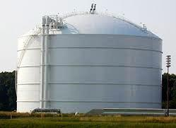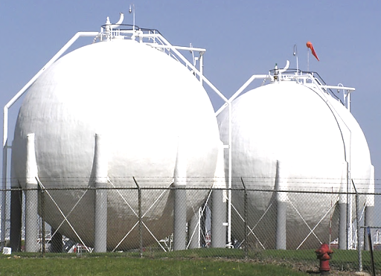

Modern LNG storage tanks are typically full containment type. Large tanks are cylindrical in design with a domed steel or concrete roof, but can be also a pre-stressed concrete with an outer-wall and a high-nickel steel inner tank, with extremely efficient insulation between the walls. Sometimes more expensive underground tanks are used for storage. Smaller quantities, say 700 m³ (190,000 US gallons) and less, may be stored in horizontal or vertical, vacuum-jacketed, pressure vessels.

Spherical shaped according to ASME pressure vessels, are also used in gas and liquid storage, including midstream, downstream, petrochemical, chemical, waste water, and aerospace. Spheres can store many products such as anhydrous ammonia, LPG, NGL, gasoline, naphtha, butadiene, ethylene, hydrogen, oxygen, nitrogen, argon, LNG, biogas, sewage gas and waste water. Most of these spheres feature double walls with an evacuated, perlite-filled annular space.

The common characteristic of LNG Storage tanks is the ability to store LNG at the very low temperature of -162 °C (-260 °F). LNG storage tanks have double containers, and the outer containers contain insulation materials. Storage pressure in these tanks is very low, less than 10 kPa (1.45 psig). These tanks may be at pressures anywhere from less than 50 kPa to over 1,700 kPa (7 psig to 250 psig). The boil-off gas is typically compressed and exported as natural gas, or is re-liquefied and returned to storage.

LNG FPSO: Or LNG Floating Production, Storage and Offloading, is a floating offshore installation which processes hydrocarbons and refrigerates gas to produce LNG (Liquefied Natural Gas). The installation may feed gas directly from a gas well or a gas network in conjunction with crude oil production. Current designs for medium size units have LNG storage capacity between 180,000 to 190,000 m³ and LPG storage capacities of approximately 25,000 m³. A very large scale FPSO unit may have the LNG storage capacity of 220,000 m³ and proposed LPG and condensate storage in the range of 100,000 m³.

A typical LNG FPSO design, bases the installation on an LNG carrier hull. The various parts of the process equipment are located topside and distributed as modules, installed on the deck. The storage capacity of a FPSO is related to the need to store LNG and LPG (Liquefied Petroleum Gas), dependent on the feed gas composition. FPSOs are preferred in offshore, as they are easy to install and do not require a local pipeline infrastructure to carry oil and gas. FPSOs can be a conversion of an oil tanker or can be a vessel built specially for the LNG application.

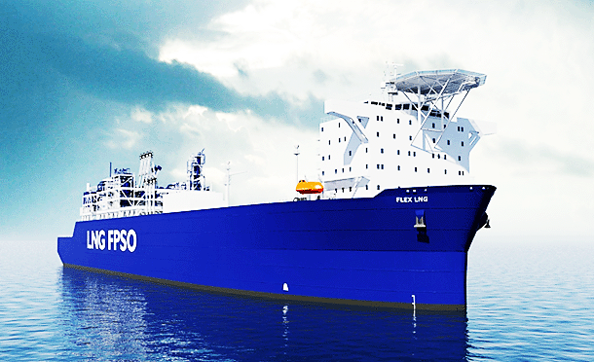

FSRU (Floating Storage and Regasification Unit): Is an offshore unit, which receives and regasifies LNG to provide gas to onshore consumers. Regasification units may also be located quayside or at any sheltered place. Floating storage units (FSRUs) can provide a flexible and economic alternative to land-based LNG receiving terminals. The floating installations may either be located near-shore (e.g. alongside a pier) or offshore (permanently moored to the seafloor).Depending on their mode of operation (dry-docking vs. wet-docking) and local regulation, FSRUs can be considered either as ships or as offshore installations. FSRUs may also be converted from existing vessels, typically LNG carriers.

SRV (Shuttle Regasification Vessels): Is an LNG vessel with onboard LNG vaporizers, or a vessel that transports LNG. The regasified LNG is discharged from de SRV via a turret and swivel through a mooring and unloading buoy connected to a riser and subsea pipeline, or connected to an offloading buoy to discharge, and then may be disconnected and leave to collect a new cargo. A large version of a SRV can also operate as a Floating, Storage and Regasification Unit (FSRU).
The SRV is classified as a ship, then, this implies that the equipment systems are built at regular shipyards. The SRV vessel is capable of staying moored to the transfer system at a location offshore, in severe weather conditions. The onboard regasification capacity can reach 600 million cubic feet per day. The vaporization capacity is designed to empty a 140,000 m³ vessel in less than 6 days, but the capacity can be doubled by additional units.

Gas Compression and Metering Systems: The air compressor is a specific type of gas compres-sor, increases the pressure of gas by reducing its volume, similar to pumps, as both raise the pressure of a fluid to be transported through a pipeline. Since gases are compressible, the compressor reduces the volume of a gas. Turbine compressors serve to operate a centrifugal compressor, which contains a type of fan that compresses and pumps the natural gas through the pipeline. The compression includes a large section of associated equipment, such as scrubbers (removing liquid droplets) and heat exchangers, lube oil treatment etc.

Compressors are driven by gas turbines or electrical motors. The basic operation of the gas turbine is similar to the steam turbine commonly used in power plants, except that air is used instead of water. Fresh atmospheric air flows through a compressor that brings it to higher pressure. Gas from separators loses pressure, and then must be re-compressed to be transported. For gas gathering systems, it is common to meter the individual gathering lines into a manifold pipeline. Metering stations allow operators to monitor and manage the natural gas and oil exported from the production installation.

Typically the metering installation consists of several record meters, since only one meter has not a full capacity range and associated loops, as accuracy of all meters have to be tested and calibrated at regular intervals. These metering stations employ specialized instrumentation to measure the natural gas or oil as it flows through the pipeline, without impeding its flow movement. This metered volume represents a transfer of owner ship from a producer to a customer.

Offshore Gas Production: Exploration and production at sea would be impossible without drilling platforms and drillships and depending on the depth of the water, oil and gas companies use different types of methods. Drilling platforms are suitable for exploration in shallow waters up to 60 meters deep and stand on a flooded pontoon on the seabed. After completing the production operations the pontoons are emptied and the platform will be towed to a different location. In deeper waters of up to 300 meters, drilling platforms, known as jack-up rigs, are used.

These platforms have legs that can be lowered and will anchor themselves by burrowing several meters into the seabed. To maintain their position above the well, semi-submersibles are attached to the seabed with steel wires and anchors (moored rigs). In extreme conditions, drillships are also used. Semi-submersible platforms and drillships must keep their exact position even in severe and heavy seas; otherwise the drill pipes could break and cause a lot of damage. This task is possible and performed by thrusters, which can rotate by 360º and compensate for virtually any movement.

In offshore production, oil and gas are extracted from the wells and brought to the surface to a host facility above the ocean surface. The type of facility depends on the location, water depth, climate and the facility’s size and capabilities. When an offshore deposit is ready for production, either a drilling platform is converted into a production platform or a production platform is installed above the well. After extraction, the natural resources are taken from the well directly to the mainland by pipeline or are loaded into tankers at the oil production platform. Old tankers or purpose-built ships are often used as floating production storage and offloading (FPSO) units; they float from one production platform to the next.

Like oil, natural gas is often found underwater in offshore gas fields such as the North Sea, and the Sable Offshore Energy Project in the Scotian Shelf near Sable Island. Fixed platforms were initially used for the offshore development, but as the fields have gone deeper, floating production facilities have become the main solution for the offshore production. There are mainly four types of floating production facilities; Floating Production Storage and Offloading (FPSO) ships, Tension Leg Platforms (TLPs), Spars and Production Semi-Submersibles.

Demand for natural gas continues to increase and it is fast becoming the preferred fossil fuel for a number of applications. These solutions focus on economic processing, storage and transportation of gas, either as a liquid (LNG, LPG or GTL), as a compressed gas (CNG), or as a product using both compression and liquefaction, and in the case of hydrates, as a solid. Currently, approximately 30 percent of world oil and gas production comes from offshore and it is expected to continue to increase in the future.

Oil & Gas Pipeline Inspection: In order to ensure the efficient and safe operation of the pipelines, operators routinely inspect their pipelines for corrosion and defects, through the use of sophisticated pieces of equipment known as pigs. Pigs are intelligent robotic devices that are propelled down pipelines to evaluate the interior of a pipe, suited to test pipe thickness, roundness, check for signs of corrosion and detect leaks. Defects along inside of the pipeline may either impede the flow of gas, or pose a potential safety risk for the operation of the gas pipeline. Sending a pig down a fluid duct is known as “pigging” to wholly inspection of the pipeline. Oil and gas pipelines dimensions are commonly from 6 to 48 inches in diameter.

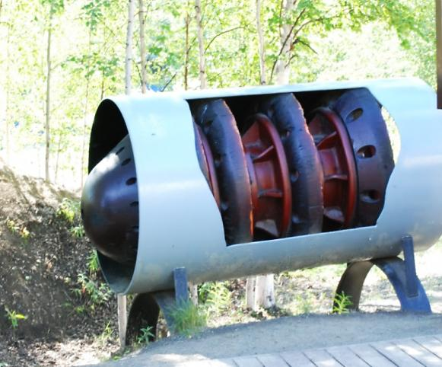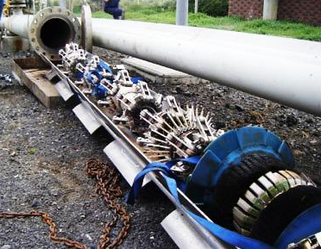
Pipeline inspection with “pigs”

The gas pipeline is fed from high pressure compressors, contrary to oil pipelines that are driven by powerful booster pumps. For longer pipelines, intermediate compressor stations or pump stations are required due to distance or crossing of mountain and hills. Pipeline terminals include termination systems and at least a pig launcher and a receiver has to be supplied, to allow insertion of a pipeline pigging, used to clean or inspect the pipeline. This may need, essentially at the start and final, large chambers pressurized and purged to insert and remove the pig or scraper without depressurizing the pipeline.

References:

Cross, Roy. 1919. A Handbook of Petroleum, Asphalt and Natural Gas.

Devold, Håvard, Oil and Gas Production Handbook, ©2006 ABB ATPA Oil and Gas;

DNV, Floating Liquefied Gas Terminals, Offshore Technical Guidance OTG-02, 2011;

Gary J.H., Handwerk, Petroleum Refining: Technology and Economics, Taylor & Francis, 2005;

Jones D.S.J., Elements of Petroleum Processing, John Wiley & Sons, 1995;

Links:

http://www.npc.org/

http://www.spe.org/

https://en.wikipedia.org/wiki/Oil_refinery

http://naturalgas.org/

http://www.petroleum.co.uk/

http://oilandgastechnologies.wordpress.com/

https://www.rigzone.com/training/

http://www.nfpa.org/

https://www.osha.gov/

http://petrowiki.org/PetroWiki

https://en.wikipedia.org/wiki/Liquefied_petroleum_gas

http://en.wikipedia.org/wiki/Petroleum_industry

Videos:

Oil & Gas Refining – Production and Processes (VLC media - MP4)

https://www.youtube.com/watch?v=gYnGgre83CI

https://www.youtube.com/watch?v=JZdvsQzOKuk

